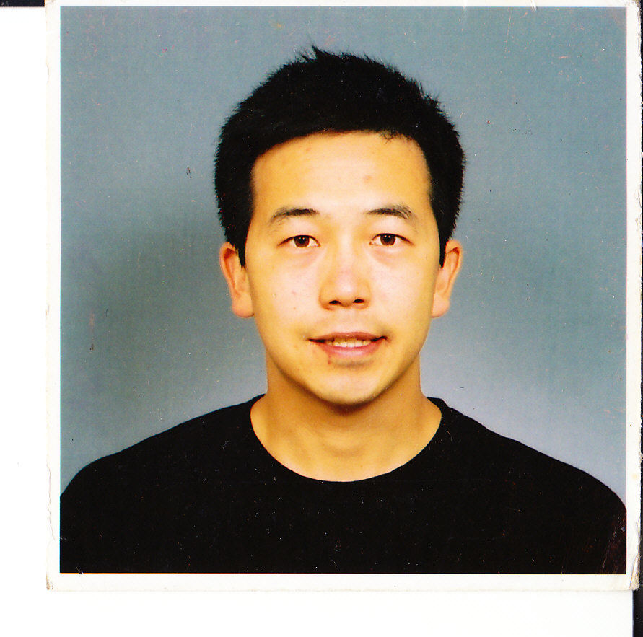 | EUGENE PARK  Northern Jeolla Province, Iksan, Eo-Yang Neighborhood, Doo-Sol Villa  010-7558-6027  nycsciteach@yahoo.com or eugene.park@lc.cuny.edu  (please e-mail me first before you call)  WEBSITE: http://www.geocities.ws/nycsciteach  Objectives  Full Time ESL teacher/Branch Manager

Education

Licensed in Education effective September 1, 2010
Master’s Degree in Education Lehman College GPA:3.60

Professional Development workshops during the summer 2009 in Dolan DNA Laboratory Certification in Genetics/DNA, Leadership Training Certfication in Genetics/DNA, and Classroom Management through ASPDP

Past enrollment in PD workshops of over 500 hours through United Federation of Teachers (UFT), NYC Board of Education, Urban Advantage, Globe Earth Science getenergysmart.org, Effective Scaffolding for English Language Learners (extremely useful), Cornell’s Nanotechnology workshops (2006) in 3 years

M.A. degree (Awarded Dec. 2001) in PUBLIC ADMINISTRATION TROY STATE UNIVERSITY GRADUATE SCHOOL OF PUBLIC ADMINISTRATION GPA: 3.40

M.A. graduate credits from UNIVERSITY OF ARIZONA TUCSON AZ, 95760 PUBLIC HEALTH ADMINISTRATION (towards TSU diploma) 1994-1997

Post-graduate Medical School courses/surgery, medicine, and psychiatry rotations in St. Louis University School of Medicine 1990-1994

B.S. degree (Awarded May 1990) ADELPHI UNIVERSITY GARDEN CITY NY, 11530 in CHEMISTRY (Extensive credits in Physics and Math) Semester Hours: 145 GPA: 3.35

WHEATLEY HIGH SCHOOL OLD WESTBURY NY 11568. DIPLOMA 1986
AP course credits for American History, European History, Calculus, Biology, Physics

NYC Public School Work Experience
2008-2010 JHS194Q William Carr Junior High School
Supervisor: AP Karen Logan/Principal Iannizzi
* Responsible for SCIENCE education for 150 Students (4 mainstream, 1 special education) in 6th, 7th and 8th grades
* Fully utilized Glencoe audiovisual and laboratory technology to the maximal benefit of his students thanks to PD training within 6^{th,} 7th and 8th grade GLENCOE Systems
* Fully knowledgeable in dealing with science state testing issues and in the framework of handling preparation challenges for students in Grade 8
* Improved detailed data tracking of students, assessment procedures, extensive lesson planning for all topics covered by the Glencoe curriculum within all 3 branches of science
* Chosen to teach Saturday Testing Preparation in Science Grade 8 for JHS194Q students
* Exerted maximal effort to teach 3 grades of science simultaneously for a full year
* Urban Advantage teacher to promote science exit projects for middle school students

2007-2008 IS25Q Adrien Block Intermediate School
Supervisors: AP David Erdil/AP Irene Zimmet
* Responsible for SCIENCE education for 100 Students (2 mainstream, 1 accelerated) and one mainstream MATH class of 26 students
* Continually reinvented his functional website for students to further explore/research science and get critical updated class/school information for their class (www.geocities.com/nycsciteach)
* Fully and successfully utilized Glencoe audiovisual and laboratory technology to the maximal benefit of his students thanks to excellent PD training within 3,4 & 6th grade GLENCOE and FOSS Systems
* Acted as Health Education Teacher and introduced students to basic Powerpoint and Excel programs for use in Science Exit Projects
* Had 6th graders create inquiry-based science exit projects for their academic fair
* Used many innovative hands-on and technology experiences in his Mathematics classes
* Fully knowledgeable in Math State Testing issues and challenges for students in Grade 6-8
* Selected as a Table Leader and Grader for the Grades 3-8 English Language Arts, Math State Test, and Grade 8 Science Tests for Region 3 (Grading Books available upon request)
* Chosen to teach Morning and After School Testing Preparation in Math Grade 6, Math Grade 8, and Science Grade 8 for IS25Q students by administration

2005-2007 MS216Q GEORGE J RYAN MIDDLE SCHOOL
Supervisor: AP Daphne Van Dorn/AP Susan Stine
GENERAL SCIENCE 6TH GRADE teacher for over 250 student for 2 years
* Responsible for science education for 100-140 Students per year and $5,000 of scientific equipment/supplies from Urban Advantage middle school exit project program
* Developed functional website for students to further explore/research science and get critical updated information for their class (www.geocities.com/nycsciteach)
* Resolved all issues between parents and their child’s school to their satisfaction
* Implemented and taught to several teachers Microsoft Excel into grading systems & scientific data tables
* Excelled in setting up and presenting to large audiences using Powerpoint presentation
* Conducted research, presented clear data, and offered concise plans and extra credit assignments to improve on students’ progress using the latest computer tools for students, supervisors, and parents.

2001-2005 Various English academies in Korea such as Motivating Individual Success (MIS), POLY International School, CHUNGSOL International School (CIS), Center for International Education (CIE)
LOCATION: SEOUL, KOREA
SUPERVISORS: DAVID KANG/ JANET HWANG / TONY OH / MYUNGGI KIM Permission to Contact
Description of Involvement/Responsibilities
Taught elementary and middle school Vocabulary, Grammar, Writing, and TOEFL using standard American textbooks and Korean to over 190 students. Critical tasks included curriculum planning, monthly report card evaluation and testing, and essay writing development for all students. Taught elementary and middle school Mathematics and Science using standard American textbooks and Korean curriculum to over 170 students. Critical tasks included curriculum planning, monthly report card evaluation and testing, and parent-teacher counseling for all students. Supervised 6 other instructors. 6 months experience teaching TOEFL/TOEIC/ESL/SSAT/ Geometry and Biology in English to over 40 high and middle school students. Supervised 2 other instructors.
Greatest Accomplishment: Ensure several Korean students achieve high SSAT and TOEFL scores to enter private and public American schools. INSTRUCTOR of the Month December 2003 and April 2004 Ensured successful launch of and quality education in new English language immersion institute in the area.

Military Work Experience

1999-2000 ADJUTANT/PERSONNEL MANAGER(FIRST LIEUTENANT),
SUPERVISOR: MAJOR JOHN P. ROGERS, COMM 054-970-8365 Permission to Contact
Duties and Accomplishments:
As the Adjutant/Commander's Assistant for over 2 years in 16th Medical Logistics Battalion and Raymond W, Bliss Army Community Hospital, fully understands and implemented command regulations, policy, and guidance. Ensured that all personnel were reminded of and fully involved and knowledgeable in any taskers that the Commander or Chief Executive Officer assigned to them. Thoroughly trained on all personnel issues during the 2 years as the Personnel Manager of the 16th Medical Logistics Battalion without the assistance of a genuine Personnel NCO during my tenure. As the battalion EO Officer, developed training techniques (lesson planning, various methods of instructions, and methods for evaluating training outcome). Briefed newcomers' on EEO procedures and policy. Used knowledge of counseling and other dispute resolution techniques.

1997-1999: STORAGE and DISTRIBUTION/WAREHOUSE
OFFICER-IN-CHARGE / PLATOON LEADER
SUPERVISOR: CAPTAIN RUSSELL T. OXFORD Permission to Contact
Duties and Accomplishments:
Well-rounded experience in all facets of a medical storage and distribution operation for high demand customers as a Storage and Distribution Supervisor. Provided both physical and financial accountability for medical stock record account property. Analyzed medical supply system to detect deficiencies, determined and implemented corrective actions.

1994-1997: ASSISTANT CHIEF COORDINATED CARE DIVISION (CCD) ,
ORGANIZATION: U.S. ARMY MEDICAL ACTIVITY RAYMOND W. BLISS ARMY COMMUNITY HOSPITAL (RWBACH)
LOCATION: FORT HUACHUCA AZ 85613 (UNITED STATES)
SUPERVISOR: MAJOR BROOKSHIRE, 001-520-452-5432 Permission to Contact
Duties and Accomplishments:
As the Assistant Chief, Coordinated Care Division, recompiled the strategic plan of the Raymond W. Bliss Army Community Hospital in accordance with JCAHO standards. Oversaw the implementation of TRICARE transition from CHAMPUS. As the inprocessing briefer of the whole base, briefed over 40 inprocessing soldiers on the health care services offered in Fort Huachuca. Responsible for planning, developing, directing and coordinating the administrative non-direct medical patient care, for being thoroughly conversant with all policies, directives and regulations.

Volunteer / Minimum Wage Activities

1988 – 1990: CHIEF TUTOR in PHYSICS/CHEMISTRY/ MATH/BIOLOGY
ORGANIZATION: ADELPHI UNIVERSITY
LOCATION: SOUTH STREET GARDEN CITY NY
DATES of PARTICIPATION:
AVERAGE HOURS/WEEK 10 hours/week
Description of Involvement/Responsibilities
Tutored over 15 students on minimum wage salary. Gave guidance on how to solve math or science problems in several creative ways. Pointed out different tables or formulas necessary to understand and solve different problems without just giving answers. Always challenged my students to try and conquer harder problems to reinforce their learning.
Greatest Accomplishment: Most of my students received A or A- on their report cards within their challenging subjects.

Applicant Certification

I certify that, to the best of my knowledge and belief, all of the information on and attached to this application is true, correct, complete and made in good faith. I understand that false or fraudulent information on or attached to this application may be grounds for not hiring me or for firing me after I begin work, and may be punishable by fine or imprisonment. I understand that any information I give may be investigated.

SIGNATURE Eugene Park DATE SIGNED Monday August 2, 2010

Unofficial Transcript for Eugene Park
Lehman
Cumulative GPA: 3.762 | Indexable Credits: 40.0
Degree Track: GRADUATE DEGREE | Credits Earned: 40.0
Skills Math: | Skills Reading:
Skills Writing: | Total Credits Attempted: 40.0
Total Credits Earned: 40.0 | Transfer Credits: 0.0

Transfer College: HUNTER CUNY
Start: | End:

Course | Description | Grade | Credits
CHE - 560 | Topics In Chemistry | A | 3.0
PERMIT 09/06
OTHER COURSES
Credit Type: PERMIT | Start Date: June 1, 2006
Summer 2005
Credits Attempted: 7.0 | Credits Earned: 7.0 | Term GPA: 3.700
Graduate Division | Non-degree Tuition
Undergrad Non-degree | Undecided Grad

Course | Description | Grade | Credits | Equated Credits | Hours
ESC - 501 | Psy Foundations Educ | B+ | 3.0 | 3.0 | 3.0
ESC - 519 | Tchng Sci 2ndry Schl | A | 3.0 | 3.0 | 3.0
ESC - 789 | Ind Stdy-curric Devl | A | 1.0 | 1.0 | 1.0

Fall 2005
Credits Attempted: 6.0 | Credits Earned: 6.0 | Term GPA: 3.850
Graduate Division | Higher Tuition
Lower Freshmen | Science Education S2

Course | Description | Grade | Credits | Equated Credits | Hours
ESC - 529 | Lang.litcy.educ.tech | A- | 3.0 | 3.0 | 3.0
ESC - 770 | Tops:meth Tch Scienc | A | 3.0 | 3.0 | 3.0

Spring 2006
Credits Attempted: 9.0 | Credits Earned: 9.0 | Term GPA: 3.566
Graduate Division | Higher Tuition
Lower Freshmen | Science Education S2

Course | Description | Grade | Credits | Equated Credits | Hours
ESC - 767 | Mus/res. Tch. Sci. | A | 3.0 | 3.0 | 3.0
ESC - 502 | His. Found. Us Educ. | B- | 3.0 | 3.0 | 3.0
ESC - 755 | Tch. Hist. Dev. Sci. | A | 3.0 | 3.0 | 3.0

Summer 2006
Credits Attempted: | Credits Earned: | Term GPA:
Graduate Division | Higher Tuition
Lower Freshmen | Science Education S2

Course | Description | Grade | Credits | Equated Credits | Hours
PERM - 613 | On Permit For 3 Crs. | P | 0.0 | 0.0 | 3.0

Fall 2006
Credits Attempted: 3.0 | Credits Earned: 3.0 | Term GPA: 4.000
Graduate Division | Higher Tuition
Lower Freshmen | Science Education S2

Course | Description | Grade | Credits | Equated Credits | Hours
ESC - 722 | Tchng Commun Skills | A | 3.0 | 3.0 | 3.0
PERM - 613 | On Permit For 3 Crs. | P | 0.0 | 0.0 | 3.0

Spring 2007
Credits Attempted: 6.0 | Credits Earned: 6.0 | Term GPA: 3.200
Graduate Division | Higher Tuition
Lower Freshmen | Science Education S2

Course | Description | Grade | Credits | Equated Credits | Hours
ESC - 595 | Intrnshp 2nd Sch Tch | A- | 3.0 | 3.0 | 3.0
ESC - 705 | Methods Of Research | B- | 3.0 | 3.0 | 3.0

Spring 2009
Credits Attempted: 3.0 | Credits Earned: 3.0 | Term GPA: 3.766
Graduate Division | Higher Tuition
Lower Freshmen | Science Education S2

Course | Description | Grade | Credits | Equated Credits | Hours
ESC - 706 | Project Seminar I | B+ | 1.0 | 1.0 | 1.0
ESC - 707 | Project Seminar | A | 2.0 | 2.0 | 2.0

Spring 2010
Credits Attempted: | Credits Earned: | Term GPA:
Graduate Division | Higher Tuition
Lower Freshmen | Science Education S2

Course | Description | Grade | Credits | Equated Credits | Hours
GEO - 601 | Earth Sys Sci-eductr |  | 4.0 | 4.0 | 4.0

Important Note: This is an UNOFFICIAL student transcript. Information as of 3/25/2010 10:27 PM

