Mar 22, 2012

Kenneth R. Scott
90 Reynolds Drive.
Brockville, Ontario
K6V 1X1
CANADA
(613) 246-5360 - cell
(613) 342-5589 – home (8am – 11:30am KST.)
Email: kenscott2012@hotmail.com

Dear sir or madam:
I am currently looking for employment as an English teacher in South Korea. I have completed my ITTT, TEFL Teacher Training course as well as the ‘Teaching Young Learners’ course.
I am available to start work in May or June of 2012. I am particularly looking for employment in a smaller village or town in a private school teaching groups of kindergarten – elementary aged children. It is my belief that in doing this, I will be in a better position to absorb the Korean culture and build a better rapport with the people.
Thank you for giving consideration to my resume.

Ken Scott.

Kenneth Scott

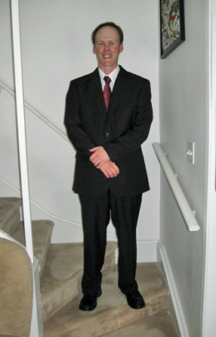

RESUME

PERSONAL

Bate of Birth December 19, 1970
Driver’s License Class “G”
Citizenship Canadian
Language English

EDUCATION

Brockville Collegiate Institute
Ontario Secondary School Diploma

University of Toronto
1992-1996
B.A. in Journalism

ITTT TEFL Certification Course
Completed April 26, 2010

ITTT TEFL Young Learners Course
Completed Oct. 23, 2010

REFERENCES

Rev. Douglas Burns, (613) 498-3376
Peter Godding (Sector Manager, H.M. Coastguard, Scotland) - 011 441854 613 076
Duane Henderson (Asst. Manager Euroscot Seafood Ltd.) – 011 441571 844 036
John or Peter Hickling (Owners of Ritchie’s Wholesale) – 613 342-2305

WORK EXPERIENCE

October 2005 Ritchie’s Wholesale:
To Title: Warehouse Manager
Present Duties: Inventory control, shipping and receiving, and customer service.
Tel. (613) 342-2305 Peter or John Hickling - owners.
-Please see attached reference letter.

January 25th, 2002 Euroscot Seafood Ltd.
To (address on reference letter)
August 17th, 2005 Title: Docker and forklift operator
Duties: Driving the forklift, unloading French, Spanish and
Faeroe Island fishing vessels by hand.
Grading species of fish, weighing, loading and unloading
lorries, stock taking, belt progression…
Reason for Leaving: To return to Canada

February 2002 Maritime and Coastguard Agency (Lochinver, Scotland)
To Title: Volunteer Rescue Officer
August 2005 Duties: Search and Rescue is the activity of locating and recovering
persons either in distress, potential distress or missing and
delivering them to a place of safety.
Training: First Aid, cliff rescue, (techniques equipment, and practical),
Navigation, knots, maps and compass, and much more.

July 2000 Odd jobs in Lochinver, Scotland. This includes two summers at
To the Albannach Hotel as a room cleaner, and then room manager.
January 2002 Reason for Leaving: Found full time employment at Euroscot
Seafood Ltd.

October 1996 Freelance photographer for area newspapers including The Toronto
To Sun. Interest pictures were taken and then sold to papers by way
July 1997 of usage.

IN GENERAL:

Along with my other job skills, I have also worked at the Brockville Psychiatric Hospital during the summers of 1990 and 1991 as a housekeeper. My jobs included, cleaning and sanitizing patient quarters, washrooms, jet-tubs, and toilets. Cleaning floors and windows as well as entire wards.
While at B.P.H. I completed my first W.H.I.M.I.S. course and my second was at McDougall Liquid Waste.

Hobbies and Volunteer Work.

In the summers of 1990 and 1991 I was a coach for the Brockville Special Olympics floor hockey team.
In September 2003 I was accepted into Her Majesty’s Coastguard, as a Search and Rescue Officer. As well as First Aid, the M.C.A. has taught me many skills. Some of these include, cliff rescue, map and compass reading, survival, leadership skills, and how to be properly thrown from a helicopter.

My favorite pastimes would definitely have to be Scuba Diving, and camping.
I also enjoy reading, hiking and photography.

Over the years I have travelled around the globe and have always enjoyed the adventures that came with it. Being open minded and always willing to discover and learn new things have always kept me young.

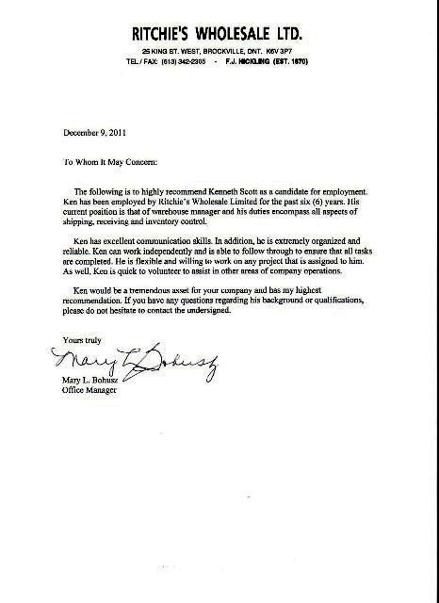

EUROSCOT SEAFOODS LTD
CULAG PIER
LOCHINVER IV27 4LF |  |  | 1
SUTHERLAND | SCOTLAND | DATE : | 15-08-05
TEL : | 0044 ( 0 ) 1571 844 770 | FAX : | 0044 ( 0 ) 1571 844 771
MOB : | 0044 ( 0 ) 7718 974 157
e-mail: | lochinver@euroscotseafoods.fsnet.co.uk

REFERANCE & CERTIFICATE OF EMPLOYMENT

Kenneth Scott

Job title: Counter Balance Forklift Driver – Fish Grader/Laborer
Employed with Euroscot Seafoods Ltd from the 25th January 2002 to 15th August 2005.

During Kenneth’s time with the company he proved himself to be a very confident, punctual and hard working employee, a pleasure to work with.

Being the type of business that Euroscot Seafoods Ltd is (Agents for fishing vessels) Kenneth had a large variety of duties which varied day to day depending on the vessel that was landing their fish, whatever was involved I could always rely on him to do an efficient and professional job.

I would most definitely employ him again if he ever decides to return to Scotland.

Operations Manager

Duncan Dennis

