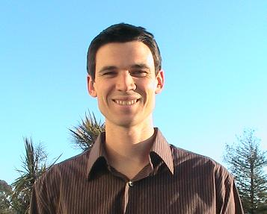
Kevin U. Brown
6135 Buena Vista Ave.
Oakland, CA, 94618
(510) 421-1920
skateparks424@yahoo.com

EDUCATION:
California Polytechnic State University, San Luis Obispo Dec 2004
• Bachelor of Arts in Industrial Technology
Dec 2004

Certificate of Educational Studies in TESOL, Intesol Spain,
Barcelona Mar 2005

CONSTRUCTION EXPERIENCE
• Demolition, framing, plumbing, electrical, painting, and finish carpentry for Golden Snail Builders
May 2008 – Current
• Head Builder for the Defremery Skateboard Park in Oakland, CA
Aug 2008 – Current
• Have built all kinds of wood skateboard park elements
June 1996 – Current
TEACHING EXPERIENCE
TEFL (Teaching English as a Foreign Language) Certified Instructor:

Language Schools in California
• English Language Studies (Berkeley): Taught all levels
Dec 2007 – Apr 2008
• Kaplan (San Francisco): Taught morning and afternoon intermediate
May 2007 – Sep 2007
• Kaplan (Berkeley): Taught morning and afternoon lower intermediate Sep 2006 – May 2007
Language Schools in Barcelona, Spain
• Taught all levels at Quality English, Aston Idiomas, La’Aula, and Edison Language School
Apr – Dec 2005

ADDITIONAL EXPERIENCE AND SKILLS
• Auto Cad and Microsoft Word Proficient
• Fluent in Spanish and speak a little Korean

