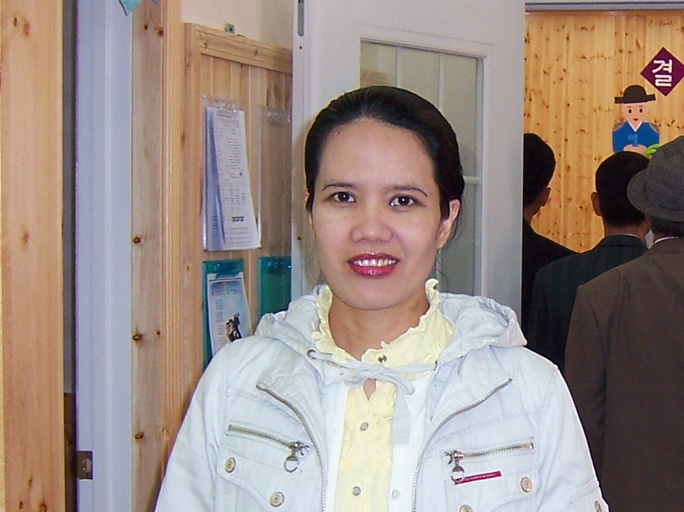

RESUME

PERSONAL INFORMATION

Name Novella Cala-or Tano
Address Heamang Apartment A dong 103 ho 230-3
Pyeongnae Dong Namyangju City Kyong Gi Do
South Korea 472-936
Contact Number 010 2073 4580
Age 36 years old
Date of Birth November 05, 1973
Birth Place Oton, Iloilo Philippines
Gender Female
Civil Status Married
Citizenship Filipino
Height 5' 4"
Weight 50 kgs.
Religion Seventh Day Adventist
Father's Name Manuel C. Tano
Occupation Electrician
Mother's Name Ma. Luz C. Tano
Occupation Photography
Language or dialect I can speak or write English, Filipino, Ilonggo
Person to be contacted in case
of emergency Hwa Dong Cheon
Address Heamang Apartment A dong 103 ho 230-3
Pyeongnae Dong Namyangju City Kyong Gi Do
South Korea 472-936
Contact Number 011 387 3004

EDUCATIONAL BACKGROUND

Elementary Botong SDA Multigrade School
Deans List
March 1987
High School Botong- Cabanbanan National High School
Top 5 among the graduating class
March 1991
University Mountain View College
Course Bachelor of Science in Accountacy
March 1999

Vocational Mira-flor Fashion Academy
Course Dressmaking
1992

SEMINARS AND TRAININGS

1. RESCUE 741(Life Saving Training)
Philippine

2. JPIA(Future Accountant Group)
Business Strategies

3. English and Bible Training
1000 Missionary Movement

EMPLOYMENT RECORD
1. Kindergarten Teacher
Multigrade School, Philippines
1999

2. Bureau of Custom
Iloilo Philippines
2000

3. Disbursing Officer (Cashier)
Sarabia Manor Hotel, Philippines
2000 - 2001

4. Missionary Accountant
1000 Missionary Movement
2001 - 2004

5. English and Bible Teacher
Ga Pyong, South Korea
2004 - 2006

6. English Teacher
Chuncheon Samyook Elementary School
2006 - 2007

7. English Teacher
E-Bo Young Talking Club
Ho Pyong Dong
2008 – 2009

8. Kindergarten English Teacher
MARU Ho Pyong Dong, South Korea
2009
9. Tutorials / phone Teachings
Anywhere in my place.

OTHERS: You can contact me anytime in the night. Thank you very much.

I hereby certify that the above information is true and correct to the best of my knowledge and belief.

_______________________

NOVELLA C. TANO

