Curriculum Vitae

Michelle Glancy

August 2011

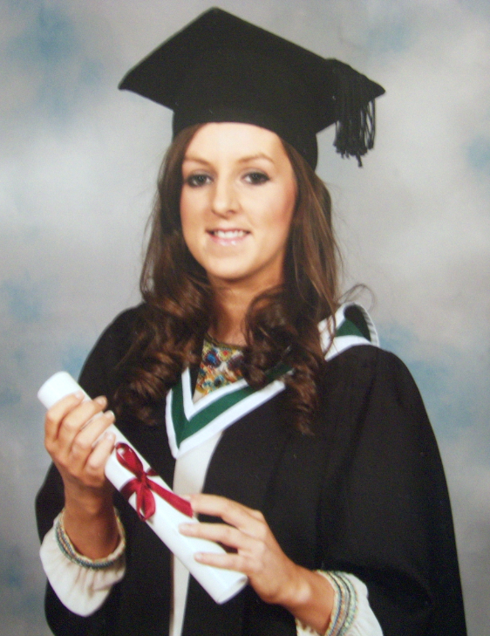
Personal Details

Name: Michelle Glancy

Address: Cloonsheebane
Carrick-on-Shannon,
Co. Leitrim
Ireland

Contact Details: Mobile: 00 353 (0)86 1649801
Email: glancymichelle@hotmail.com

Date of Birth: 7th February 1989

Education Qualifications

School | Dates | Certificates
Marist Girls National School, Carrick-on-Shannon | Sep 1994 - Jun 2001
Carrick-on-Shannon, Community School | Sep 2001 - Jun 2003 | Junior Certificate
  Subject | Level | Grade
  Irish | Higher | B
  English | Higher | C
  Maths | Higher | D
  Geography | Higher | B
  History | Higher | C
  Science | Higher | C
  French | Higher | D
  Home Ec. | Higher | C
  Music | Higher | B
  Woodwork | Ordinary | A
  Religion | Higher | D
  CSPE | Common | B
Carrick-on-Shannon, Community School | Sep2003 - Jun 2006 | Leaving Certificate
  Subject | Level | Grade
  Irish | H | C1
  Maths | O | B1
  English | H | C1
  Biology | H | D1
  French | O | C1
  Music | H | B1
  Geography | H | C3
University College Dublin | Sep 2006 – May 2010 | Bachelor of Arts - Honours  Subjects:  Major: Irish  Minor: Geography  First Year Major: Music  Electives: Linguistics, Sports Science, Study Skills, Introduction to Sports Massage.

Work Experience

From | To | Name/Address of Employer | Title and Details of employment
Jun 2007 | Sep 2007 | Leitrim Co Council  Aras an Chontae  Carrick-on-Shannon | Student  Working in the Housing Dept. Receptionist duties, housing applications, filing, and data entry.
Nov 2007 | May 08 | Heaton’s Store  Townspark  Carrick-on-Shannon | Shop Assistant  (Holidays and weekends)  General shop duties, cash management, customer services.
Aug 2009 | Feb 2011 | Heaton’s Store  Townspark  Carrick-on-Shannon | Shop Assistant  (Holidays and weekends)  General shop duties, cash management, customer services.
Sept 2010 | June 2011 | Community School  Carrick-on-Shannon |  | Teacher/Class Supervisor.  Teaching Irish and Geography to students ranging from First year to Leaving Certificate. Supervising classes.
Nov 2010 | June 2011 | Dept. of Education |  | Teacher  Home schooling a Leaving Certificate student Irish. Covering the Irish Leaving Certificate course.
July 2011 | Aug 2011 | Leitrim GAA Coaching, Cùl Camps, Carrick-on-Shannon |  | Football Coach  Coaching children aged 5 to 12 football skills at GAA Summer Camps.

Interests and Achievements

Gaelic Football

- Member of Leitrim Ladies senior panel 2011
- Member of St.Marys GAA club.
- Holder of various underage medals.
- Holder of two junior ladies county titles.
- Holder of intermediate B ladies county title.
- Two runner-up Connacht medals with the senior secondary schools team.
- St. Marys Secretary September 2009 - December 2009
- Member of St. Mary’s club 125 team. A team selected to celebrate 125 years of the Gaelic Athletic association
- Current joint manager of St. Mary’s girls Under 12 team
- Coach in the Gaelic for Girls programme administered by County Leitrim Sports Partnership

****************

Gymnastics

- Leitrim & Connacht titles in under age gymnastics and rhythmic gymnastics.

Music

- Grade V piano from the Royal Irish Academy of Music.

Speech & Drama

- Attended speech and drama school and achieved many lower level qualifications.

Other

- Foundation Coaching Course in Gaelic Football.
- Award 1 Coaching Course youth & Adult in Gaelic Football.
- Code of Ethnics: Child Protection in Sport Awareness Workshop.
- Other Information

- My other sporting interests include basketball, swimming and horse riding.
I am a very good Irish speaker and have a keen interest in the language. I attended the Gaeltacht courses in Connemara on three occasions. In my final year I held the position of Cinnire in the Irish college “Spleodar” in 2004. My duties as Cinnire included being responsible for children under 14, assisting them with their learning of Irish, supervision and discipline. As part of my Arts degree course I also attended the Gaeltacht on numerous occasions.
- Efficient organiser and always like to facilitate young people in enjoying sports and educational activities.
I enjoy leading young people in enjoying sports and educational activities.

****************

Bronze Medal in the President’s Gaisce Awards.

Skills

- European Computer Driving License
- Irish Language speaker

References

Mr. Paul Beirne
Vice – Principal
Community School
Carrick-on-Shannon
Co.Leitrim
Phone: 00353719620880

