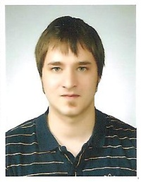

Name: Daniel Soeren Huebner

Address: 164-68 BO1 Cheonho-dong,
Gangdong-gu,
134-020 Seoul
Mobilephone: 01076608565
E-Mail: huebis-guts@gmx.net

Date of Birth: 10.02.1986,
in 23701 Eutin, Germany.

Marital Status: Married, no children yet.

Education:
1992-1996: elementary school, Eutin, Germany.

1996-2002: secondary modern school, Eutin,
Germany.

2002-2005: education and training as a
kindergarten teacher, Lensahn,
Germany.

Sep.2005- Sep.2006: travel and work in Australia.

Feb.2007- Dec.2007: Christian-Albrechts- Universitaet
zu Kiel. Some coursework done.
Other Qualifications: Cambridge First Certificate
in English (FCE) ESOL Level 1.

Holding a Korean F-2 Visa,
married to my Korean wife.

I worked in the german school at
4-13 Hannam- dong, Yongsan-gu
for a few month.

Right now I study a little bit Korean
by myself.

