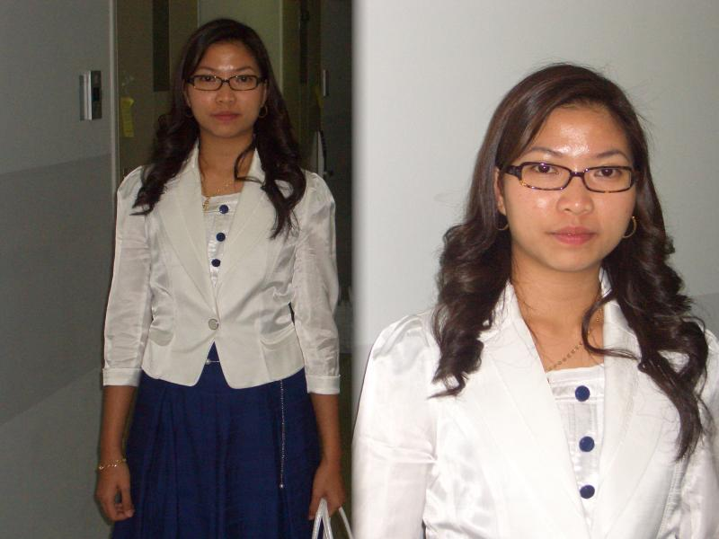
Ana Marie Delgado Mun
260-153 Itaewon 2-dong
Yongsan-Gu Seoul
anahdelg@yahoo.com
Mobile #: 010-4664-1602
Tel. #: 02) 790-2196

************************************************************************************

OBJECTIVE: To obtain experience, share some knowledge and to
enhance my interpersonal skills

PERSONAL INFORMATION:

NATIONALITY: Filipino
HOMETOWN: Manila, Philippines
BIRTHDATE: 1983, December 07
CIVIL STATUS: Married

EDUCATIONAL ATTAINMENT:

PRIMARY: Kapitan Moy Elementary School (1990-1996)
Marikina City, Manila Philippines
SECONDARY: Roosevelt College Marikina (1996-2000)
Marikina City, Manila Philippines
PRIMARY: Jose Rizal University (2000-2005)
Mandaluyong City, Manila Philippines
COURSE: Bachelor of Science in Accountancy

WORKING EXPERIENCES:

JOSE RIZAL UNIVERSITY: Office clerk
April 2005 - Sept. 2005
RUSTY LOPEZ ENT. INC.: Accounting Staff
Dec. 2005 - July 2006
RUSS MARKETING INC.: Accounts Payable Staff
July 2006 - Sept. 2006

