Resume

Personal Particular
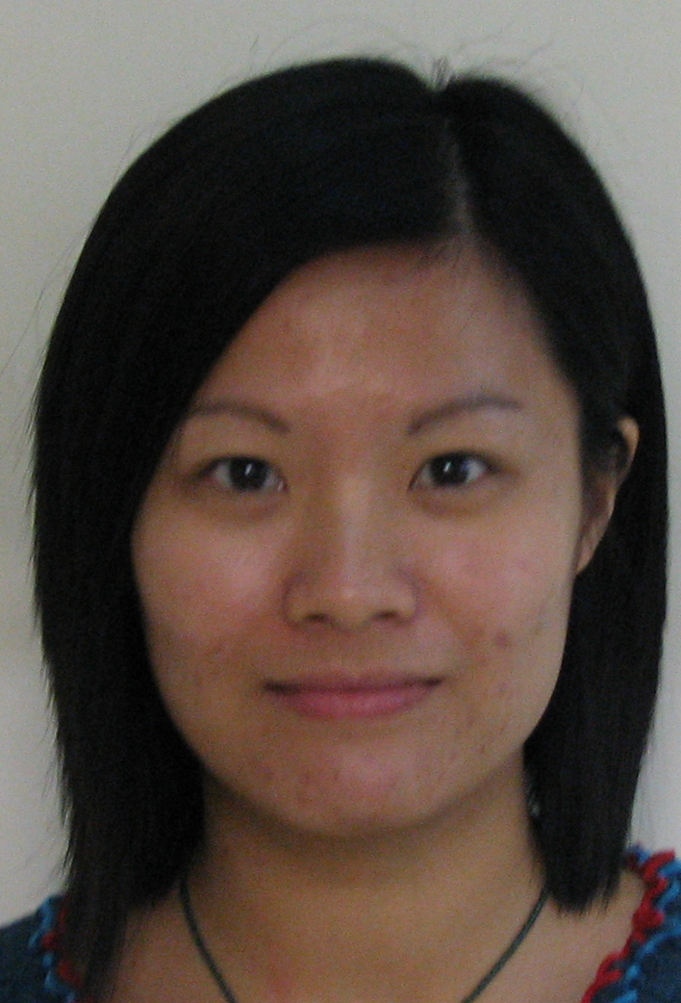
Name LAU SIU WA
Sex Female
Date & Place of Birth April 24 1984, Hong Kong
Martial Status Single
Address Flat E 8/F Block D Tsuen Tak Gardens Tsuen Wan N.T.
Telephone (mobile) 008 852 6121 0261
E-mail: wacerise@hotmail.com

Education and Qualification
2007 – 2008 Hong Kong Baptist University
- Postgraduate Diploma of Education in Liberal Studies
- Major in Liberal Studies; Minor in History & Chinese History

2004 – 2007 City University of Hong Kong
- Bachelor of Social Sciences (Honours) in Policy Studies and Administration
- Major in China Studies, Politics & International Affairs

1996 – 2003 Queen’s College Old Boys’ Association Secondary School
- Hong Kong Advanced Level of Examination (2003 & 2004)
- Chinese History (B), History (D), Chinese Literature (D), Chinese Language & Culture (D),
- Use of Englsh (E)

- Hong Kong Certificate of Education Examination (2001)
- Chinese Literature (B), History (B), Chinese Language (B), Chinese History (C), English (E),
- Mathematics (E)

Related Work Experience
Novemeber 2009 to July 2010 Assistant Lecturer
Vocational Training Council - IVE (Chai Wan)

May to July 2009 High School teacher
Queen’s College Old Boys’ Association Secondary School (Tsing Yi)

March to April 2009 High School teacher
Ma On Shan St. Joseph Seconday School (Ma On Shan)

October to December 2008 High School teacher
TWGHs Kwok Yat Wai College (Tin Shui Wai)

September to October 2008 High School teacher
Fanling Government School (Fanling)

January to July 2007 Full Time Teaching Assistant
CCC Chuen Yuen College (Kwai Chung)

Extra-curricular Activities
2004 – 2005 Committee, City University of Hong Kong Students’ Union Editorial Board
My responsibilities included:
  - Assisting in edit newspapers and publications of City University of Hong Kong
  - Providing administrative support on all kinds of editorial affairs

2001 – 2002 President, Chinese Club of Queen’s College Old Boys’ Association Secondary School
My responsibilities included:
  - Orangizing activities to encourage students to parpticipate actively in Chinese activities
  - Providing administrative support on all kinds of chinese affairs

July 2005 Representative of Hong Kong in a Nanjing Tour,
Research and Study of Contemporary China Research and Study of Contemporary China

July 2000 Representative of Hong Kong in a Chengdu Tour, Millennium Study Tour

Language
Verbal Cantonese dialect Excellent
English Excellent
Putonghua Excellent
Korean Fair

Written Chinese Excellent
English Excellent
Korean Fair

Computer Knowledge
Microsoft of Word, Excel, PowerPoint, Typing of Chinese & English (40 words per minute), Website Design, Adobe Photoshop

Hobbies and Interests
Hobbies Badminton, Squash, Swimming
Reading history-related books and articles & local, China, International news

Referees
Dr Arthur Cheung, Kam-chuen
Teaching Fellow of Department of Public and Social Administration
Prof Dip HKP, MA, PhD Warwick
Tel: +852 2788 8755
Email: saarthur@cityu.edu.hk
Address: AC-B7316, City University of Hong Kong, Tat Chee Avenue, Kowloon Tong, Kowloon

Dr Hui, Glenn Kwok-hung
Teaching Fellow of Department of Public and Social Administration
BA UCLA, MA PhD CityU Instructor
Tel: +852 2788 7016
Email: glennhui@cityu.edu.hk
Address: AC-B7505, City University of Hong Kong, Tat Chee Avenue, Kowloon Tong, Kowloon

Available upon request
Immediate available

