Name | Marina Pak
Address | Seoul, Tongdaemun Stadium St. Area
Phone | 010 77 999 55 7
E-mail | park_marina@mail.ru
Date of Birth | December 27, 1981
Marital Status | single
Objective | Office-Manager-interpreter (English)
Education | Bachelor
1999–2003 | Pedagogical University of Uzbekistan. Tashkent
Faculty | Russian and Korean philology
Languages | English – working knowledge (Intermediate), Korean - good
Experience & Skills | - Business correspondence;  - Negotiations arrangement, contacts with foreign partners;  - Office work.
Work experience | 3 years
2008-2006 | ЧП «CHINEL»
2009-2008  2009-2010 | “LUCKY” South-Korean Boutique  Sales-Manager  «NOVA-CARGO»  Assistant-manager
Skills | experienced user of PC (Word, Excel, Internet, CorelDraw, PowerPoint)
Personal Skills | Hard-working person, good decision making, administrative, communicational and interpersonal skills.
Additional Information | Working as An English Tutor for 6-12 months in Seoul
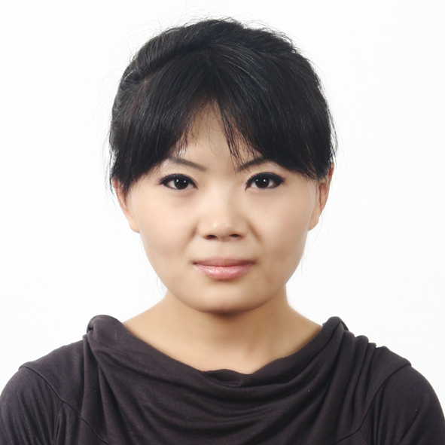
RESUME

