RIAZ HUSSAIN

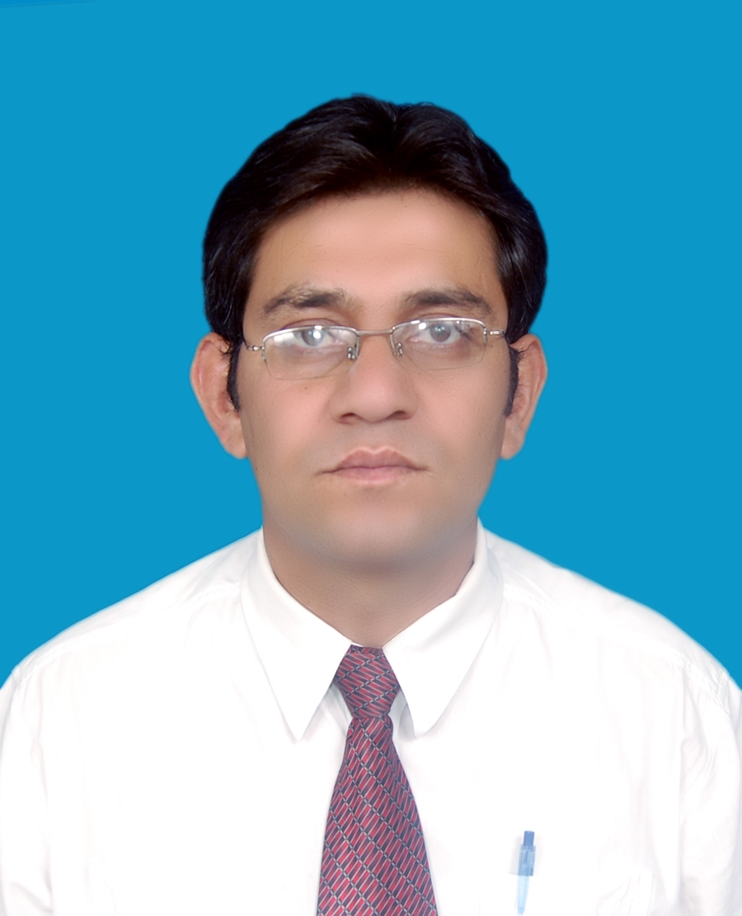

Didar House Near police Ground

Mujahid Colony konodas

Gilgit, Northern Areas

Phone # (05811) Res: 53821 Off: 52446-52447

Cell: 03449495838

E-mail: riazhussainabadi@hotmail.com

Work Experience:

April2008 to date

English Language teacher,

Aga Khan Higher secondary school

Northern Areas, Gilgit
Major areas:
- Facilitating participants in acquiring the essentials of the language focusing on speaking, writing, reading comprehension and listening skills
▪ Teaching English to both school and college classes

January 2007 April 2008 Teacher Educator (English)

Aga Khan Education Service, Pakistan

Northern Areas, Gilgit
- Plan and conduct trainings for teachers
- Developing modules for trainings
- Regular reporting of trainings and programs
- Monitoring and follow-ups
- Classroom observations

April 2006 to 2007 English Language teacher,

Army public School and College (Hayat Shaheed), Pakistan, Northern Areas, Gilgit
Major responsibilities
    - Teaching English to both middle and high classes
    - Conducting English language classes to students after school hours
    - Facilitating participants in acquiring the essentials of the language focusing on speaking, writing, reading and listening skills

Nov2002 to April2006 English Language Teacher,
Sir Syed Public school , Gilgit
Major responsibilities
    - Teaching English to both middle and high classes
    - Conducting English language classes to students after school hours
- Facilitating participants in acquiring the essentials of the language focusing on speaking, writing, reading comprehension and listening skills
Academic Qualification:

M.A AJK University, Muzaffar Abad
Major Subjects:
    - Linguistics
    - Phonetics and phonology
    - TEFL
    - English Literature
PGD(TEFL) Allama Iqbal open University, Islamabad
Major Subject:
    - Teaching of Grammar
    - Teaching of Phonetics
    - EFL In Classroom
B.ED Karakurum International university, Gilgit
Major Subjects:
    - Educational Psychology
    - Philosophy of Education
    - Teaching On English
    - School Organization
BA Punjab university
Major Subjects:
    - Economics
    - Political Science
    - Persian

F.Sc FBISE
Major Subjects:
    - English
    - Physics
    - Mathematics
    - Chemistry

Matriculation Mirpur Board AJK
Major Subjects:
    - English
    - Physics
    - Mathematics
    - Chemistry
    - Biology

MA (TEFL) Allama Iqbal Open University, Islamabad
Major Subject:
    - Educational psychology
    - English for Specific Purpose
    - Semantics and discourse analysis

Workshops/Conferences/Seminars Attended:
- Workshop on Communication Skill organised by Aga Khan Social Welfare Board, Pakistan in 2002
- Workshop on Personality Traits organised by Aga Khan Social Welfare Board Pakistan in 2003
- Seminar on the Black Hole Theory organised by Karakuram International University in 2007
- Three days workshop on shina grammar and folk tales organized by summer institute of Linguistics USA in 2008 and contributed in the publication of Likhano Bijon and Shina Urdu aur English me bol chal with the collaboration of shina Language and cultural promotion society Gilgit.
- One day workshop on Action Research organized by Aga Khan education service Pakistan in 2007.
- Two days training workshop on Teaching skills organized by oxford university press in 2008.
- Three days work shop on Issues in Language development organized by frontier Language institution(FLI) Peshawar in 2009.
- One week workshop on Research Methodology at Allamma Iqbal open University Islamabad

Languages Skill:
English; Speak, Read, Write
Urdu; Speak, Read, Write
Shina; Speak, Read, Write
Brushaski; Speak, Read, Write
Punjabi; Speak, Read, Write
Pahadi; Read, Write
Computer literacy:
Proficient in Microsoft Office System, Web Browsing Packages; type 40 wpm with complete accuracy
Personal Detail:
Gender; Male
Marital Status; Married
Nationality; Pakistani
Domicile; Gilgit
Mailing Address; Didar House Mujahid colony konodas, Gilgit
References:
Gulab Khan
Principal
Aga Khan Higher secondary scchool
Northern Areas, Gilgit
Phone # 05811-55071
Burhan-ud-Din
Principal
Sir Syed Public School
Northern Areas, Gilgit
Phone # 05811-53719

