RIAZ HUSSAIN

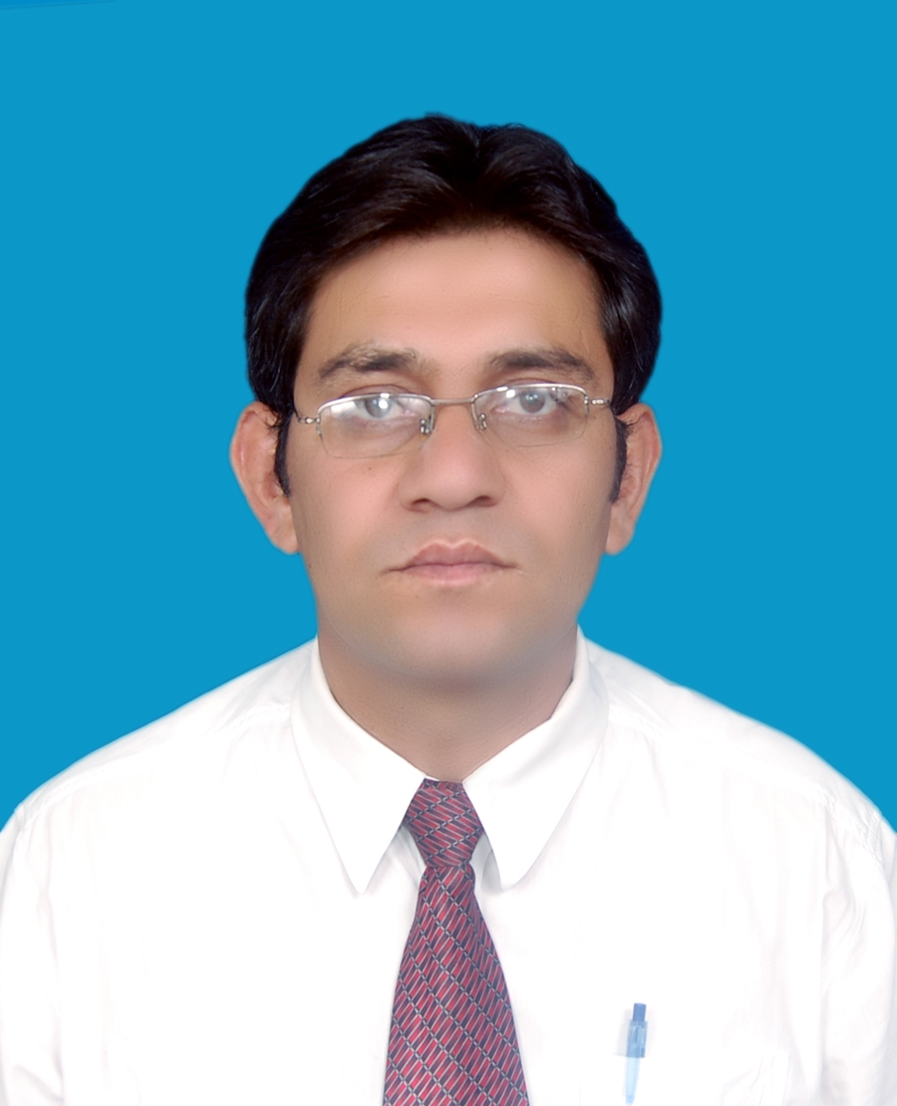

Didar House Near police Ground

Mujahid Colony konodas

Gilgit, Gilgit-Baltistan

Phone # (05811) Res: 53821 Off: 52446-52447

Cell: 03449495838

E-mail: riazhussainabadi@hotmail.com

Work Experience:

April2008 to date

English Language teacher,

Aga Khan Higher secondary school

Northern Areas, Gilgit
Major areas:
- Facilitating participants in acquiring the essentials of the language focusing on speaking, writing, reading comprehension and listening skills
▪ Teaching English to both school and college classes

January 2007 April 2008 Teacher Educator (English)

Aga Khan Education Service, Pakistan

Northern Areas, Gilgit
- Plan and conduct trainings for teachers
- Developing modules for trainings
- Regular reporting of trainings and programs
- Monitoring and follow-ups
- Classroom observations

April 2006 to 2007 English Language teacher,

Army public School and College (Hayat Shaheed), Pakistan, Northern Areas, Gilgit
Major responsibilities
    - Teaching English to both middle and high classes
    - Conducting English language classes to students after school hours
    - Facilitating participants in acquiring the essentials of the language focusing on speaking, writing, reading and listening skills
Nov2002 to April2006 English Language Teacher,
Sir Syed Public school, Gilgit
Major responsibilities
    - Teaching English to both middle and high classes
    - Conducting English language classes to students after school hours
- Facilitating participants in acquiring the essentials of the language focusing on speaking, writing, reading comprehension and listening skills
Academic Qualification:

MA (TEFL) Allama Iqbal Open University, Islamabad (In Progress)
Major Subject:
    - Educational psychology and management of learning
    - English for Specific Purposes
    - Semantics and discourse analysis

B.ED Karakurum International university, Gilgit
(2008)
Major Subjects:
    - Educational Psychology
    - Philosophy of Education
    - Teaching On English
    - School Organization

PGD (TEFL) Allama Iqbal Open University, Islamabad
(2006-2007)
Major Subject:
    - Teaching of Grammar
    - Phonetics and Phonology
    - EFL In Classroom
    - Teaching Practice
    - Teaching Skills
M.A AJK University, Muzaffarabad
(2000-2003)
Major Subjects:
    - Linguistics
    - Stylistics
    - Grammar
    - Phonetics and phonology
    - TEFL
    - English Literature
BA Punjab university
(1997-1999) Major Subjects:
    - Economics
    - Political Science
    - Persian

F.Sc Federal Board of intermediate and secondary (1994-1996) education Islamabad
Major Subjects:
    - English
    - Physics
    - Mathematics
    - Chemistry

Matriculation Mirpur Board AJK
Major Subjects:
    - English
    - Physics
    - Mathematics
    - Chemistry
    - Biology
Workshops/Conferences/Seminars Attended:
- Workshop on Communication Skill organised by Aga Khan Social Welfare Board, Pakistan in 2002
- Workshop on Personality Traits organised by Aga Khan Social Welfare Board Pakistan in 2003
- Seminar on the Black Hole Theory organised by Karakuram International University in 2007
- Three days workshop on Shina Grammar and Folk Tales organized by summer institute of Linguistics USA in 2008 and contributed in the publication of Likhano Bijon and Shina Urdu Aur English May Bol Chal with the collaboration of shina Language and cultural promotion society Gilgit.
- One day workshop on Action Research organized by Aga Khan education service Pakistan in 2007.
- Two days training workshop on Teaching skills organized by oxford university press in 2008.
- Three days work shop on Issues in Language development organized by frontier Language institution (FLI) Peshawar in 2009.
- One week workshop on Research Methodology at Allama Iqbal open University Islamabad
- Worked as member editorial of magazine Literary Horizon published by department of English AJK University Muzaffarabad Azad Kashmir
- Have been president of Northern Areas Students Association(NASA) AJK University Muzaffarabad Azad Kashmir
- Working as reporter with weekly WADI Gilgit-Baltistan since 2003.

Languages Skill:
English; Speak, Read, Write, listen
Urdu; Speak, Read, Write, listen
Shina; Speak, Read, Write, listen
Brushski; Speak, Read, listen
Punjabi; Speak, listen
Pahadi; Speak, listen
Computer literacy:
Proficient in Microsoft Office System, Web Browsing Packages; type 40 wpm with complete accuracy
Personal Detail:
Gender; Male
Marital Status; Married
Nationality; Pakistani
Domicile; Gilgit
Mailing Address; Didar House Mujahid colony konodas, Gilgit
References:
Gulab Khan
Principal
Aga Khan Higher secondary school
Konodas, Gilgit
Phone # 05811-55071
Burhan-ud-Din
Principal
Sir Syed Public School
Kashrot,Gilgit
Phone # 05811-53719

