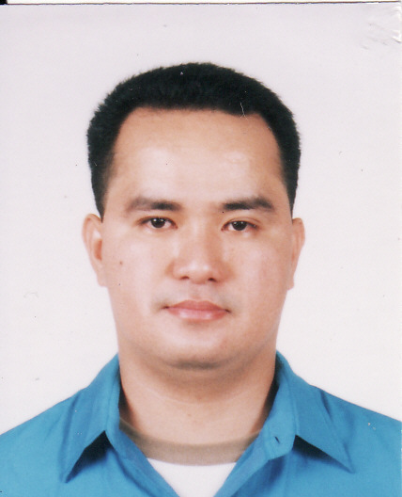
Randy E. Gulapa
# 68-918 Jangwi 2 Dong
Seungbuk-gu, Seoul
E-mail simplyred_821@yahoo.com
Handy phone # 010 4344 2108

Objective: To apply the things I’ve learned from school as well as from my job experiences.

Tertiary: Baliuag University - June 1992 – March 1996
Gil carlos street, Baliuag Bulacan
Course: Bachelor of Science in Business Administration
Major in Management

Secondary: Mariano Ponce High School - June 1988 – March 1992
Benigno Aquino Avenue, Baliuag Bulacan

Primary: Saint Mary’s Academy - June 1982 – March 1988
Racelis Street, Baliuag Bulacan

Seminar Attended:
- Seminar on Extra Value Added Tax, held at Traders Hotel Roxas Boulevard Pasay City on February 10, 1996
- Seminar on PHILAMLIFE Insurance held at Intercontinental Hotel
Makati City

Skills:
Posses a knowledge in Marketing, Managing and Selling

Tendering:
Computer Literate
Can Speak fluent English, Filipino and Korean language

Work Experienced :

REX Academy
238-53 taenung-dong Nowon-Gu Seoul
Position: English Teacher

REX Academy
177-128 Myeonmok-dong Jungrang-Gu, Seoul
Position: English Teacher

Joy Academy
Myeong-il Dong Seoul
Position: English Teacher

Character References :

Mrs. Kim Won ook
Myeong-il Dong, Seoul
HP# 016 203 8151

Mrs. Ju Yang Hyook
238-53 Taenung 2 Dong Nowon-gu, Seoul
Tel# 02 977 8216 HP# 017 212 0205

I hereby declare that all statements in this resume are true and correct to the best of my knowledge and belief.

--------------------------------

Randy E. Gulapa
Applicants Signature

