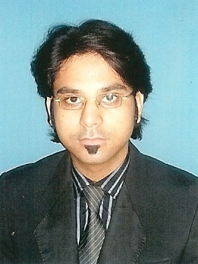
RAZA HASSAN QURESHI

Bungalow # 103/120 Abdullah City Qasimabad Hyderabad
Cell # 0332-2628755
razahassan44@hotmail.com

CAREER PROFILE

To work in a challenging environment and occupy a position which provide career and personal growth opportunities.
An enthusiastic business finalist committed to a career in engineering.

EDUCATION & QUALIFICATION

Bachelors of Engineering (Petroleum and Natural Gas)
Mehran University of Engineering & Technology, Jamshoro, 2010.

Board of Intermediate and Secondary Education, Hyderabad. Intermediate, 2005.

Board of Intermediate and Secondary Education, Hyderabad. Matriculation, 2003.

FINAL YEAR PROJECT

Prediction of Sand Production & Multiple Sand Control Techniques.

MEMBER OF

Pakistan Engineering Council (PEC)



Society of Petroleum Engineers (SPE)

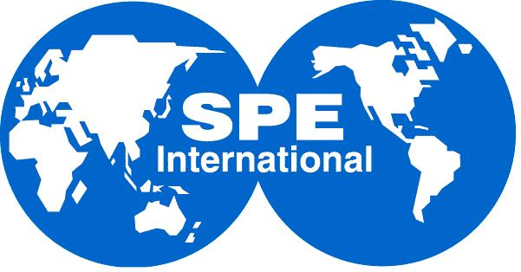

COMPUTER SKILLS

Microsoft Windows, Microsoft Office, Internet, Email and Surfing.

LANGUAGES KNOWN

Good command in Reading, Writing and Speaking of

English

Sindhi

Urdu.

INTERESTS

Listening to Music

Reading Books

Playing Cricket

PERSONAL INFORMATION

Father’s Name Ghulam Hassan Qureshi
Date of Birth September 08, 1987
Nationality Pakistani
CNIC 41506-0345486-9
Marital Status Single

REFERENCES

Will be provided when required.

