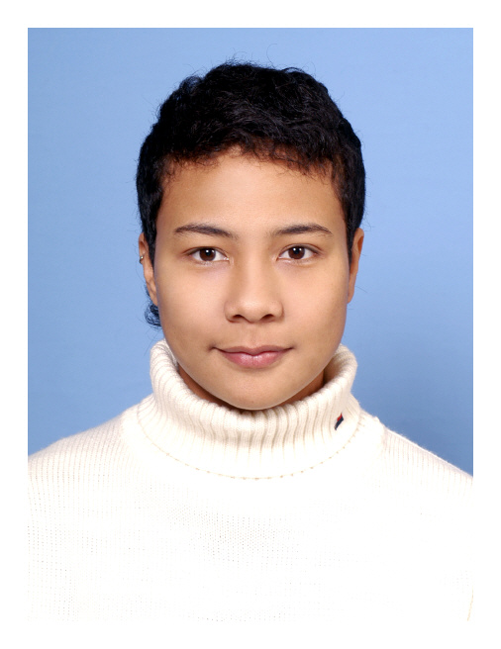
Ridvaniyyih Qurattul Ayn Willis

• DOB: Sep 18th, 1978
• Nationality: American
• Citizenship: U.S.A.
• Race: Amerasian (American mix Taiwanese)
• Email Address: kai.is.willis@gmail.com
EDUCATION
LTTC (London Teacher Training College)
- Diploma in TESOL
Oklahoma City University
- Bachelor of Arts in Mass Communication
- Major: Liberal Studies
WORK EXPERIENCE
GEOS Language Centre Singapore Aug 09 – Present
Training Manager / English Teacher
- Develop the school’s curriculum for different levels including: elementary, pre-intermediate, intermediate, and upper intermediate.
- Conduct lessons according to the school’s curriculum and enrichment programs.
- Classroom management and maintain a pleasant learning environment.
- Set up learning corners.
- Carry out routine care duties.
- Organize and participate in school events.
- Design teacher training programs.
- Teachers’ class scheduling.
GEOS Language Centre Singapore Feb 08 – July 09
English Teacher
- Conduct lessons according to the school’s curriculum and enrichment programs.
- Classroom management and maintain a pleasant learning environment.
- Set up learning corners.
- Carry out routine care duties.
- Organize and participate in school events
Tutor Sep 05– Jan 08
English / Chinese Tutoring
- Teach Asian children, teenagers and adults from various countries the English / Chinese language, including spoken, written and literature.
Joy Children’s Language School (Taiwan, Xin-Dian branch) June 04– May 05
School Manager / English Teacher
- Marketing and administration of school.
- Identify new areas of child and student services and develop long term expansion plans.
- Prepare course objectives and course outline following curriculum guidelines or requirements of government.
- Plan student recruiting activities.
- Teach children and teenagers the English language and literature.
- Organize events.
Joy Children’s Language School (Taiwan, Xin-Dian branch) Mar 02 – June 04
English Teacher
- Teach children and teenagers the English language and literature.
Various Translation Agencies (Taiwan) Aug 01 – May 05
Freelance Translator
- Translate documents from English to Chinese, vice versa.
LANGUAGE SKILLS
English
- Spoken: Excellent
- Written: Excellent
Chinese Mandarin (Traditional and simplified)
- Spoken: Excellent
- Written: Excellent
Korean
- Spoken: A little
- Written: Capable
- Reading: Capable
PREFERRED LOCATION
- Seoul
STARTING DATE
February or March 2010

