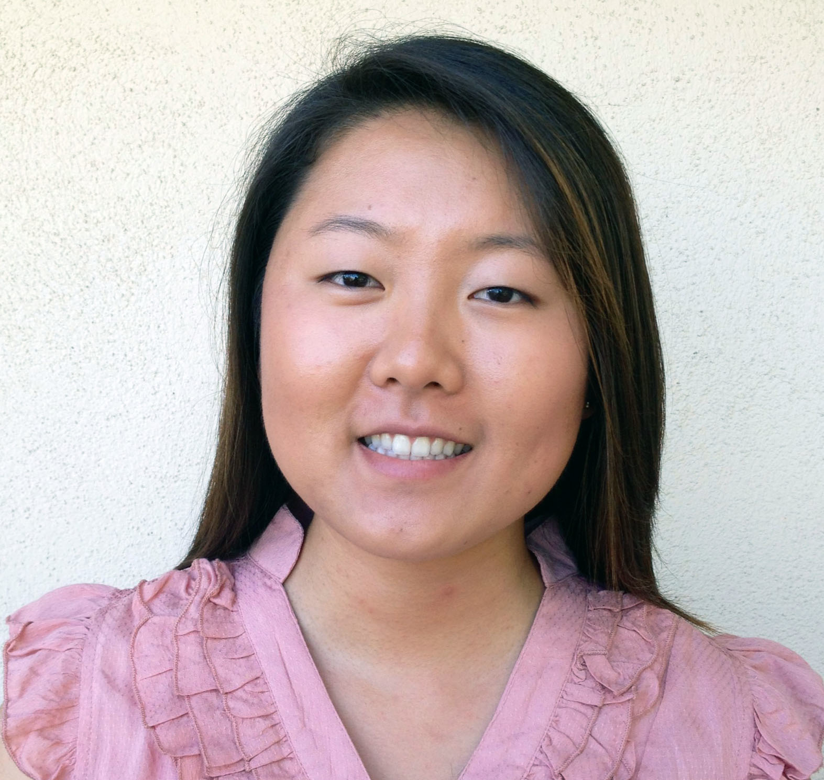
Diana Jung 812 Roxbury Drive
Date of Birth: January 30, 1989 Fullerton, CA 92833
Gender: Female United States
Nationality: American Citizen
(714) 888 – 4248 Available Date: November 2013
dejung89@gmail.com

Skype ID: dejung89

Objective:
To be a positive English language teacher. I will bring my cheerful and optimistic personality to encourage English language learners of all ages to practice English confidently and happily. I will educate students so they gain a proficient understanding of English using the methods and guidelines my employer would want me to use. Lastly, I want to integrate the Korean culture as an essential part of my identity and express my gratitude by providing my skills as a natural English speaker.

Education:
Bachelor of Arts: Double Major in International Studies & Urban Studies, UC Irvine, CA Fall 2011
High School Diploma, John F. Kennedy High School, La Palma, CA June 2007

Experience:
Private Tutor, Irvine, CA
2013
- Tutored a Korean adult in grammar and writing
- Tutoring sessions were 2 hours long, twice a week
- Used English throughout sessions to maximize language immersion
- Provided Korean words for comparisons and examples
- Developed the usage of natural American English language usage and understanding

Private Tutor, La Palma, CA
2005
- Tutored an 8 year-old male child in reading and comprehension
- Tutoring sessions were 2 hours long, twice a week, afterschool
- Utilized methods such as enthusiasm, role-play, and discussion to help the child stay awake, motivated, and engaged in the activity

Volunteer, Braille Institute, Anaheim, CA
2003 – 2006
- Supervised visually-impaired children and young adults in activities that build confidence and practical life skills
- Explained instructions carefully and helped direct activities to support a good learning environment
- Participated in activities so children felt more comfortable and welcome

Study Abroad Student, UCI Travel Study, Pembroke College – University of Cambridge, UK
June – July 2008
- Participated in the Summer Travel Study program at UC Irvine
- Traveled throughout the English Isles
- Learned valuable social skills for both large and small groups and also individual living

Professional Experience:
Office Services Coordinator, International Programs, UC Irvine – Extension
October 2011 – September 2013
- Received specialized training in communicating effectively with new learners of English
- Manage application processing for 4,000+ international students per year while reviewing for completeness, payment, and minimum requirements
- Act as the initial contact for students, agents, and partner universities for application procedures, program details, immigration information, and commission policies
- Assist in managing relations with over 200 agents and partner universities
- Provide advising for student schedules, attendance, fee statements, grades, and refer to appropriate resources and departmental units on- and off- campus
- Process student documents including enrollment verification letters, withdrawals, refunds, intention forms, transfer-out forms, and health insurance waivers
- Manage new student registration and document collection, including I-20s, passports, and I-94s for English language, Professional Certificate, and Custom Designed Programs
- Work in coordination with Immigration personnel to meet SEVIS registration deadlines
- Supervise and train 5-10 student assistants on customer service, program inquiries, and daily administrative duties

Office General Assistant and Activity Lead, International Programs, UC Irvine – Extension
December 2009 – September 2011
- Assisted in planning and managing on- and off- campus activities for international students enrolled in UC Irvine Extension – International Programs
- Managed Communication Club, assisted students with non-academic resources, and oriented them to campus life
- Transported and chaperoned students for on- and off- campus activities
- Acquired extensive knowledge and skills about UC Irvine Extension programs and procedures

Skills:
- Microsoft Office
- Conversational Korean
- 80 W.P.M. Typing Proficiency
- PC and Mac
- Digital Photography

