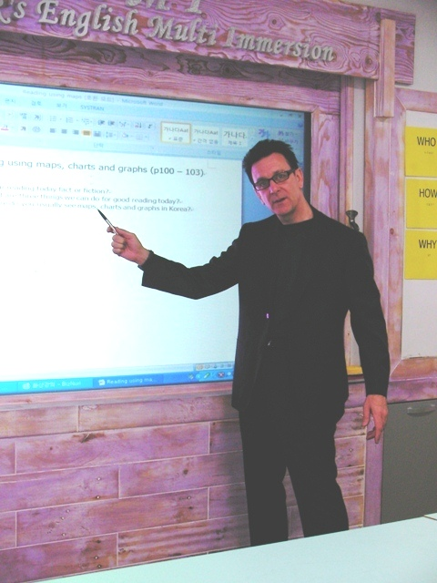
“Efficient English”

Stephen Brian Gee
Apartment 305 Freelancer Officetel
Sau-Dong
Gimpo Si
Gyonggido
South Korea 414040

Tel ~ 010-844-14222 Email : stephen1302@gmail.com

Educational Achievements

- Post Graduate Diploma of Teaching ~ University of Technology, Auckland, New Zealand, 2002.
- Bachelor of Social Science Degree (A average) ~ Waikato University, New Zealand, 1992.
- Post Graduate Certificate in Men’s Health ~ Curtin University, Perth, Western Australia, 2000.
- Master of Education Degree Certificates ~ Waikato University, New Zealand 1993. Group-work & Program Design, Counselling Skills, Counselling Theory.
- TEFOL Certificate – International College of Applied Linguistics 2004.
- Portfolio of Technical College Certificates in Communications and Human Relations, Training and Group-work, Family Systems therapy ~ Napier and Auckland Training Institutes, 1982 – 92.
Personal background

- Born 1959 in York, England. Upbringing in U.K. Cyprus, India and Singapore.
- Educated in International Primary schools in Cyprus and Singapore, then English Grammar
Schools.
- In 1981 emigrated to New Zealand and took NZ citizenship.
- Personal interests: hiking and tennis, music production, photography.

Relevant experience

- English Teacher – 8 years in South Korea.
Prize winner for excellence amongst EPIK teachers nationally.
Senior Teacher at Sogang University Language Program, Busan.
Currently employed at Tongjin Public High School. I have enjoyed coaching students of all ages
towards winning speech contests. I have successfully upgraded and referenced 2 faculty rooms,
and furnished 2 entire schools with educational displays.
I specialise in Group dynamics and introducing powerful multimedia learning software and
classroom methods. I have experience in teaching English as a second language through Maths,
Science, Art, Music, Physical Education and Social Studies. I have taught English both formally
and informally in UK, Germany, Thailand, China, Australia and New Zealand.
- Valued by students, staff and parents as encouraging, disciplined, energetic, fun and engaging, effective.

- Probation Officer – 1 year. Department of Corrections, Auckland.
Senior Officer’s caseload within first 3 months. Routinely giving sentencing reports to District Court Judges within very tight deadlines after interviewing criminals and their affiliates. Trained to performance level 2 new Officers use of systems software use and interviewing techniques. Successfully ran a monthly rehabilitation Education Group for ex-offenders.
- Sharp motivational, assessment, evaluation and report writing skills.
- Working with a large number of clients under tight deadlines.

- Rehabilitation Therapist – 1 year. Paremoremo Prison, Auckland.
Delivering education and therapeutic group-work. Conducting extensive interviews and psychometric testing to produce evaluation reports for parole and treatment.
- Working safely in very stressful group situations. Rapidly making complex ethical decisions. Liaising with wide range of professionals to write balanced comprehensive reports.

- Group Counsellor – 2 years. Man Alive Counselling Service. Waitakere City.
Managing education and therapy groups for men sentenced by local Courts. Teaching wide variety of stress management and communication skills.
Training 4 novice counsellors to service level.
- Using wide range of teaching methods from intense 1-1 structured interviews to action methods in group-work.
Ensuring the learning environment is safe and challenging.

- Mental Health Trainer – 18 months. Auckland Healthcare.
Designing, delivering and evaluating 3 day educational workshops and 12 week long courses on psychological and social care of mental health clients. Wide ranging students – from initiate
Home Care Assistants through to experienced Psychiatrists.
- Effectively planning, teaching and assessing at widely different levels.

- Community Mental Health Social Worker – 4 years. Auckland Healthcare.
Successfully designing and delivering life skills programs to mental health clients.
Working with clients, families, allied health professionals and advocacy groups.
- Rapidly designing effective life skills Education programs - still used in therapeutic communities in New Zealand.

- Group Counsellor – 18 months. Anglican Social Services. Hamilton.
Delivering educational group-work for men on community based sentences for the Department of Corrections. Successfully training 3 novice counsellors to full operational level.
- Effectively overseeing program design, delivery, evaluation and redesign.

- Home Manager – 5 years. Presbyterian Support Services, Napier and Haven Trust, Hamilton.
Designing then managing 2 community homes for 20 people with a wide variety of disabilities who had previously lived for many years in hospitals.
- Successfully coaching residents to run the home and surrounding gardens independently; Then to provide outreach services to other people with disabilities in the local community.

References

Mr Kim Hae Chang (Senior English Teacher)
Tongjin High School
Tongjin Eup, Masong-ri, Gyonggido
Tel: 010-2029-4682 E mail: chang0117@hanmail.net

Mr Cheong il Mun (Vice Principal)
Seohae Sahmyook Elementary School,
Gwangcheon Eup. Hongseong Gun, ChungNam.
Tel: 041-641-2502 E mail: cimun36@hanmail.net

