Resume

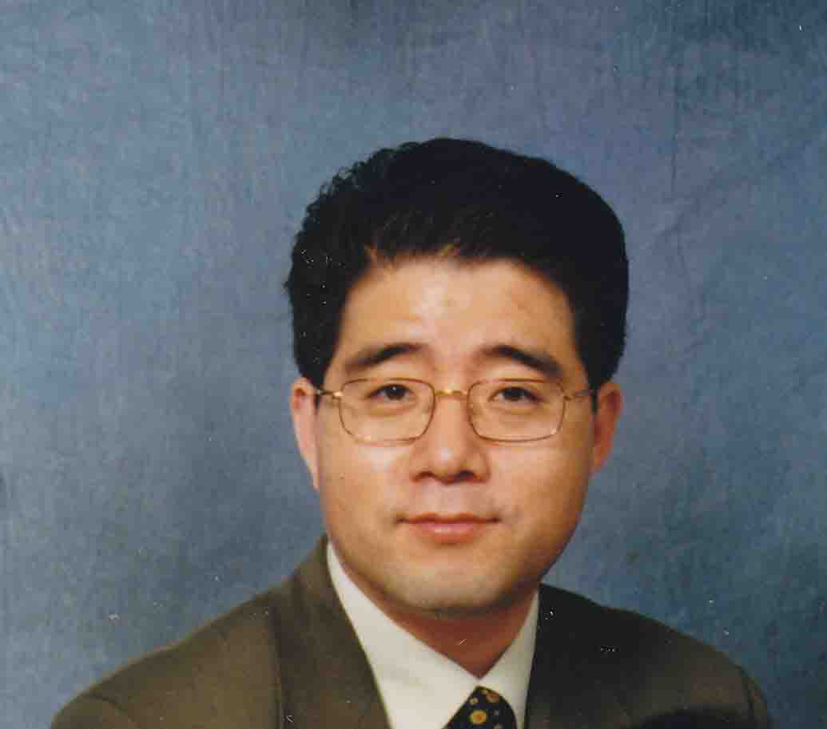
Mr. Mark Sunghoon Hong
707-25 Cedarcroft Blvd.
North York, ON M2R 2Z3
Tel. (416) 893-2231

Fax. (416) 792-9434

Introduction and Objective:
I have 17 years experience in studying, living, and working in Canada, in various work environments. I am fluent in both Korean and English, awarded with M.A. majoring at English, in English Department, Graduate School, University of Toronto, Canada.

I am seeking a position in teaching English in Korea; the areas of teaching can include English conversation, business English courses, grammar (TOEFL, TOEIC), and translation of various specialized business fields, as well as middle and high school grammar, though these are not my preference.

Remuneration can be negotiated after review of the teaching material and actual teaching. Commission of achievement and flexible payment based on capacity is also an option.

Education (Post-secondary)
1984 – 1988: B.A., English Language and Literature, Kyungpook Nat’l University, Taegu, Korea

1989 – 1991: M.A., English Literature, Graduate School, Kyungpook Nat’l University, Taegu, Korea

1992 – 1993: Drama Centre, Graduate School, University of Toronto, Canada

1993 – 1995: M.A., English Department, Graduate School, University of Toronto, Canada

Compulsory Army Service
1988 – 1989: Private, Korean Navy, South Korea

Work Experience
1989 – 1991: Assistant Teacher, English Language Institution, Kyungpook Nat’l
University, Taegu, Korea

1990 – 1992: Teacher, Sungmoon Hakwon, Pohang, Korea

1992.6: Arrived at Toronto, ON, Canada

1993 – 1995: Chef/Manager, Home Arirang (Korean-Chinese restaurant), Toronto,
Ontario
Kitchen management and cooking:

1995 – 1999: General Manager, Tricom Management Services Inc., Toronto, Ontario
The company provided services of a turn-key business set up services,
during the period, I was involved in setting up, running, six Japanese
Restaurants, and one sports bar, including management, financing, and
construction.

1999: Immigration to Canada (Prior to this year, was under foreign student and
working Visa)

1999 – 2004: Account Manager: P.A. Financial, Inc. Thornhill, Ontario
Life insurance salesperson

1999 - 2004: Financial Adviser: Reliance Management Consultant Inc., Mississauga, Ontario
Since 1999, my main work has been loan brokering, including mortgages, specialized on commercial mortgages, and business loans.

2004 – present: Private Loan Broker, WP Capital Inc., Mississauga, Ontario
Since 2004, I was working independently under the company name.

2005 – present: General Manager, Enfresin Global Inc.
The company has exclusive distributorship of a bio-degradable plastic
resin and its products, I was working for the contract between German bio-plastic company and its mother company in Korea. However, it is not generating steady income, waiting for the result of the international tests and certifications.

Minor Work Experience
1996 – 2003: Private Tutoring, English

Special Award
1992 – 1993: Rotary Fellowship Awarded

All the required certificates will be submitted upon request based on your positive response.

