Resume

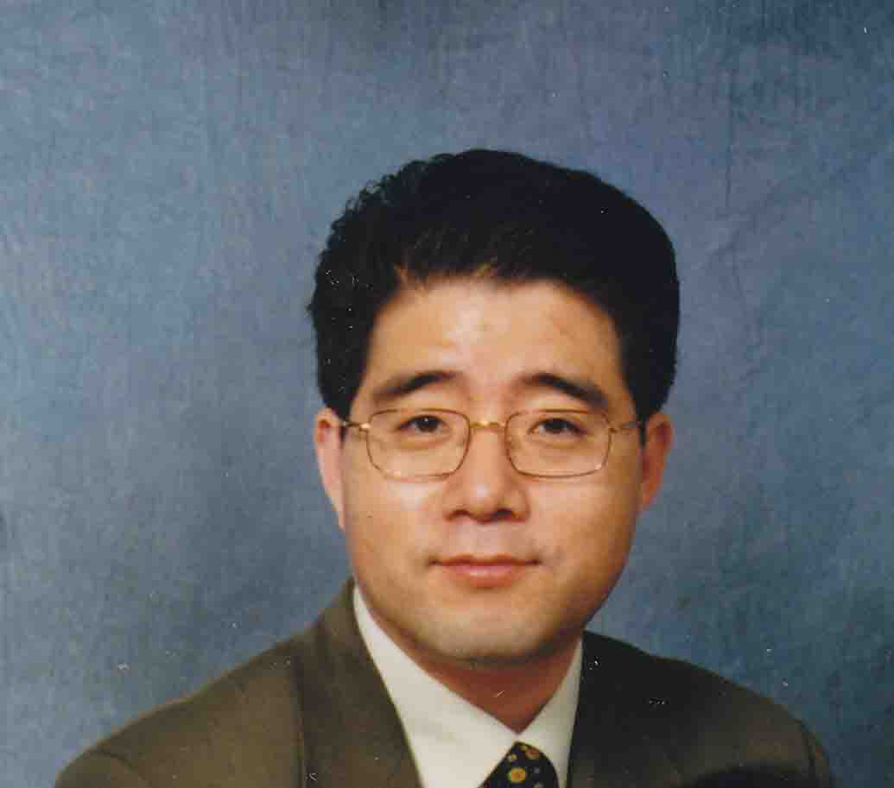
Mr. Mark Sunghoon Hong
707-25 Cedarcroft Blvd.
North York, ON M2R 2Z3
Tel. (416) 893-2231

Fax. (416) 792-9434

Contact (Korea): (010) 3015-3136

Introduction and Objective:
I have 17 years experience in studying, living, and working in Canada. I am fluent in both Korean and English, awarded with M.A., majoring at English, in English Department, Graduate School, University of Toronto, Canada.

I am seeking a position in teaching Advanced level Business English in Korea to medium and above level participants; the areas of teaching can include English conversation, various English tests (TOEFL, TOEIC, TEPS, etc.), and translation of various specialized business fields, as well as school level grammar.

I will be most useful in short term listening, reading and speaking training courses, using my instruction material, especially in business English, utilizing my knowledge in meta-cognitive understanding of Korean learners, and actual experience in various business environments, including presentations, meetings and negotiations.

Education (Post-secondary)
1984 – 1988: B.A., English Language and Literature, Kyungpook Nat’l University, Taegu, Korea

1989 – 1991: M.A., English Literature, Graduate School, Kyungpook Nat’l University, Taegu, Korea

1992 – 1993: Drama Centre, Graduate School, University of Toronto, Canada

1993 – 1995: M.A., English Department, Graduate School, University of Toronto, Canada

Compulsory Army Service
1988 – 1989: Private, Korean Navy, South Korea

General Work Experience
1989 – 1991: Assistant Teacher, English Language Institution, Kyungpook Nat’l
University, Taegu, Korea

1990 – 1992: Teacher, Sungmoon Hakwon, Pohang, Korea

1992.6: Arrived at Toronto, ON, Canada

1993 – 1995: Chef/Manager, Home Arirang (Korean-Chinese restaurant), Toronto,
Ontario
Kitchen management and cooking:

1995 – 1999: General Manager, Tricom Management Services Inc., Toronto, Ontario
The company provided services of a turn-key business set up services, including financing arrangement, management consultants.

1999: Immigration to Canada (Prior to this year, was under foreign student and
working Visa)

1999 – 2004: Account Manager: P.A. Financial, Inc. Thornhill, Ontario
Life insurance salesperson

1999 - 2004: Financial Adviser: Reliance Management Consultant Inc., Mississauga, Ontario
Since 1999, my main work has been loan brokering, including mortgages, specialized on commercial mortgages, and business loans for small and
medium size companies.

2004 – present: Private Loan Broker, WP Capital Inc., Mississauga, Ontario
Since 2004, I was working independently under the company name.

2005 – present: General Manager, Enfresin Global Inc.
The company has exclusive distributorship of a bio-degradable plastic
resin and its products, I was working for the contract between German bio-plastic companies and its mother company in Korea.

Teaching Experience
1985 – 1988: Tutor, English, Daegu, Korea

1989 – 1992: English Teacher, Sungmoon Hakwon, South Korea

1993 – 1995: Private English Tutor, Toronto, Canada

2005 – 2008: English Teacher, CTC Institute, Toronto, Canada

Special Award
1992 – 1993: Rotary Fellowship Awarded

All the required certificates will be submitted upon request based on your positive response.

