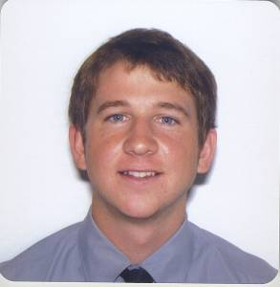
_________________Sam Donner______________
Oceanside, CA 92054 ⋅ sdonner21@hotmail.com ⋅ 010-5838-0723

Objective
TESOL/TESL certified teacher with relevant experience for a position as an
English as a Second Language teacher.

Qualifications
- Over 18 months experience as an ESL instructor and tutor for reading and writing.
- Experienced in working with children and adults of various cultural backgrounds.
- Excellent communication and organizational skills.
- Passionate and committed to seeing students reach full potential.
- Technologically proficient in Microsoft Word, Excel, and PowerPoint.

Work Experience
English Tutor • Tested and evaluated new computer
John Corcoran Literacy program for improving reading skills.
Foundation, California • Tutored English reading and writing to
12/08 - 08/09 to children utilizing the new software.

ESL Teacher • Prepared task-oriented lesson plans, teaching
Shane English School materials, and activities based on student’s Taiwan needs.
10/07 - 10/08 • Enhanced Grammar, Reading, Writing,
Speaking, and Listening skills.

Children’s Teacher • Prepared activities and games facilitating
Carlsbad Community Church a fun and exciting educational experience.
California • Provided a safe and enjoyable environment,
01/09 - 08/09 conducive to learning and growth.

Relevant Experience
Over 300 hours of service to various community groups and organizations including:
• Special Olympics Coach  - Youth Basketball Coach | - Oceanside Senior Citizen Center  - De Colores, service trip to Mexico
Education
2007, Loyola Marymount University Bachelor of Arts, Psychology
Los Angeles, California Minor in Philosophy

2007, Oxford Seminars Post-grad certificate, Teaching English as
San Diego, California Second Language (TESOL)

