PERSONAL:

NAME: Jacobus Gerhardus (Jacob) van Dyk
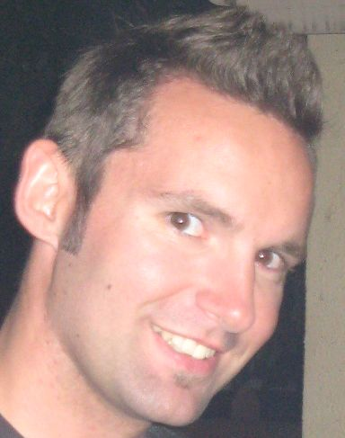
BIRTHDAY: 25 April 1983
ID NUMBER: 8304255117085
PHONE NUMBER: 074 107 3897 (South Africa)
010 8728 5226 (Korea)
ADDRESS: 132 Fagan Street
Strand
7140
South Africa
SPOKEN LANGUAGES: Afrikaans
English
(Currently learning Korean)
DRIVERS LICENCE: Yes

EDUCATION:
HIGH SCHOOL:
Hoër Volkskool Graaff-Reinet (1996 – 2001)
Matriculated 2001 with two distinctions*
Subjects:
Afrikaans HG*
English HG*
Maths HG
Science SG
Biology HG
Woodwork SG
Computer Science SG

SPORT:
- 1st Team Rugby
- 1st Team Athletics
- School Colors in Athletics

LEADERSHIP:
- Athletics team captain
- School prefect
- Served on Culture committee
- Head of schools Radio station
- Head of schools Webpage
- First aid

TERSIARY EDUCATION:
- North West University (Potchefstroom Campus) 2002 – 2005
- Graduated in 2005 with a BA degree in Psychology and Human Movement Science

2002:
- Joined Caput Men’s Residence
- Served on Residence’s Recruitment committee
- Served on Residence’s Social committee
- Took part in informal Serenade

SPORT:
- 1st Team Rugby
- 1st Team Soccer

2003:
- Head of Academic Student Association (Biocinetics Recreation and Sport Science)
- Received a diploma for Level 1 Gymnastics Coaching
- Received a diploma for Level 1 Rugby Coaching
- Received a diploma for Level 1 Swim Coaching
- Received a diploma for Level 1 Cricket Coaching
- Received a diploma for Level 1 First Aid
- Took part in informal Serenade

SPORT:
- 1st Team Rugby
- 1st Team Soccer
- 1st Team Basketball
2004:
- Became Residence Prefect
- Head of Residence’s Finances
- Head of Residence’s Actuality

SPORT:
- 1st Team Rugby
- 1st Team Soccer
- 1st Team Basketball

2005:
- Completed my degree

2006:
- Studying part time – Honors in Psychology
- Worked full time at Virgin Active as Lifestyle Consultant (Fitness)
Courses done:
- V-core
- V-cycle (Spinning)
- V-fit (Functional Training & Explosive Power)

2007
- Worked full time at Perfect Health Wellness Center as a Marketing & Sales Consultant, and did extremely well as a Sales consultant.

December 2007 – September 2008
- Promoted as General Manager of Perfect Health Exclusive Club.
- As the club was still under construction when I was appointed, I operated as the Project Manager of the club, overseeing construction, installation and setup op the club.
- This included planning of operation and lay-out of the club itself.
- Perfect Health Exclusive Club opened on the 1st of March and I started working there as General Manager.
My duties included:
- Daily running of club
- Handle Finances of Club
- Handle Sales & Marketing
- Running Floor and Floor Instructors
- Maintenance

November 2008 –
- Started teaching English at E.Bo Young’s Talking Club in Bongdam (close to Suwon) in South Korea.
- Teaching kids from age 6 to 15 years.
- Teaching Grammar, Pronunciation, Reading and English Conversation
I’m currently still teaching at this academy. My contract ends the end of June 2011

- I started my TEFL (Teaching English as Foreign Language) course. It’s a 100hour course and I will have completed it by May 2011.

DIVERSE:
Skilled in Windows, Word, Excel etc.
Skilled in Adobe Photoshop
Worked part time as a Carpenter
Hobbies: Playing guitar, playing PS3 and Snowboarding

REVRENCES:
Mr. M Galant
Fitness Manager – Virgin Active Somerset West
076 182 0478

Ms. Heloïse Botha
General Manager – Virgin Active Paarl
084 508 1876

Mr. Jan la Grange
General Manager – Perfect Health Wellness Centre Stellenbosch
082 881 1041

Ms. Julia Jung
Director/Owner – E.bo Young’s Talking Club (Bongdam branch)
031 278 0582 – Landline
010 5127 2217 – Cellphone

CV of JACOBUS GERHARDUS (JACO) VAN DYK

