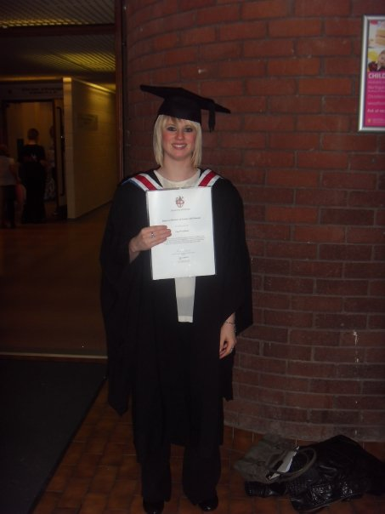  Lisa Woodland |  |  | Application to teach English in South Korea preferably within Seoul
Witchwell Cottage, Church Lane, Little Wenlock, Shropshire, England, TF6 5BB
07756634125
Lisaw@msn.com

Objective |  | To teach English in South Korea
Summary |  | - Experience: Last summer, I taught English in the Dominican Republic to children between the ages of 5 and 18. Therefore, I have first hand experience of teaching English to non English speaking people.  - Skill: The experience I gained through Dominican Republic has shown that I have the ability to successfully teach to English to others, who have limited or no English speaking capability through experimenting with means of communication. I also acquired teaching techniques that can be transferred into a Korean classroom and will be just as successful.  - Personal Quality: I am a confident person who is a fast learner, I am also very dedicated to any task at hand and will not stop until I feel the task is complete to the highest standard.
Education |  | Degree of Bachelor of Science with Honors in Psychology (Class Two, Division One) University of Chester, Cheshire, U.K.  I focused on child psychology and how the brain works when we learn; including how we develop and process language. |  | 2009

Career History & Accomplishments
 | Costa Coffee, Trained & certified Barista  - People Skills: Serving customers within a fast paced and stressful environment has improved my communication skills. Whilst serving many different types of people, I have learnt to adapt my communication techniques with different people. This skill will be very useful when teaching children from a different culture to my own.  - Initiative: Within this job I am required to have the initiative to see what tasks need completing around the work place, and then to either fulfill them myself or to delegate them to another member of staff. This will be useful when teaching, as I will have the confidence and initiative to implement my own ideas in the classroom.  - Organization and time management: organizing how I spend my time on specific tasks has greatly improved since working at Costa as I have noticed that time is the key to how successful or unsuccessful a shift is run. The importance of time can be reflected in teaching as it is important to manage how much time you spend with each individual, for example one child may need to have more time spent on them, as they may not be at the same level as the other children. This extra time needs to be managed effectively so that the other children in the class do not suffer. How long a child spends on a certain activity is also important, for example if they spend too long on a certain activity the child may become bored and uninterested, whereas if too little time is spent, they may not gain the maximum amount of information from the given activity. |  |  | 2009-Present
 | Adoption and Fostering Agency - Ellesmere Port  - .I volunteered within a fostering and adoption agency where children had been taken out of their homes due to improper care. The children were not developed to the standards of the other children their age and the aim of the programme was to get them at the same level. Due to the poor backgrounds of the children most of them had certain behavioral issues such as some being unusually disruptive and some unusually shy and socially withdrawn.  - During this volunteering I learned how to deal with different types of children and how to handle their individual problems. Many difficulties arose, such as the children not listening or paying attention. This became stressful at times, but I managed to deal with this effectively. As it is inevitable that I will experience difficult children when teaching in South Korea, these skills will be useful.  Summer School Little Wenlock Community Centre  - This summer school programme was designed to look after and keep children occupied during the summer when their parents were at work. The job entailed me to supervise the children and keep them interested in the games they were playing as well as settling any disputes between them. I had to keep professional whilst ensuring that they felt comfortable enough to come and talk to me if something was bothering them, such as being left out or bullied by another member of the group.  - Balance: during this volunteering I learned how to keep a balance between maintaining order with the children and making sure that they were having fun. Knowing how to maintain this balance would be vital in a classroom situation.  Dominican Republic Volunteer Programme  - I volunteered in the Dominican Republic teaching English to Spanish speaking children between the ages of 5 and 19. This role involved working with others to plan the daily activities and to carry them out. I had to use fun and interesting games and work to teach the children English.  - Communication: during this experience I had to learn how to communicate with the children at a level where they were actually learning off me. To do this I invented certain hand gestures that became universal across the camp to help bridge together the language barrier.  - Experience: in general I gained a lot from the experience of teaching, and realized how much I enjoyed being in another culture, learning from them as much as they learned from me. During that time, I faced many problems such as a hurricane, where we had to get evacuated from where we were staying. Also, my bank card got stolen, leaving me with no money. I overcame these problems, ready to face the next and still enjoyed the time that I spent there.  Revolution Bar Inventive Leisure  - This job consisted of making a wide variety of coctails and drinks to customers. The job required memory skills in order to keep track of complicated cocktail recipies and drink as well making sure the customer gets served as fast as possible.  - Order: During this job I had to deal with drunk and aggressive people which may have given me extra skills to keep order to disruptive pupulis.  - Team work: during my time at Revolution I have learned to work well in a large team to help each other out to make sure that every customer is satisfied. |  |  | 2006-2007  2007  2008  2008-present
 | Da Vinci Italian Restaurant Kitchen Assistant  - This job entailed working as a kitchen assistant to the owner/chef of the restaurant. I had to work quickly and effectively, carrying out my tasks such as plating up the starters and desserts, alongside following the constant demands and needs of the chef. This job taught me to quickly prioritize what I believed to be the most important tasks and carrying them out to the best of my ability in a quick and orderly fashion. This will help me to be selective with my lesson plans in South Korea.  - Keeping calm: the environment became very fast paced and stressful at times, during these periods I had to keep calm and stay focused to keep the kitchen running smoothly. This focus and patience will be useful within a hectic classroom.  - Reliability: as I was the only kitchen assistant at any one time I had to be very reliable as the kitchen would suffer without me. This reliability would obviously be vital when needed in a classroom.  Junior Sports Leadership Award  - Got trained in how to teach sport to children. I had to organize my own hourly sessions.  - I needed to be confident in myself and the ideas that I had, as I had to teach up to 20 children on my own.  - I was successful in teaching many sports such as rounders, cricket, tennis and table tennis.  - As well as teaching them sports, I taught the children social skills such as co-operation, sportsmanship and leadership. |  |  | 2002-2006  2003

Personal Interests
- Socializing with friends
- Reading and going to the cinema
- British Psychology Association membership
- Child and social psychology

1. Please explain why you are the right type of person to teach overseas.
Firstly, I am highly interested in interacting with others and how people interact with each other, especially how these interactions differ between cultures. Therefore I am the right person to teach overseas as I am open to new and different types of environments. Along with having previously taught English to children in the Dominican Republic, I know I have the ability to teach overseas and have acquired the skills and confidence to do the same in Korea. Secondly, I believe I am the right person to teach overseas as I have the confidence and dedication to teach others. Therefore I would wholly commit to my students. I am also a friendly person and a very fast learner.

2. Please explain what qualities you think are necessary to be a good teacher.
Commitment is important as you need to stay committed to the children and help them for as long as they need. You need to be organized so all of the days activities and teachings are planned out along with contingency plans incase anything goes wrong. Within Korea overcoming the language barrier is a huge part to whether the teaching is successful. So, a good teacher needs to create successful communication techniques whilst remaining patient and calm if techniques do not work, in such a case a good teacher will rethink and change the method of communication into something more successful.

3. Please describe how you would deal with a workplace dispute with another co-worker or supervisor.
I would request to speak to them alone to discuss the disagreement, I would sit and listen to their side of the dispute and then calmly explain mine. I would try to come to some sort of agreement by a series further discussion and compromise.

4. Please describe some actions you could take if you began feeling homesick or lonely while in Korea.
From previous experience I have never come across a problem with homesickness. However if this did occur I would speak to someone who I am close to, such as a family member at home, or a friend in Korea. I would remind myself what a great opportunity Korea is and that I may never get to do anything so rewarding and fulfilling again. I would also try to socialize more with the people around me so Korea starts to feel more like home.

5. Do you have any other plans for your time in Korea? (Further study, hobbies to pursue, places to visit?)
Child and social psychology is of great interest of mine and so during my time in Korea I would like to further my knowledge of these two areas by trying to see as much of Korea as possible to gain insight into the similarities and differences of this culture to my own. I would do this by focusing on how Koreans live and interact with each other. To widen my knowledge further, I hope to travel to as many different areas of the world as possible as I do not want to limit my knowledge of social psychology to that of my own.

