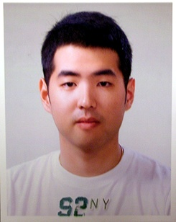
Peter Kang (강용구)
Kangnam-gu, Dogok-dong, Samho Apt 1-601
Seoul, Korea 135-270
Birth Date: 1984/Sept/4th
Citizenship: Canada
Visa status: F4
Languages spoken: English/Korean
Possible start date: immediately
Cell phone: 010-6529-7179
Email: bellevuepride@hotmail.com

Education
1992-1993: -Westwood Elementary, CA, USA
1993-1997: -Eonju Elementary, Seoul, Korea
1997-2000: -Dogok Middle School, Seoul, Korea
2000-2001: -Sangmoon High School, Seoul, Korea
2001-2002: -Bellevue High School, WA, USA
2002-2003: -Abbotsford Senior Secondary, BC, Canada
-Government scholarship from Provincial Exams
2003-2009: -University of British Columbia, BC, Canada
-Ranked 36th place among the world universities
-B.S. in Biology
-Dean’s honors list in the last two years
-Dental Admission Test score: 22/23/28 (AA/TS/PA)
95.4/97.7/100 percentile
Volunteer Experience
2005-2009: -UBC hospital, 4 consecutive years

Work Experience
2001-2002: -“La Batelle” in Bellevue Square Mall, WA, USA
- Barista/Cashier
2002-2003: -“Secrete Garden”, Abbotsford, BC, Canada
-Server/Kitchen helper
2005-2009: -Private tutor of 6 students
-Subject taught: Gr.10, 11, 12 Biology, Chemistry, Math

Dentistry Experience
2005-2006: -Lee Soo Chan Dental Clinic
-During the summer
-Observer, Internship
-About 100 hrs
2007-2009: -UIC Chicago Dental Hospital
-Observer, Assistant
-About 200 hrs
2009-Current- Imperial Palace Dental Clinic
-Translator, Observer, Internship
-About 300 hrs

