50/24 hillside plaza and condotel 4, unit 1106, huay kaew road, muang, chiang mai, thailand 50300
E-mail: nmcollin60@yahoo.com
Norman Collin
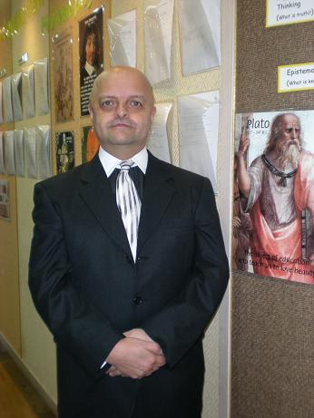
Personal Information
- Nationality: Canadian
- Age: 48
RELEVANT Work experience
August 2000~June 2008 YBM-ECC Sanggye-Dong
English Teacher
- Teaching Kindergarten and Post-Kindergarten; including conversation, phonics, reading comprehension, writing, grammar, and research methods
- Developing curriculum for advanced Post-Kindergarten classes from 2003~2008, including selection of textbooks
- Teaching intermediate to advanced courses in language arts, social studies, philosophy, and religious studies
- Administering abridged Standard Achievement Tests (Grades 3 and 5) to assess students’ reading and writing levels compared to standards expected of North American students
- Instructing classes in the use of an English dictionary
- Instructing advanced students in requisite computer skills for producing Word Document essays in accordance with basic MLA guidelines
- Incorporating audio-visual materials and developing study guides for classes in philosophy and religious studies
- Developing comprehensive exams for philosophy and religious studies styled on introductory university courses; exams comprised of short answer questions, paragraph topics, and detailed expository essays
- Teaching and implementing compulsory cursive writing for Post-Kindergarten classes from grade 3 onwards
- Conducting model lessons and workshops for teachers and parents demonstrating use of core language books, as well as techniques on teaching phonics and writing
Education
Sep. 1998~May 1999 Brock University, Ontario, Canada
MA in Philosophy (still in progress)
- Specialized in East-West comparative philosophy
- Taught maximum allowable introductory seminars (3) per semester
- Taught a main lecture for 1st year introductory class in philosophy
- Served as a student marker for a 2nd year Buddhism course
- Developed comprehensive teacher/student evaluations for 1st year classes
- Developed comprehensive essay evaluations for introductory classes
- Prepared and conducted exam tutorials for introductory classes

Sep. 1992~Apr. 1997 University of Prince Edward Island, PEI, Canada
BA in Philosophy and Religious Studies
- Prepared and conducted weekly tutorials for introductory logic course during my senior year
- Graded assignments and exams for introductory logic course
- Served as Student Representative for the Philosophy Department (1992~19993/1994~1995)
- Participated in course selections for the Philosophy Department
- Elected to the UPEI Student Council as the Mature and Part-Time Student Representative (1992~1993/1994~1995)
- Involved in establishing the Charter for the Organization for Atlantic Part-Time and Mature University Students (OPTAMUS) (1992~1997)
Awards received
Professional (2004)
Teaching and Services Award from YBM Education
Educational (1998)
Internal Provincial Graduate Scholarship (Brock University)
Philosophy Departmental Fellowship (Brock University)
References
Academic Supervisor (2006~Present)
Ms. Christine Choi
(Phone) 951-0509; (Email) happy215@hanmail.net
Academic Supervisor (2000~2006)
Ms. Jana Lee
(Phone) 016-221-8963; (Email) janaleeko@naver.com

Norman Collin
50/24 Hillside Plaza & Condotel 4, Unit 1106
Huay Kaew Road, Muang
Chiang Mai, Thailand
50300

Having taught ESL in Korea from 2000~2008, I am writing to express my interest in further applying my skills and experience within the private or public school sectors. In addition to my familiarity with standard ESL curriculum, I also have extensive experience researching and selecting primary textbooks for both Intermediate and Advanced classes (grades 1~6); texts on writing, reading comprehension, grammar, language arts, social studies, philosophy, and religion. My involvement in developing and organizing the curriculum for these special classes began in 2003. It was at that time (2003~2005) that I also assisted in restructuring the phonics curriculum for the kindergarten program at Sanggye ECC. Highlights of my teaching and research include but are not limited to:

- Researching appropriate age/grade level textbooks for philosophy and religious studies classes (2006)
- Planning detailed course outlines and syllabi for Post-Kindergarten classes (2003~2007)
- Incorporating internet and encyclopedia-based research assignments for Post-Kindergarten classes, grades 2 and 5
- Designing philosophy and religious studies classes on the university model of lectures and seminars; the idea being that the students would become more proficient at critically analyzing information, more efficient at taking notes, and perfect their public speaking skills
- Using educational audio-visual aids in philosophy and religious studies to assist students in further developing their listening-comprehension skills, as well as to supplement their primary texts

These highlights, together with my CV, attest not only to my uncommonly thorough background in teaching and research, but also to my character as a conceptual thinker, a generator of creative ideas, and a self-starter. In short, my experiences as a teacher have enabled me to develop skills that would make me a valuable asset to your school.

I am available August 1st, 2009 and look forward to the opportunity of working with your school, and to the new challenges and experiences which lie ahead.

Sincerely,

Norman Collin

