Resume for Bev Wigginton

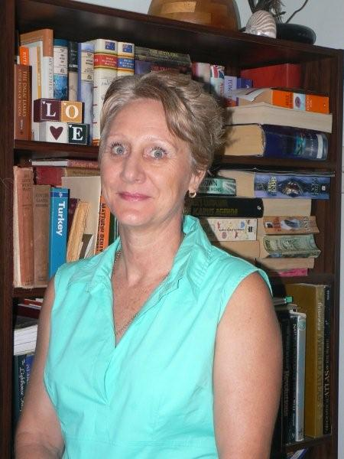

7 Oliver Street
Boonah Queensland 4310

Australia

fourwiggs@aapt.net.au

 | Personal Details
Address | 7 Oliver Street  Boonah Q 4310 Australia
Telephone  Email | 61 07 5463 2586 (H)  fourwiggs@aapt.net.au | 0409 910 332 Mobile
Queensland Teacher Registration No. | 709407
 | Academic Profile
2007 – Semester II | Better Behavior Better Learning | On line course  Education Queensland
1999 | Certificate IV Assessment and Workplace Training | Bremer TAFE, Queensland
1994 - 1997 | Master of Health Administration | University of New South Wales Australia
1984 - 1988 | Bachelor of Human Movement Studies (Education)  Major in English Literature | University of Queensland, Australia
1980 - 1983 | State Registered Nurse | Redcliffe Hospital Queensland
 | Professional Membership
 | Queensland Teacher’s Union
 | William Glasser Institute Australia
 | Queensland Nurse’s Union

Career Profile | Location | Duties
Sept. 2002 to present | Department Education, Training and the Arts, Moreton Region Queensland | Advisory Visiting Teacher Behavior Yr P-10
January 2000 - Sept. 2002 | Boonah State High School Queensland Department Education, Training and the Arts, Moreton Region Queensland | Teacher HPE, English, SOSE, HRE, Chair WH&S Committee, part time Advisory visiting teacher behavior
June 1999 - June 2004 | St John Ambulance Queensland | Senior and Advanced First Aid Instructor
Feb 1998 - Dec 1999 | Bremer TAFE – Community and Education Programs Unit | Lecturer Workplace Health & Safety and Management of Organizations
January 1995- January 1998 | Fassifern Retirement Village | State registered Nurse Permanent P/T
April 1995 - Jan 2000 | Department of Education Queensland | Primary and Secondary Supply Term 4 1995 Leichhardt SS Year 6 class teacher
July 1994-May 1997, May 2000-May 2007 | Blue Nursing Service Fassifern | State Registered Nurse – casual domiciliary (in home care)
September 1993-February 1994 | St Andrew’s War memorial Hospital Brisbane | State Registered Nurse – full time cardiac ward
July – September 1993 | Department of Education Queensland | Drug Education Project Officer Cornwell Street
January – July 1993 | Kenmore State High School Queensland | Teacher HPE Yr 8-12  English Yr 8-10
Jan 1989 – Dec 1992 | North Rockhampton SHS Queensland | Teacher HPE Yr 8-11  English Yr 8  Yr level coordinator Yr 10-11
September 89 -January 1993 | Mater Misericordiae Hospital Rockhampton Queensland | State Registered Nurse Casual
January 1988-January 1989 | The Prince Charles Hospital Brisbane Queensland | State Registered Nurse – Permanent P/T Coronary Care Unit
September 1984-January 1988 | Royal Brisbane Hospital Queensland | State Registered Nurse – casual, Permanent P/T

Relevant Experience | Course | Presenter/Length
2009 | Collecting data and Providing Feedback to Teachers | Presenter - Team PD seminar 1 hour
 | Creating Supportive Classroom | Presenter – 9 hours Ashwell State School staff
 | Positive Learning Centre Ipswich | 2 weeks – Yr 5-10 Teacher
 | All Saints Catholic Primary School | School Board Member
 | Boonah Girl Guides | President Support Group
2008 | Students with Special Needs – Autistic Spectrum Disorder, Attention Deficit Hyperactivity Disorder | Ian Lillico 1 day seminar
 | Post Traumatic Stress and Grief | Mater Hospital – 2 hour seminar
 | Understanding Poverty Workshop | 1 day Co –presenter – Leichhardt State School
 | CPR Update | Queensland Ambulance half day
 | All Saints Primary School | School Board Member
 | Boonah Girl Guides | President Support Group
 | Fassifern Netball Association | Umpire Convenor
2007 | Queensland Curriculum, Assessment and Reporting QCAR | Trisha Stinson Half day seminar
 | Facilitator Training in Essential Skills for Classroom Management | Centre for Behavior Support Professional Development Education Queensland 2 day program
 | Better Behavior Better Learning | Online learning Course Education Queensland
 | Understanding Poverty Ruby Payne | Kath Herbert AHA 2 day Workshop
 | Classroom Profiling Refresher | Mark Davidson – 2 days Bundaberg
 | Speech Language Impairment | Gill Lovie and Hayley Croft – 2 hour seminar
 | Positive Behavior Support | Linda Tunny – 1 day
 | Laidley District Professional Development Day | Co presenter – Early Years Behavior Strategies
 | Boonah Amateur Swimming Club | President
 | Fassifern Netball Association | Team coach and Intermediate convener
 | Boonah Girl Guides | Vice President support group
2006 | Functional behavior assessment refresher | Cherie Moore – half day seminar
 | CPR Update | Queensland Ambulance
2006 cont. | All Saints Primary School | School Board Member
 | Fassifern Netball Association | Coach and Junior Convener
 | Boonah Amateur Swimming Club | Secretary
2005 | Inclusion Seminar | Loretta Giorcelli and other presenters 1 day UQ Ipswich
 | National Safe Schools Framework | I day seminar – various presenters
 | Shifting to Inclusion Workshop | Rob Mills and Education House Brisbane – 1 day
 | Classroom Profiling Refresher | Mark Davidson – 2 days
 | Rock and Water Workshop | Freerk Ykema Gaduaku Institute 3 days
 | All Saints Primary School | School Board Member
 | Boonah Amateur Swimming Club | Secretary
 | Fassifern Netball Association | Coach and Junior Convener
2004 | THRASS – Teaching Handwriting, Reading and Spelling Skills | Pat Beattie – 3 day training
 | Inclusive Education from Theory to Practice | Dr. Rosemary Tannock and Dr. Louise Porter 1 day Seminar ADHD
 | Program Achieve Early Childhood Program and Investing in Parents Program | Michael Bernard PhD half day seminar
 | Intensive Behavior Intervention Strategy (IBIS) | Warren Dawson and Natalie Swaine (DSSU), 10 day training and assignment
 | Resourcing Methodology for Students with Disabilities | Michael Walsh and Jim Weidman  Bundamba SSC 2 hour seminar
 | Fassifern Netball Association | Netta Coach and Convener

Personal Statement

I am keen to teach in Korea for 2009 for professional, family and cultural reasons.

Professional

I have been a teacher in Queensland, Australia since 1989. During this time I have taught elementary, secondary school and adult students in a wide range of subjects and settings, including:
- Health and Physical Education | - Senior First Aid
- English | - Workplace Health and Safety
- Studies of Society and the Environment | - Understanding Organizations

I am also proficient in Information Technology and routinely use email; word processing; power point and excel in my daily work practice.

Since the year 2000, I have been an Advisory Visiting Teacher – Behavior, in a consultative role liaising with: students; administrators; teachers; other specialists such as speech language pathologists, guidance officers; pediatricians; psychologists and parents to engage those students with challenging behaviors into the classroom. This work has involved mentoring teachers to accommodate the specific needs of students through:
- developing an understanding of diagnoses such as Autistic Spectrum Disorder; Attention Deficit Disorders; Speech Language Impairment; Intellectual Impairment and mental health concerns such as anxiety and school refusal.
- utilizing a variety of teaching approaches and alternative classroom management strategies, along with making curriculum modifications
- creating/providing individual and classroom resources such as, visual subject timetables; behavior goal sheets; social story books and posters.

As part of the consultative role, I have presented professional development seminars to beginning and experienced teachers on the above topics and feel I am suitably qualified to be of assistance to any of your teachers desiring to know more about the “Australian” experience of teaching and learning.

Prior to this I was a high school teacher teaching English and physical education. In all my teaching I incorporate lots of visuals and provide hands on learning activities to enhance understanding of the curriculum and have students engaged with learning in a fun and interactive environment.

I look forward to the opportunity to bring my teaching skills to your country so that I can assist your students to better understand the English language. On a more personal note, my son and his Korean family are living in Yeongdeungpo and I would like to be teaching in Seoul so I can close to my relatives to assist them with learning English and about our Australian culture.

I am well placed to teach English at elementary and public schools through my experience with creating language accessible documents and making curriculum adjustments in my current work setting along with the experience of teaching Years 8- 10 English in secondary schools in Queensland.

