CURRICULUM VITAE
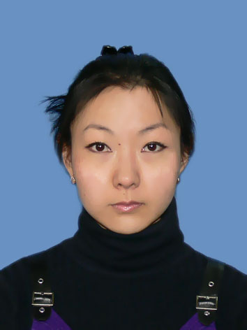
Personal details
Name Anna Lim
Address 94, Adilbekov Kerimshe Street, Shymkent, Kazakhstan
Tel: (7252)21 33 00; (7252) 47 01 58; +7 701 233 55 84;
Email: lim_anyuta@mail.ru; mynameis_an@mail.ru
Date of birth 1988/05/10
Marital status Single
Nationality Korean
Citizenship Kazakhstan

Personal profile
I am reliable, well organized and punctual. I am able to work individually and comfortable working as part of a team. I am ethnic Korean, moreover, I specialize in foreign languages, that is the reason why I will to learn the Korean language. I have experience of living abroad (China), and now clearly realize priorities in my life.

Languages
Russian (native)
English (Advanced)
Chinese (Intermediate)
Korean (Beginner – Elementary)

Key skills
Free user of Microsoft Word and Excel
Confident communicator
Self-motivated

Work experience
2008.06.25 – 2009.02.15 Home tutor of English and Chinese;
2009.02.15 – 2010.05.15 Teacher of English and Chinese - Foreign Languages Teaching Centre “ABC”
2009 – 2010 Chinese language teacher; “PARASAT” college attached to South Kazakhstan
Humanitarian University by M. Saparbayev
2010.05.15 – now Teacher of English and Chinese - Teaching Centre “АНЛИМ” (UNLIM)
from 2010.09.01 organized free course of learning Korean

Education
Secondary education:
1995 – 2006 Humanitarian and environmental school № 1 named after A.S Pushkin

Higher education:
2006 – 2011 South Kazakhstan State University;
faculty of Foreign Languages (instruction by correspondence);
specialization: Two Foreign languages

Language Courses:
2004 – 2006 Intensive English Language Courses; Linguistic School by T. Gubaidullina
2006 – 2008 Intensive Chinese Language Courses; North-West University, Xi’An, China

Interests
Reading, listening to music, writing poems (not professional), drawing (not professional).

References
Added:
#1 Recommendation letter from the Head of the English Department; South Kazakhstan State University
#2 Recommendation letter from the representative of Korean Cultural Centre; Shymkent, Kazakhstan

