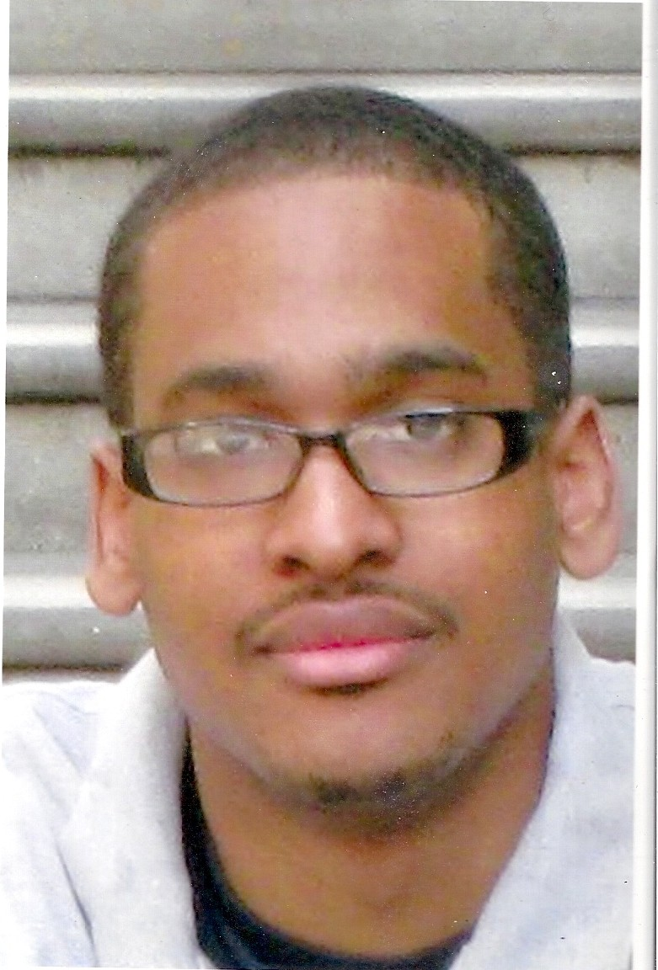

Terrell Langston
Los Angeles, CA, 90045
310-743-3735
tshawn82@aol.com

QUALIFICATIONS SUMMARY
Strong analytical skills and problem solving skills; Excellent written and verbal communication; Work well with teams; Ability to handle multiple tasks; Excellent Microsoft Office skills; Detail oriented with strong management and leadership skills
COMPUTER SKILLS
Microsoft Word, Microsoft Excel, Microsoft PowerPoint, Outlook, FileMaker Pro
EDUCATION
Master in Business Administration (Finance), Jan 2008
University of La Verne
RELEVANT COURSEWORK
Marketing Management, Financial Management, Financial Strategies & Polices, Analysis of Business Operations, Organizational Theory & Behavior, Economics of the Firm, E-Business, Investment & Portfolio Analysis, Accounting for Decision Making, Managing in a Global Economy, Business Seminar
Bachelor of Arts, Broadcasting
University of La Verne
WORK EXPERIENCE
Permit Place Inc.-Van Nuys, CA August 2008-July 2010

Permit Place Inc. provides nationwide and local permit management services to retailers, restaurants, owners and developers speeding the difficult and cumbersome process of securing building permits; provides banks, title insurance companies with permit verification services on their assets and provides building permit data as sales leads to the construction supply and finance service industries.

Project Manager
**Project managed Tenant Improvement, Entitlement and Conditional Use permit projects by collecting, compiling and organizing all documentation requirements and checking for accuracy
**Review architectural and engineering plans with to ensure a successful submittal to local building and planning departments
**Schedule and coordinate meeting with City and County officials, developer, architects and retailers regarding commercial and residential projects
**Attend, record and document project meetings
**Multi-task while maintaining a full project load; prioritizes and completes daily assigned tasks
**Travel locally and nationally on a day’s notice
** Manage vendors and keep projects and within scheduled hours and budget
**Maintain calendar and contacts
**Maintain project databases and working files
**Produce and distribute project and critical action reports to clients and team
**Tracking, preparing and reviewing incoming and outgoing shipments
**Perform permit records research

Greenfloc USA May 2008-August 2008
Market Research Analyst (Internship)
**Gather and analyze primary and secondary data
**Conduct feasibility analysis
**Provide customer, industry, competitive and market trend analysis
Promiscuous Films-Los Angeles, CA June 2008
The Surrogate movie trailer
Production Assistant
Ghost Robot-Hollywood, CA May, 2008
Production Assistant
**Unload and setup equipment and decorate the set for the alternative/country band Old 97’s one day 17 hour music video shoot
**Provided assistance where needed on set
**Used as an extra in the music video
KUSI 9 News - San Diego, San Diego, CA
Nov. 2005 - June 2006
Video News Editor
**Television News Editor for 6 pm, 10 pm, and 11 pm newscast shows
**Edited television reporter news package stories and general news stories
**Edited the video to match the script of the news stories
**Routed satellite news feeds and electronic news gathering feeds into the editing bay
**Worked closely with Producers, Photographers and Reporters to edit the best news stories.
CBS 2 News - Palm Desert, Palm Desert, CA
June 2004 - Nov. 2005
Chief Video News Editor/ Video News Photographer
**Television News Editor for the 4 pm, 5 pm, 6 pm, and 6:30 pm entertainment show called "Eye On the Desert at CBS 2"
**Delegated video editing to other editors
**Worked closely with Executive Producer, Producer, Reporter and Photographer
**Checked quality of work performed by editing staff
**Video Photographer for general news stories and sports
**Assistant producer for CBS 2's High School Football Show
ABC 7 - Los Angeles, Glendale, CA
Feb. 2004 - June 2004
Assistant Editor/ Production Assistant (Internship)
**Watched and logged sports games footage
**Assisted in editing of the best sports highlights within game
**Setup for reporter live shots at the Los Angeles Lakers and Los Angeles Kings games
**Interviewed players in locker room after the games
LVTV-3, La Verne, CA
2000 - 2004
Camera Operator/Director/Audio and Controls (Paid and Volunteer)
** Operated video camera; Performed photographer duties; Directed TV shows, city projects and college sports produced for the city of La Verne's public Access channel
KULV, La Verne, CA
2001 - 2003
Radio Disc Jockey/Producer (Volunteer)
**Performed Radio Disc Jockey (DJ) duties
**Produced promotional ads aired during broadcast
University of La Verne – Summer Basketball Camp
2001-2003
Basketball Instructor
**Instructed youth from 5-14 years old in the fundamentals of basketball, value of teamwork and self-discipline.

University of La Verne – Men’s Basketball Team
2000-2004
**3 year starter

