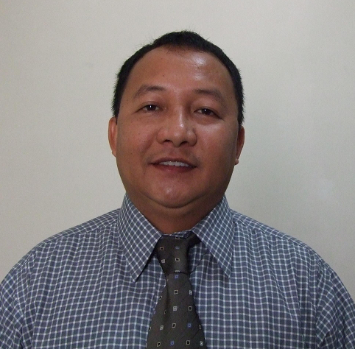

ANTONIO B. EVANGELIO
Flat 1405 Al Sheba Building, Al Nahda, Sharjah, U.A.E.
Contact #s: 0097150-9558472
E-mail: tonehevangelio@yahoo.com.ph

CAREER OBJECTIVE

To secure a suitable, challenging and growth oriented position fit for my qualifications where I can best utilize my knowledge and full potential to the maximum level for the progress of the institution and enhance my personal and professional growth.

PROFILES AND SUMMARY OF QUALIFICATIONS

Graduate of Bachelor of Arts in Philosophy at St. Francis de Sales Major Seminary, Lipa City and Bachelor of Science in Theology at Maryhill School of Theology in Quezon City. Nine years of experience as an Administrator in the Prelature of Infanta (Aurora/Quezon Province) at the same time a Teacher/Professor at Mount Carmel College, and Marketing Executive cum Sales Coordinator since May 2007 to present in a General Trading Company in Dubai, United Arab Emirates. I am focused and target driven, motivated self-starter, able to quickly grasp issues and attend to details while maintaining a view of the big picture, an expert in handling multiple tasks and achieving on-time completion of deadlines. A creative, resourceful, goal oriented and flexible person, able to adapt to changing situation, believes in team work and professional ethics that enables to easily establish rapport both with the clients and colleagues. Can motivate and encourage individuals to achieve organizational objectives and goals. Lastly, I am fluent in speaking and writing English, and Computer literate.

PROFESSIONAL BACKGROUND

- MARKETING EXECUTIVE CUM SALES COORDINATOR
Sunnex General Trading LLC
Muraqqabat Street, Deira, Dubai, UAE
May 2007 to Present

JOB DESCRIPTION
- Responsible in achieving company's goal and sales target.
- Over all in-charge of sales and coordination
- Prepare professional proposals and presentations and enhance relations with customers
- Create new accounts, and maintaining strong relationship with existing accounts and customers
- Attend to customers’ inquiries, telemarketing, making quotations, and invoicing
- Execute marketing strategies, tactics and product demonstrations
- Responsible in the preparation, handling and clearing of documents (Import-Export Procedures)
- Coordinating with Courier and Logistics Companies (Air and Sea) and Customs liaising.
- Submit sales reports on monthly and quarterly basis
- Other duties as maybe designated by the General Manager

- ADMINISTRATOR
Prelature of Infanta
Infanta, Quezon Philippines
March 1997-March 2006

- Served as Administrator for nine years in the following parishes and towns of Aurora province:
- St. Patrick’s, Dingalan, Aurora March 2004- March 2006
- Mary Mother of the Church of the Poor,
Maria Aurora, Aurora June 2001- February 2004
- San Luis Obispo, Baler, Aurora June 2000- May 2001
- St. Vincent Ferrer, Maria Aurora, Aurora June 1999- May 2000
- St. Joseph the Worker, Dilasag, Aurora March 1997- May 1999

- TEACHER/PROFESSOR
- Mt. Carmel College
Baler, Aurora
June 1999-March 2004

NON-GOVERNMENT ORGANIZATIONS’ WORK

- Founder and Organizer of Different Organizations Worked on organizing, recruitment of members, planning, implementation and monitoring of the project
- Conducted Disaster Management and relief operation in badly hit communities due to two consecutive typhoons in Dingalan, Aurora, November 2004
- Involved in housing project assistance conducted by Nat’l Secretariat for Social Action (NASSA), Franciscan Movement—Justice and Peace for the Integrity of Creation, YMCA of the Philippines, Prelature of Infanta Social Action Center, and CFC- Gawad Kalinga for more or less a thousand homeless families.

OTHER RELATED EXPERIENCES:

CENTER FOR PASTORAL CONCERNS, UP VILLAGE, DILIMAN, QUEZON CITY June 1991- March 1993
◻Worked on youth and women organizing in urban communities
◻Held trainings and seminars regarding empowerment and gender sensitivity

LABOR EDUCATION AND RESEARCH NETWORK (LEARN), Sct. Rallos, Kamuning, Quezon City

- Worked on the mobilization of the labor sector through trainings and seminars on the following respective dates:
- June 1995- December 1996
- June 1993- March 1994

SEMINARS ATTENDED

- Hazard Assessment and Disaster Management (Dingalan, Aurora) January 10-14, 2005
- Peace and Partnership (Hiroshima, Japan) August 5-10, 2005
- Footsteps: Personality Formation and Transformation (Calamba, Laguna) April 10-25, 2005
- Stewardship and the Church of the Poor (Cebu City) January 11-16, 2003
- Poverty Alleviation and the Church (Tagaytay City) March 10-15, 2003
- Environmental Protection and Waste Management (Marikina City) October 16-21, 2002
- Ecology and Humanity (Baler, Aurora) April 1-5, 2001

EDUCATION
- Bachelor of Science in Theology AY 1992-1994/
Maryhill School of Theology, New Manila, Quezon City, Philippines AY 1995-1997
- Bachelor of Arts in Philosophy AY 1987-1991
St. Francis de Sales Major Seminary, Lipa City, Batangas, Philippines
- High School --- Mt. Carmel High School, Polillo, Quezon AY 1982-1986

PERSONAL DATA

Birthday: June 07, 1969
Citizenship: Filipino
Civil Status: Married
Sex: Male

CHARACTER REFERENCE

Available upon request

