RESUME

PERSONAL DETAILS

NAME: Paul Gregory GRAHAM

ADDRESS: 202 Unit 564-3 Yeonnam Dong, Mapo-Gu, Seoul

EMAIL : pgraham28@hotmail.com

MOBILE: 010 5453 3554

DATE OF BIRTH: 28 April 1982

PLACE OF BIRTH: Blacktown, Sydney, NSW, Australia

MARITAL STATUS: Engaged

HEIGHT: 193 cm (6’4”)

WEIGHT: 95 kg

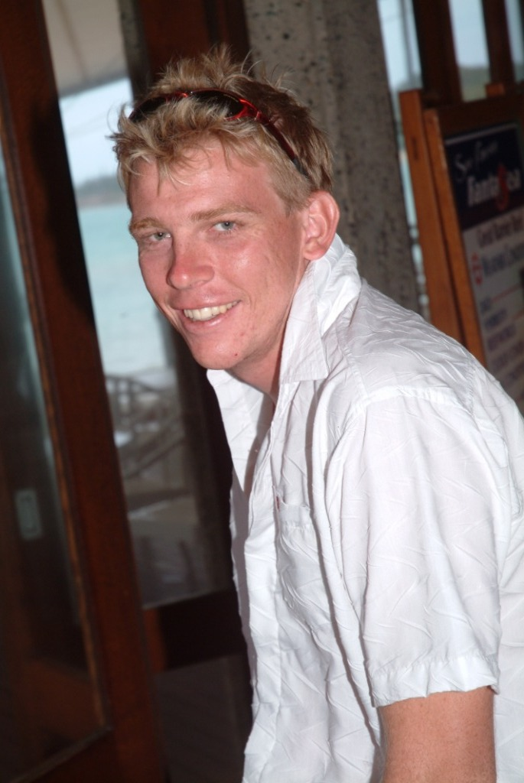

EDUCATION

2007 – 2008 Chinese Language Study at Jilin University China

2000 – 2003 Completed a Bachelor of Sports Tourism Management Degree at
Southern Cross University - Lismore
1999 Completed Higher School Certificate at
Nambucca Heads High School

OTHER QUALIFICATIONS

2006 – October Acquired a Blue Card to work with children.

2005 – February Renewed Senior First Aid/CPR Certificate
Run by Parasol EMT – Nambucca Heads, NSW

2003 – November Responsible Conduct of Gaming (RCG)
Run by Alex Beaumont Hospitality Training College

2003 – November Bar and Cocktail Course
Run by Alex Beaumont Hospitality Training College

2003- October Pool Lifeguard Course, Bronze Medallion, Oxygen Equipment Training
Run by the Royal Life Saving Society – Coffs Harbour, NSW

2003 – June Renewed Senior First Aid/CPR Certificate
Camp Skyline – Michigan, USA

2003 – June Attended National Powerboat Licence Course
Run by Australian Boating College – Nambucca Heads, NSW
Acquired Boat Licence

2003 – April Acquired International ‘A’ Skydiving Licence
Ripcord Skydivers – Gatton, Qld

2002 - July Responsible Serving of Alcohol Certificate (RSA)
Run at Southern Cross University - Coffs Harbour, NSW

2002 – April – July Introductory Japanese Class
Run at Southern Cross University by Tazuko McLaren

2001 - June Senior First Aid/CPR Certificate
Run by Australian Surf Life Saving - Port Macquarie, NSW
EMPLOYMENT

Sep 2008 to Mar 2009: Employer - EduTALL Korea, Goyang City.
I have been working for EduTALL Korea which is a private company contracted to work in schools in the Goyang City area. I have taught grade 6 students at Hwajeong Elementry School for the last 6 months. I also taught teachers and students at Jido and Naeyu Elementary Schools.

Oct 2007 to Aug 2008: Private English Lessons in China
A total of 12 Korean students aged 8 to 19
Speaking, Writing, Reading

Oct 2006 to April 2007: Employer - Kingfisher Bay Resort, Fraser Island, QLD

Position: Tour Guide, Watersports Instructor, Shop Attendant, Front Office, Tour Bookings, Kids Club Manager, Babysitter.
Duties: Conduct guided tours. Instruct sailing, canoes and kayaks. Sell products and be in charge of stocktakes and resort information. Computer work including reservations, payments and tour bookings. Run a Junior Program educating children within the resort. Babysitting duties.

April 2004 to Sept 2006: Employer - Club Med Resorts

Club Med Lindeman Island – QLD (Apr 04 – Nov 05)
Position: Lifeguard
Duties: Supervise pool safety and organise pool activities & games
Position: Archery Instructor
Duties: Provide archery lessons to adults and children and organise tournaments.

Position: Sailing Instructor/Supervisor
Duties: Provide sailing/windsurfing lessons. Ensure safety procedures are followed. Organise tournaments and events.

Club Med Ria Bintan – Indonesia (Dec 05 – June 06)
Position: Water Sports Team.
Duties: Provide sailing lessons as above.

Club Med Kabira – Japan (June 06 – Sept 06)
Position: Water Sports Team.
Duties: Provide windsurfing lessons. Run snorkelling tours. Organise beach activities and events.

Oct 2003 to March 2004: Employer - Wonderland, Sydney, NSW

Position: Lifeguard and Attractions Attendant
Duties: Supervise pool, operate rides, maintain safety conditions, guest relations, park services, relief supervisor.

June 2003 to Aug 2003: Employer - Camp Skyline, Michigan, USA

Position: Camp Counsellor
Duties: 24 hour responsibility for a group of between four and seven 8 to 10 year olds from their arrival at camp each Sunday to their departure the following Friday. Responsibilities included organising the group for meals, showers and bed, and being involved in all camp activities such as arts and crafts, fishing, canoeing, archery, ropes courses, hiking, swimming, camp fires and story reading. One group of campers were special needs adults ranging in age from 20 to 83 years old.

Dec 2002 to May 2003: Employer - Ripcord Skydivers, Glenmore Grove, Qld

Internship (Unpaid)
Position: Manifest.
Duties: Greet customers, Money Collection, Instructor Organisation, Pilot Communication, Assistant Safety Officer, Phone Answering, Marketing, Computer Data Entry

Feb 2003 to May 2003 Employer - Eagle Boys Pizza, Gatton, Qld

Position: Pizza Delivery
Duties: Pizza delivery, phone orders, customer service, pizza preparation.

Dec 2001 to Feb 2002: Employer – Daydream Island Resort, Whitsunday’s, Qld
University Holidays
Position: Food & Beverage Assistant.
Duties: Assist the baker with food preparation and cleaning in the bakery.

Nov 2000 to Jan 2001: Employer – Nautilus Beach Resort, Coffs Harbour, NSW
University Holidays
Position: Houseman.
Duties: Outdoor maintenance, Cleaning Windows, Deckchairs and Awnings, Some indoor housekeeping

June 1997 to Feb 2000: Employer – Various retail outlets – after school and weekend work

TRAVEL EXPERIENCE

Working: Two months in the United States in a summer camp in Michigan.
Six months in a resort on Bintan Island, Indonesia.
Three months on the island of Ishigaki, Okinawa, Japan.

Leisure: Two months travelling the East and West Coasts and the Great Lakes area in the United States.
A short time on the North Island of New Zealand.
A two week holiday spent in both Bali, Indonesia and Phuket, Thailand.
Many stopovers, day trips and short stays in Singapore.
One week in Malaysia on both the East Coast and in Kuala Lumpur.
Two weeks in the Maldives at an island resort

Study: I have spent one year in China studying Chinese at Jilin University.

SPECIAL SKILLS

Energy & Enthusiasm: I am at my best when I am active and taking part in physical activity

Team Work: I have worked and lived as part of a team in my positions at Ripcord Skydivers, Camp Skyline, Wonderland, Club Med and Kingfisher Bay.

Outdoor Skills: My work at Ripcord Skydivers involved outdoor work and communication with both pilots and students. My work at camp Skyline involved numerous outdoor activities. My work at Wonderland and Club Med revolved around water sport activities. My work at Kingfisher Bay involved outdoor tour guiding.

Customer Skills: I love interaction with other people. I have excellent customer service skills as a result of my work in a skydiving school, a summer camp, a theme park and numerous international resorts. I have worked with many international guests and thrive on their enthusiasm.

Computer Skills: I am able to use various computer programs competently.

Other Languages: I have completed an introductory Japanese class. My exposure to international resort guests has allowed me to further develop my Japanese language skills to a point where I can hold a basic conversation in Japanese and my Korean has been improving. Basic greetings are understood in French, Spanish, Italian, German, Afrikans, Chinese, Indonesian and Malay.

Event Organisation: I have organised a local fun run for 600 people at university.
I have organised squash tournaments and club championships. I have promoted and organised many sporting events for resort guests.

Staff Management: While not always formally labelled as a supervisor I have been called upon on numerous occasions to fill in at a supervisory level. I have a keen sense of fairness when it comes to dealing with staff issues, but also clearly understand that the organisation comes before any single member of staff. I have found that I am able to produce an environment that provides for the efficient use of staff resources, while helping the guests enjoy a memorable holiday experience.

Personal Reference: Danika Bae (Bae Ju Young) Phone: 010 2354 3554
We have been a couple for over three years, working and studying together.

