Resume

Thomas Keeling
Seoul, South Korea
010-3504-3864
F-2 Visa

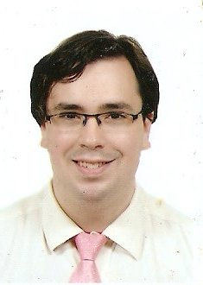

Career Objective: I’m looking for a job in which I will be able to use the skills I have learned in order to help others. I would like to work in a place in which I can be a part of a successful team.

Experience: English Teacher: CLI: Maple Bear (March 2010 ~)

English Teacher: Singok Elementary (April 2010 - October 2010)

English Teacher: Eunpyeong-Gu Winter Camp (Jan. 2010)

English Teacher: Hwibong Elementary (June 2009 – Nov. 2009)

English Teacher: English Channel Guro Digital (2008-2009)

English Teacher: Seokcheon Elementary (2007-2008)

English Teacher: Jung Chul Hakwon Chuncheon Campus (2006-2007)

Software Tester: Volt Technical Services (2005)

Treasurer: Sky View Hall Student Government (University of Arizona 2000)

Last Position: CLI: Maple Bear
Seoul, Jongno-Gu, Korea

Singok Elementary
Gimpo, Korea

Eunpyeong-Gu Winter Camp
Seoul, Eunpyeong-Gu, Korea

Hwibong Elementary
Seoul, Dongdaemun-Gu, Korea

Seokcheon Elementary
Bucheon, Korea

Jung Chul Hakwon
Chuncheon, Korea

VMC
11611 Willows Rd NE
Redmond WA 98052
(425) 558-7700

Education: Mountlake Terrace High School (1996-2000)

University of Arizona (2000 - 2005)
B.A. Political Science

Skills: Computer, Word Processing, and Excel

Personal: Age 29
Hobbies Tennis and Biking

