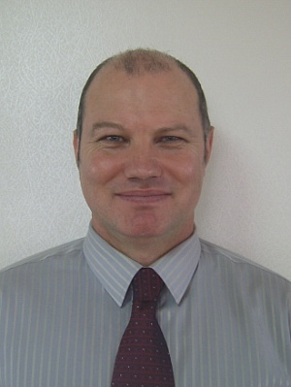

Resume
Philip Pedersen

Address
Ill-dong 656-6, 403
Sangnock-gu
Ansan
Gyeonggi-do

HP: 010 7756 1066
E-mail: nowarelic@yahoo.co.nz

Education
Bachelor of Arts, Massey University, Palmerston North (NZ)
Major: History.
Minors: English Literature, Social Anthropology

TESOL Certificate, International TEFL teacher Training

New Zealand Certificate of Science, Central Institute of Technology, Upper Hutt (NZ)
Major: Industrial Chemistry

Work Experience
English in Seoul Program (In the World) at Naengjeong Elementary School, Jeongwang Dong, Oido (Dec, 2007- Present).

Somang Foreign Language Institute, Gojan Dong, Ansan (Aug, 2006-Aug, 2007).

Kid's Herald School, Yeonsu Gu, Incheon (Dec, 2002-July, 2004).

ECC Mapo, Mapo Gu, Seoul (July, 2001-Aug, 2002).
Professional Background
In my current place of employment I have been teaching conversational English and phonics to elementary school students, focusing whenever possible, on syntax and basic grammar, and conducting placement interviews. Prior to this I worked with adult students for a year teaching Conversational English, grammar and essay writing skills. I also spent time coaching some of my students for job interviews that were to be conducted in English. My other duties also have also included student assessment, drafting test papers, and selecting new textbooks. Prior to teaching adults I worked extensively with children for three years, teaching elementary, middle and high school students. During this time I taught mainly conversational English, but also grammar and writing skills to the more advanced of my students. While still in New Zealand, I participated in a voluntary program, home tutoring Korean students and immigrants in conversational English.

Related Skills
My communication skills were also tested while completing my Bachelor of Arts degree at Massey University, which is one of the most prestigious universities in New Zealand. Although majoring in History, I completed several English Literature papers including Essay Writing Skills and TV and Film Script Writing. As part of my course work I was required to give seminars and actively participate in tutorial discussions. In addition to this, most of my course assignments were in essay form, thus requiring a high degree of grammatical proficiency and strong writing skills.

My background in studying English - both as a means of communication and as an academic subject - extends back further than my tertiary education. My father taught English at both elementary and high school levels, and often coached me on the complexities of the English language, giving me greater understanding and appreciation of my native tongue. These factors, along with my teaching experience have I feel, given me an advantage over many other native English instructors when teaching English to non-native English speakers.

