Leonard Yu  경기도 화성시 반송동  아시아프라자 912호  010-2824-4357  leonardyu@hotmail.com  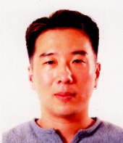 | Objective  English Teacher

Work History
2008-Present Youngjaesakwan, Dongtan
Head Native Teacher
(Speaking, Writing, Toefl, Program Development)
2007-2008 Hansol/ENG O-mokchon, Suwon
(Speaking, Essay Writing)
2006-2007 EBY Talking Club, Deungchon, Seoul
(Speaking, Essay Writing)
2005-2006, Youngjaesakwan, Shinjeoung, Seoul
(Speaking, Toelf/Essay Writing, Ivy Kids)
2004-2005, World Prep School, Naebalsan, Seoul
(Speaking)
2004-2004, Eureka School of English, Apgujeong, Seoul
(Speaking & Grammar)
2003-2004, Princeton Review, Samsung, Seoul
(Conversation)
 | Education
1996-2000 California State University, Carson City, CA
BS Business Administration: Accounting
1991-1992 Academy of Health Science, San Antonio, TX
AS Surgical Technology
 | References
 | References are available on request.

