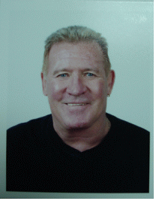

Resume

of

Murray R. Feist

Goal :
To experience Korean culture and Korean people by living and teaching in Korea while helping to improve the use of english as a Second Language.

Education:
Queens University - Kingston Ontario Canada
Diplama in Education - Graduated
Bachelor of Arts in Education
Ontario College of Teachers - Ontario Canada
Certified Ontario Teacher - Membership and Registration

Internation T.E.S.O.L Training Center - Hamilton Ontario canada.
Teacher of English to Speakers of Other Languages -graduated

Member of NALATIE International English Teachers Licensing
Authority License to teach International English

Teaching Experince :
☐ Certified Teacher in Canada from the Ontario College of Teacher Association
☐ Lesson Planning / Development, Educational Activities, Classroom Management.
☐ Designed Lessons to improve Communication, Language, and Teamwork.
☐ Taught English all Levels Kindergarden, Elementary, Middle school,
University and Adults at Wonderland 2 years, G & B 3 years.
☐ Taught English at Hanoi Vietnam 8 months for Veitnam Airlines Business course.
☐ Taught English at Elementary school 2 years.(Masan and Seosan)

Hobbies / Intrests :
Swimming, Hiking/Climbing, Traveling Asia

I will be residing in Massan and I do not have a problem working in two schools.
and no intentions to go back to Canada.
If there are any questions, Plase feel free to ask.

Thank you

Home Phone 055-223-8765(Masan South Korea)
H.P. 011-6201-8741
E-mail : ttmfeist18@hotmail.com

Regards Murray R. Feist

