Resume for ESL position 2010
Please reply to:
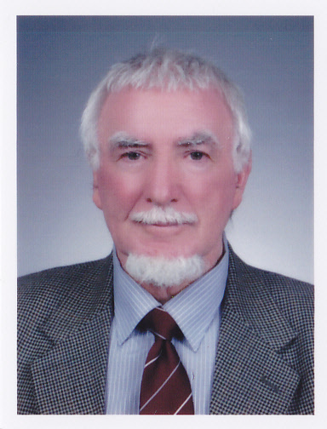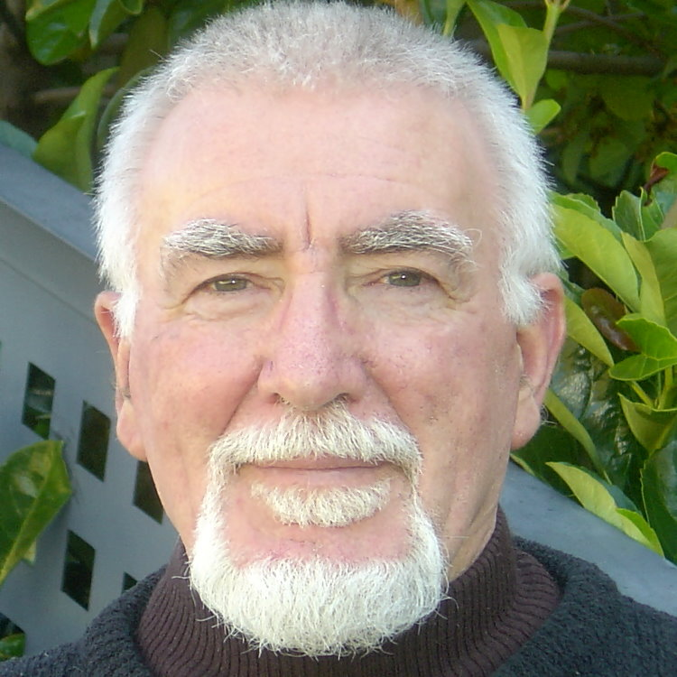
David Davis

Unit 1/1Derby Grove

Flora Hill

Bendigo

Victoria, 3550

Australia.
E-mail: djadavis@gmail.com
M. International. calls: +61 400 007 718

M. Australian. calls: 0400 007 718
Korean M. +81 (0)10 2893 8277

Objective

To obtain a position a full time ESL teaching position in South Korea for 2010 ~2011
Teaching experience:

2009 ~ 2010
Recent: Teaching ESL in Hamyang, South Korea.
Teaching levels:
Kindergarten: Phonics, ‘Good Morning Kids English’ 1/2 ; Flash cards ~ Animal, Utility, Clock, days of week, months of year, games, singing.
Elementary; Let’s Go series; Middle school: Side by Side series; Adults: Reading program, conversation, grammar.

While at Liberty Language School I successfully tutored two students, a boy and a girl, who competed in the 2010 Hamyang 1st grade Middle school speaking contest. They placed first and second respectively. Both winning a two week vacation to the USA, both going on to win a cash prize in a five school knockout speaking contest.
Reference supplied on request.
2007 ~ 2008
Newly opened school named ‘Ansan English’, in Banwol, Geyonggie-Do (September 2007 until February 2008). (The school closed due to a lack of promotion of new business, old business remained the same until closure.)
Levels taught:
- Kindergarten Two hours /wk (Three classes per hour x 20 children per class)
- Elementary (phonics 1&2)
- Middle school (creative writing)
- Junior high school (conversation, discussion, essay writing, creative writing)
- Adult classes (Intermediate level Conversational English and grammar structures)

KBK Language Academy Sang Dong, Bucheon-si (P/T16 hours per week. Finished 31st March 2008)
Levels taught:
- Mid school, iBT Debate, Listening and Reading integration
- Junior High school Debate and Conversational English.

david davis/resume/1 Wednesday, July 29, 2026
Sukchun Public Elementary School, Sang Dong, Bucheon-si (P/T after School Program)
Levels taught:
- Middle school, Junior High school Creative Writing and Reading, Listening and Speaking skills
Bucheon International English Village (Two and one half month full time contract)
Levels taught:
- Elementary grade English writing speaking, listening and reading
- Beginning conversation
- TOEFL
- ‘Lecture1’ syllabus, Anatomy and analysis of university lecture topical material and note taking.
Sukchun Elementary School Sang Dong, Bucheon-si.
Continued to co-teach Elementary grades 1-5 (Mornings only eight hours a week) at Sukchun Elementary Public School morning day classes 10am ~12:30pm. (Finished: End July 2008)
One on one tutoring of pre-university students
Teaching level: Essay writing both creative and academic, Conversational English general topics of interest.
April 2008 ~ September 2008:
Adult’s classes
Teaching level:
- Intermediate, conversational, grammar, reading writing, listening, and speaking
Three summer camps,
- Everland: A one day camp
- Muju: A four day camp
- Gwanan: (Korean Post Office Summer camp) A five day camp.

Education & Further Training

Australia City College, Brisbane, Australia
- TESOL 1V certificate
La Trobe University
- Bachelor of Applied Science (Biochemistry)(2002), Bendigo Campus, Victoria, , Australia
- Post Graduate Diploma (Botany) (2003) , Bundoora Campus, Melbourne, Australia
- La Trobe University Bridging Course (1995)
Guild of Hair Design, Toronto, Canada
Level: Masters (Hairdressing, 1967)
Diplomas of Hairdressing (1963)
- London Institute & Morris School of Hairdressing, London United Kingdom
- World Supreme Hairdressing Schools, NY, USA (1963)
Prior to teaching in Korea
- ESL Private tutoring, South Korean students Reading, Writing, Speaking, Listening, Vocabulary drills, use of International phonemes coupled to the lesson vocabulary.
- Chinese pathway master’s student: grammar corrections and correction English syntax in assignment work, conversational English.
- Ten Years Professional hairstylist.
Teaching experience
- Two years in an Advanced Hair Design Academy, teaching the latest hair fashion techniques/updating professional hairdresser’s skills.
- Private classes (ten students, one day classes, eight hour class duration)
- Beauty Industry Conventions, 2 day platform demonstration of company products (L’Oreal de Paris, Carlyle Richards) and demonstration of up-to-date hair trends to professional hairdressers.
Useful general experience:
Six years in office administration, general accounts, cost accounts, wholesale ordering, stock control, wages & banking. Two small business enterprises.

david davis/resume/2 Wednesday, July 29, 2026

Current interest: Teaching ESL and travel.

Personal Interests
Art: French: Monet. Toulouse Lautrec, Picasso, English artists: Constable, Turner.
Rodin. Recent visit to Vincent Van Gogh Exhibition at the National Art Museum, Seoul

Sculpture: Henry Moore,
Sports interest: F1Grand Prix motor racing, soccer, cricket, athletics and martial arts

Referees
Korea

ROH Sung Won, Principal (2009 – 2010) Kim Byung Kee Principal (2008)
Liberty Language School KBK language Institute
714-3 Peongyeong-ri 3F, KumHo Plaza, Sang2Dong, Korea
HamyangGun-eup Wonmi-Gu, Bucheon-Si, Korea
Kyeongnam Korea Mobile: 82.19.387.8899
Post code: 676-805 E-mail: byungkeek@naver.com

M. 011 773 8277
E. shbehappy@hanmail.net

Referees
Ms Baek (2009-2010) In Sook Jung 정인숙 (2008~2009)
Mou Mou English Home teacher English Studies Department
338-5 Juonggyang-ri Sukchun Public Elementary School
Geochang-eup 525-4 Sangdong
Geochang-gun Won Mi GU
Gyeongnam Bucheon-si
Rep of Korea Geyonggie-do
Sth Korea Email: jinnie1029@naver.com

E.jonga8280@hanmail.net
T.055-943-9925
M. 011-569-8280
F. 055-944-5007

Kindergarten: (2009-2010)
Reggio Learning Community
Lotus Flower Kindergarten
HamyangGun
Hamyang-eup
Pyeongyeong-ri
158 Peongji
676-803 Kyeonnam

Contact the Vice Principal
T. (055) 963-5530
www.ykkid.net

david davis/resume/3/referees/1 Wednesday, July 29, 2026

