565-902
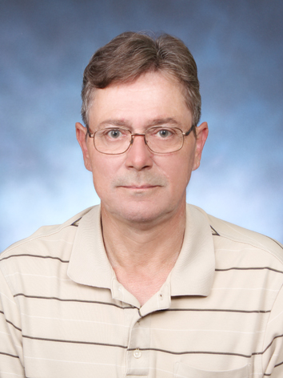
Michael J. Will
Smile House, Apt 203
892-5 Dunsan-ri Bong Dong-eup
Wanju-gun, Jeolla buk do
South Korea
Cell Phone: 010-5620-1185
email: michaelwill47@yahoo.com

OBJECTIVE: To secure a full-time, professional position.

QUALIFICATIONS

As a certified teacher who has spent my classroom teaching years in the non-traditional setting of the federal prison system, three years teaching middle school, teaching to a vast cultural array of students both young and old, and the past seven years teaching military officers and enlisted personnel, I can use these skills to better interact with the customer base I will be servicing.

EDUCATION 1990-1992 Bachelor of Science in Education, Indiana University/Purdue University at Fort Wayne, Indiana

EMPLOYMENT

July 2006-July 2013 English Instructor – Korea Defense Language Institute, formerly known as the Korean Army Intelligence School Language Department

As an instructor of conversational English for Korean military officers and senior enlisted personnel I am responsible for teaching a curriculum prepared by the United States military for foreign military personnel.

March 2006-July 2006 English Teacher – Woosuk University Language Center

As an Instructor of Korean middle school and elementary school students, I was responsible for teaching beginning English language instruction to 20 classes of middle school and 10 classes of elementary students a week.

2001-2005 Seventh Grade Language Arts Teacher and Drama Instructor, Mercer Middle School, Garden City, Georgia

2000-2001 Manager-In-Waiting, Friedman's Jewelry

As Manager-In-Waiting, I learned all aspects of the retail jewelry business. While employed at the Garden City store my concentration was on customer service and sales. During my six-month tenure, I was top salesperson of the month four times. As Assistant Manager for the downtown Savannah store, I was responsible for supervising five sales staff members, maintaining accountability for inventory, and timely collection of accounts payable.

1998-2000 Assistant Supervisor of Education, Federal Correctional Institution, Estill, SC

As Assistant Supervisor of Education, I was responsible for the overall daily operations of the education department of a federal prison. I was the immediate supervisor for eight full-time federal employees. I gave these teachers and office support staff direction, advice, and feedback on a daily basis. I counseled each on performance goals and objectives and provided each with quarterly performance evaluations and semi-annual classroom/teaching evaluations. Additionally, I served as the approving authority for the department budget. I prepared funding requests for Advanced Occupational Training programs, securing an additional $78,000 funding for fiscal year 2000.

1993-1998 Teacher, Federal Correctional Institution, Big Spring, TX

As a teacher with the Federal Bureau of Prisons, I was responsible for the daily instruction of General Educational Development courses in English, math, social studies, and science. The student population consisted of a cross-section of individuals from all sectors of society. Ages of the students ranged from 18 to 70, from all socio-economic backgrounds. Educational backgrounds ranged from no formal education to individuals who completed 12 years of formal education, but for one reason or another failed to receive their high school diploma. Additionally, I revised the course curricula for both the General Educational Development program and the English-as-a-Second Language program.

REFERENCES

Provided on request

