CARMELA BAYLOSIS
Seoul Mapo-gu Sinchon-ro2angil 31-6 #201 (Donggyo-dong)
010-5959-1983 cbaylosis@hotmail.com

PROFILE

D.O.B.: 03/30/1985
Nationality: Canadian
Gender: Female
Marital Status: Single
Available Start Date: Late August/September 2014
Current Visa: D-10

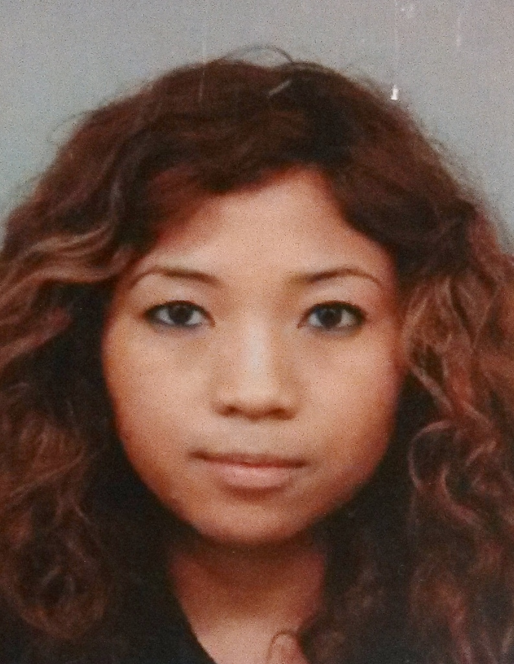

EDUCATION
Oxford Seminars (Toronto, Canada) December 2004/March 2008
The International TEFL Corporation (Toronto, Canada)
- Completed 110-hours of teacher training and certification in teaching English for Young Learners

York University (Toronto, Canada) September 2003 to June 2007
- Graduated with an honors double major in Communication Studies and Geography

WORK EXPERIENCE
English Instructor April 2014 to June 2014
Kidsbene (Seoul, South Korea)
- Taught various subjects in English to 10+ kindergarten and elementary students
- Designed creative classes and supplementary activities that promoted students’ English abilities
- Maintained homework assessments and tests for students’ evaluation and progress
- Monitored students’ physical safety inside and outside of the classroom

English Instructor April 2013 to March 2014
American School (Nagoya, Japan)
- Taught phonics to 15+ primary school children
- Conducted lessons and activities that focused on 3-letter words and short sentences
- Evaluated students’ progress through homework, spelling tests and reading exercises
- Monitored students’ physical safety during recess and lunch breaks

Assistant Language Teacher April 2012 to March 2014
Altia Central (Nagoya, Japan)
- Taught 2000+ junior high school students English as a foreign language
- Assisted teachers by providing supplemental materials that supported the weekly English lessons
- Directed listening and speaking activities for students’ review
- Provided students with a positive and motivational attitude towards the English language to further their knowledge and interest in the language and culture

ESL Instructor July 2011 to September 2011/December to January 2012
Upper Madison College (Toronto, Canada)
- Instructed 40+ international students (adults) English as a second language
- Focused on lessons that showcased their comprehension and application of their English skills (reading, writing, speaking and listening)
- Assessed students’ academic needs through tests and evaluations
- Promoted involvement in the Toronto community for more exposure to the English language and integration into Canadian society through class trips, volunteer opportunities, etc.
Foreign English Teacher March 2010 to February 2011
Daewang Middle School (Gangnam-gu District Office, Seoul, South Korea)
- Developed and delivered original lessons of grammatical and conversational topics to 500+ students to enhance understanding of the English language
- Created a 6-month science curriculum to support the school’s program for environmental studies
- Maintained extra-curricular activities and classes for students to practice their English abilities
- Assessed students’ academic performances through classwork, weekly assignments, presentations and exams
- Implemented and executed summer and winter camp lessons and activities
- Participated in co-teaching workshops with other Native and Korean teachers

Foreign English Teacher March 2009 to February 2010
Sahmyook Elementary School (Seoul, South Korea)
- Supported the school’s English-based program by teaching the subjects of Math, Science and Health to 200+ students
- Enhanced weekly lessons by incorporating hands-on activities to generate better understanding and participation from younger/lower-level students
- Evaluated students’ levels through tests and class participation
- Developed reports to track students’ academic performance and progress
- Maintained weekly meetings with Korean co-teachers to ensure proper lessons were taught

Foreign English Teacher March 2008 to March 2009
Kwangkyo Boys Middle School (Incheon Board of Education, Incheon, South Korea)
- Combined grammatical and conversational topics into weekly lessons for 500+ students
- Emphasized on dialogue/speaking-based lessons to generate participation and improve the students’ skills
- Monitored extra-curricular activities that encouraged the students’ use of the English language
- Taught a weekly teacher’s class to practice their conversational English skills

Supply Educational Assistant September 2004 to February 2008
Toronto Catholic District School Board (Toronto, Canada)
- Worked at various schools assisting students in their academic, behavioral and physical needs
- Offered one-on-one assistance to students
- Recorded students’ daily performance for their teacher’s evaluation
- Supervised students to ensure their safety inside and outside of the classroom
- Provided assistance to teachers by helping them prepare class material

VOLUNTEER EXPERIENCE
Volunteer September 2004 to 2007 (yearly)
Toronto International Film Festival Group (Toronto, Canada)
- Took part in clerical duties, assisted in promotional campaigns, directed public attendance and answered inquiries to help operate and promote the group’s film events

INTERESTS
- Keen interest in arts/design, travelling and photography

REFERENCES
- Kim Jung Hyun (former co-teacher at Sahmyook Elementary School, 2009-2010)
Telephone No.: 010-8941-1545
- Jeong Soo Ok (former co-teacher at Daewang Middle School, 2010-2011)
Email: jsoet@naver.com

