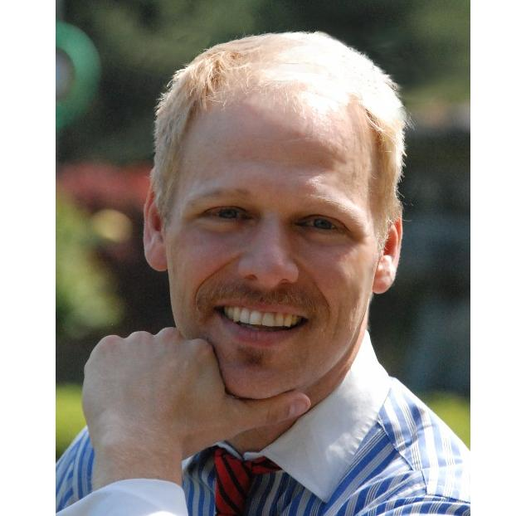
THADIUS "DI" BRAUN
FOREIGN LANGUAGE INSTRUCTOR
PO Box 582, Thompson Falls, MT 59873 (406) 827-4591
Cell # in Korea 010-7217-6468
dibraun@hotmail.com Skype ID: diester-bo

EDUCATION: TEFL Teaching Certificate, 2009 International TEFL Teacher Training
Docent Certificate, April 2006, Discovery Park-Seattle Parks Department
WA State Pesticide Applicator Certificate, Oct. 2005, WA State Dept. of Ag.
M.G. Certificate, Mar. 2003, Washington State University, K.C. Extension Office
Bachelor of Science, Aquatic Resources, May 1999 Sheldon Jackson College
Associate of Arts, Computer Science, May 1997 North Idaho College
Associate of Science, Forestry/Natural Resource Mgmt, May 1996 North Idaho College
Certificate of Completion -Guest Service in Retail Industries 1992-Target University

EXPERIENCE: 4/09-8/09 Kangwon National University, Samcheok & Dogye Campus Supervisor: Mr. Dong Heok Kwak-Director:Foreign Language Department Position: Visiting Instructor Specifications: teaching graduate- level Congnitive Linguistics and TESOL Methodology, Freshman-level conversational English, TOEIC, Children’s Summer Camp and the After-School children's program..

10/08-4/09 Ewha English Academy, Andong, S. Korea 010-7181-1804 Supervisor: Seung He Kwan Position: Foreign Language Instructor Specifications: all aspects of foreign language instruction for Korean students from age 7 through adults including the following duties: curriculum development/implementation, TOEFL/TOEIC, English conversation, speaking, listening, writing, grammar, essays, debate, marketing, daily rubric/lesson plan preparation, special events, etc.

5/07-5/08 Avalon English Academy, 15-1 Polaris #2 Building, Jeongja 1-Dong, Bundang
Gu, Seongnam-shi, Korea 082-31-714-4437 Supervisor: Nick Bland Position: Foreign
Language Teacher Specifications: Instruct elementary students in conversational and written
English as a foreign language, curriculum development, daily lesson plan preparation, etc.

10/99-7/00 Sitka Public Schools, 300 Kostrometinoff St. Sitka AK 99835 (907) 747-8622
Supervisor: Steve Bradshaw Position: Public School Substitute Teacher/Paraprofessional Instructor for “at risk” pre-teens Specifications: All aspects of homeroom class management, playground supervision, lesson preparation, intervention for special needs students, etc.

8/97-7/00 Sheldon Jackson College Learning Center (907) 747-5220 Supervisor: Alice Zelhuber-Smith Position: Learning Center Instructor, Substitute Teacher, Tutor Specifications: Teaching small classes and one on one tutoring for all college-level subjects including math, science, English, economics, computers, social studies, skiing, outdoor survival, etc. Program development and activity enhancement for Learning Center.

1/94-7/97 North Idaho Learning Center Supervisor: Michelle Jerde Position: Tutor/ Instructor Specifications: Small class instruction, tutoring all college level classes for adults, fellow students and children.

RELATED Instruction for blind students, foreign students, athletes, at-risk elementary students, non-traditional
INTERESTS & students, running start students, preschool, elementary, middle, high school, undergraduate, and
EXPERIENCE: graduate adult students, businessmen/executives, developmentally challenged students, CDL
training, CPR/ First Aid/Lifeguard training, 70 wpm typing, 350 cpm 10-key, broad-based computer/
software skills, published writing skills world-wide travel, multi-lingual including beginner-level
Spanish and Korean, some French, minor vocabulary in Swedish and German, over ten years private
tutoring, Teacher’s Aide for Chemistry, Biology, Botony, Outdoor Activities, Ceramics/Art and
Math Departments, Lab Preparator/saltwater and freshwater aquarium maintenance, Greenhouse
maintenance/pruning/ repotting, and animal husbandry, Hatchery culture of salmonids and shellfish
REFERENCES: Mrs. Alice Zellhuber-Smith (former supervisor)- 520 Monastery Street (907) 747-5220
Mrs. Clarene Trabun (former client)- 1712 E 62nd St, Spokane, WA 99203 (509) 448-0568
Patrick McGinty (former supervisor/outdoor enthusiast)-Bellingham, WA (360) 647-3654
Mr. & Mrs. Donnie Greenwood (longtime friends)-Cle Elum, WA (360) 224-5116
Mr. Robert Kim (Pastor) Global English Mission, Bundang/Suji, S. Korea 010-3905-1415
Mr. Steve Ahn (Owner/Friend) Vita English Academy, Incheon, S. Korea 010-7134-8253

