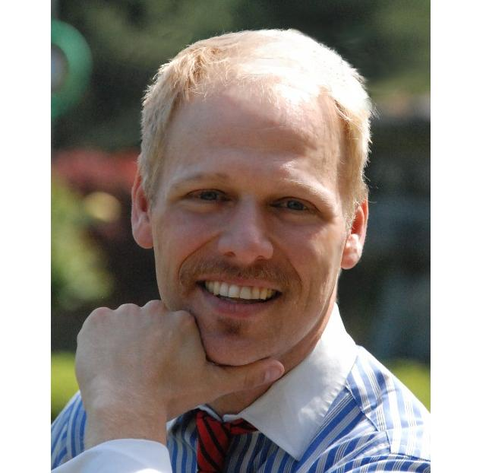
THADIUS "DI" BRAUN
PO Box 582, Thompson Falls, MT 59873
(406) 827-4591 (406)241-5119
dibraun@hotmail.com Skype ID: diester-bo

EDUCATION:
MSU Master Gardener Certificate, Mar. 2010, MSU, Bozeman, MT
TESOL Teaching Certificate, 2009 International TEFL Teacher Training
Docent Certificate, April 2006, Discovery Park-Seattle Parks Department
WA State Pesticide Applicator Certificate, Oct. 2005, WA State Dept. of Ag.
WSU Master Gardener Certificate, Mar. 2003, Wash State University, Seattle, WA
Quickbooks Certificate, Feb. 2003, Bellevue Community College, Bellevue, WA
B.S.- Aquatic Resources (Fisheries Biology), May 1999 Sheldon Jackson College, Sitka, AK
Associate of Arts, Computer Science, May 1997 North Idaho College, Cd’A, ID
Associate of Science, Forestry/Natural Resource Mgmt, May 1996 North Idaho College, Cd’A, ID

EXPERIENCE: 8/10-10/10 Cottonwood Valley Farms, 2200 Whitlash Rd., Chester, MT 59873 406-265-0858
Supervisor: Alan Skari Position: Ranch Hand/Temporary Help for Wheat Harvest Specifications: All tasks associated with harvest of <4000 acres winter and spring wheat. Trucking wheat from field to silos, auger operation, tractor use, driving dump trucks, mowing, pruning shelter belt trees/shrubs, tracking weekly hours/duties/job details, crop sampling/recording, cleanup of ranch grounds, shuttling vehicles, etc.

11/09-6/10 Inland Empire Builders, 1740 Main St. E., 406-827-3519 Supervisor: Andy
Nelson Position: Garden Dept./Greenhouse Supervisor Specifications: Ordering, Stock
Maintenance, Inventory Control, Planogram Implementation, Nursery stock culture/monitoring, pathogen ID/control, cash register backup, Special order preparation/research/sales, floor sales of all store stock, but especially garden department.

4/09-9/09 Kangwon National University, Samcheok/Dogye Campus Supervisor: Mr. Dong
Heok Kwak-Director: Foreign Language Department 033-570-6228 Position: Visiting Instructor Specifications: Foreign language instruction for graduate-level Cognitive Linguistics, TESOL Methodology, modal verbs, conversational English, TOEIC, and Children’s Summer Camp.

10/08-4/09 Ewha English Academy, Andong, S. Korea 010-7181-1804 Supervisor: Seung He Kwan Position: Foreign Language Instructor Specifications: all aspects of foreign language instruction for Korean students age 7 through adult including: curriculum development/ implementation, TOEFL/TOEIC, English conversation, speaking, listening, writing, grammar, essays, debate, marketing, daily rubric/lesson plan preparation, special event coordination, etc.

5/07-5/08 Avalon English Academy, 15-1 Polaris #2 Building, Jeongja 1-Dong, Bundang Gu, Seongnam-shi, Korea 082-31-714-4437 Supervisor: Nick Bland Position: Foreign Language Teacher Specifications: Instruct elementary students in conversational and written English as a foreign language, curriculum development, daily lesson plan preparation, etc.

1/02-5/07 Alpine Mountain Landscaping, North Bend & Thompson Falls, MT 59873 (406)
827-4591 Supervisor: Thadius Braun Position: Owner/Sole Proprietor Specifications: all
aspects of landscape design/installation/maintenance, office duties-bookkeeping, invoicing,
billing, tax management, personnel resource management, hiring, scheduling, construction of outdoor structures (i.e. gazeboes, decks, stairways, garden sheds, etc.)

RELATED Training for: TESOL, CDL, CPR, First Aid, Lifeguard, Master Gardening, Pesticide Application,
INTERESTS & Quickbooks. Over ten years private tutoring. Former Teacher’s Aide for Chemistry, Biology,
SKILLS Botony, Outdoor Activities, Ceramics/Art and Math Departments. 70 wpm typing, 350 cpm 10-key,
broad-based computer skills, published writer, world travel, multi-lingual: Spanish, Korean, and French. All outdoors pursuits: camping, hiking, photography, fishing, hunting, taxidermy, etc.

REFERENCES: Patrick McGinty (Recruiting Officer-WWU)-Bellingham, WA (360) 647-9654
Mr. Josh Rosenberger (Professor) University of Montana, Missoula, MT (406)-493-2698
Mr. & Mrs. Gene McKinzie (Retired Navy) #2 Sanders Rd, Thompson Falls, MT (406) 827-3898
Mr. Robert Kim (Pastor) Global English Mission, Bundang/Suji, S. Korea 010-3905-1415

