Curriculum Vitae
For 2010 Spring Semester
- Personal Information

Name |  |  | First, Middle, Last |  |  |  |  |  |  |  |  |  | Sex | Male(X)  Female( )
 |  |  | Robert William Harvey |  |  |  |  |  |  |  |  |  | Sex
Home  Address |  |  | 103 Chunsol Villa  133-6 Bonji  Botong Ri, Hwaseong |  |  |  |  | Telephone |  |  | 010-3158-0573
 |  |  |  |  |  |  |  | E-mail  Address |  |  | robharvey21@gmail.com
Passport  Number |  |  | Available Upon Request of Employment |  |  |  |  |  |  |  | Nationality: |  |  | English
Alien Registration Number |  |  | Available Upon Request of Employment (E-2) |  |  |  |  |  |  |  | 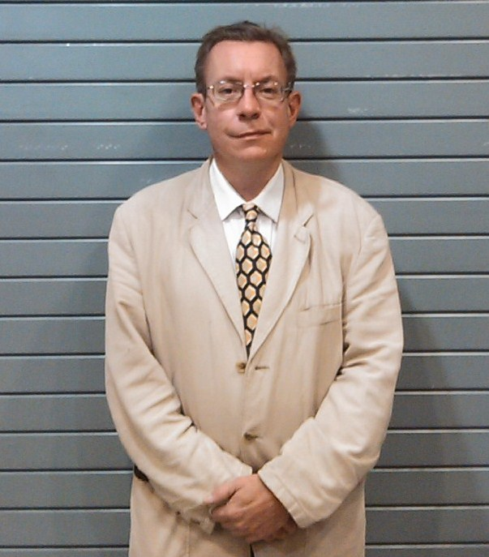
Date of Birth  (YYYY/MM/DD) |  |  | 1967 / 06 / 15
Hobbies & Interests |  |  | Theater (Acting & Directing), Reading, Swimming
Health Condition |  |  | Serious  illness or disability?  Yes ( ) No ( X ) |  | I am a very healthy individual with no health conditions  or serious disabilities.
2. Educational Background & Certification
Name of School | Years required for graduation |  |  | Period |  |  |  |  |  |  |  | Major |  |  |  | Degree | Graduation  Date
Name of School |  |  |  | Year, Month |  |  | ~ |  | Year, Month |  |  |  |  |  |  | Degree | Graduation  Date
Vancouver College | 2 |  |  | 2006 Sept |  |  |  |  | 2008 |  |  | TESOL |  |  |  | Diploma | 2007
Strathclyde University | 1 Month |  |  | 2001 Jan |  |  |  |  | 2001 June |  |  | TEFL |  |  |  | Cert. | 2001
Southampton U School of Business | 1 |  |  | 1998 Sept |  |  | ~ |  | 1999 Aug |  |  | Business |  |  |  | P.G.M. Cert. | 1999
Lancaster University | 3 |  |  | 1985 Sept |  |  | ~ |  | 1988 June |  |  | Economics |  |  |  | B.A. (Hons) | 1988
3. Teaching Experience (Present job first)
Name of School  (University) |  | Period |  |  |  |  |  |  |  | Courses / Programs of Responsibility |  |  |  |  | Title
 |  | Year, Month |  | ~ |  | Year, Month
University of Suwon |  | 2009 Mar |  |  |  | Current |  |  |  | See Below |  |  |  |  | Professor
Samsung Corp. |  | 2008 Feb |  |  |  | 2009 Feb. |  |  |  | Management English |  |  |  |  | Business Professor
Jangan College |  | 2008 Feb |  |  |  | 2009 Feb. |  |  |  | Business English  Practical English |  |  |  |  | Professor
U of Suwon |  | 2003 Aug |  |  |  | 2007 Aug. |  |  |  | ESL Freshman,  English Majors,  Language Institute,  Intensive Program,  Pre-Medical,  Study Abroad,  Summer & Winter Camp, |  |  |  |  | Professor
ELI Academy |  | 2001 Jun |  |  |  | 2003 Jul. |  |  |  | Adult & Elementary ESL |  |  |  |  | Instructor
1) Why do you want to leave your current position?
I have been working in Suwon for six years and feel that it is time for me to move, both geographically and professionally. I have gained wonderful experience during my time at Suwon University, and hopefully my every increasing teaching experience in Korea will prove of even greater benefit to my future students. Furthermore, I believe that I can provide added value and enrich the English experience of my future students.
.
2) In your professional experience up to now, what have you found to be some of the difficulties in teaching English in Korea?
Fortunately, in my nine years of teaching English at all levels from Kindergarten, through to Professional adults (For example, at Samsung Corporation), I have generally found my students to highly receptive to my teaching style, which is firmly based on a fun and safe learning environment.

Drawbacks I have encountered include shyness, embarrassment, and in some instances with university freshman students a reluctance to actively learn English, which they perceive to be a non-core subject. Tk hard to overcohis reluctance has been my greatest challenge and I work hard to overcome it.
3) What you hope to accomplish in your classes at University?
I set up my lesson plans to be communicative in nature and make my lessons relevant to my students’ needs.
I wish to see my Korean students engaged and active participants in learning of the English language.
More importantly, I want my students to feel confident in conversing in English, and not be afraid of or feel very embarrassed when they find themselves in a situation where they are required to use the English language.
In addition, I hope that my lessons also provide greater insight into cross-cultural awareness and communication.

4. References. Mr. Song – University of Suwon ESL Department Coordinator.
Dr Park – Director of ELI English Academy

