Resume

Of

Brandon.W.Brander

RESUME OF BRANDON.W.BRANDER
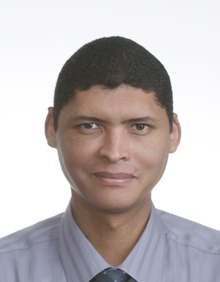

PERSONAL DETAILS

Last name: Brander
First names: Brandon William
Date of birth: 12 February 1974
Nationality: South African
Current address: 138 Grasmere Street, Crawford,7764, Cape Town, South Africa
Contact number: (0027) 21 697 2878/ 0027 76 697 5595
E-mail: brandonbrander@yahoo.com or brandonbrander@gmail.com

EDUCATIONAL BACKGROUND

PGCE (2003)-Double Majors in Education and Human Movement Sciences at the University of the Western Cape

TEFL (2002)-Teaching Methodology, Grammar, IELTS Cambridge Exams, Teaching Practice at One World Language School (South African TEFL Society)

B.A. (HMS) (1996)-Double Majors in Human Movement Sciences and Psychology

Matric (High School Diploma) Certificate (1991) - Passed with Matric Exemption at Alexander Sinton High School.

TEACHING EXPERIENCE

Global Education Center (July 2007-July 2009): Head Teacher/ ESL Teacher
[Incheon, South Korea]

Camps Bay High School (January 2007-June 2007): Math teacher
[Camps Bay, Cape Town, South Africa]

Harold Cressy High School (January 2006-December 2006): Math/Biology Teacher
[Cape Town, South Africa]

Dar-Al-Uhloom School (October 2005-January 2006): ESL Teacher
[Riyadh, Saudi Arabia]

Windsor High School (January 2000-October 2005): Math/Science Teacher
[Rondebosch East, Cape Town, South Africa]

REFERENCES

1. Christine Park, Global Education Center, Incheon, South Korea (+82) 032 560 1000
2. David de Korte, Camps Bay High School, Cape Town South Africa (+27) 21 438 1507
3. Khalid Isaacs, Harold Cressy High School, Cape Town, South Africa (+27) 21 461 3810
4. Ronald Fortune, Christel House International, Cape Town, South Africa (+27) 84 582 2114 or (+27) 21 704 9400

