Lisa Lee 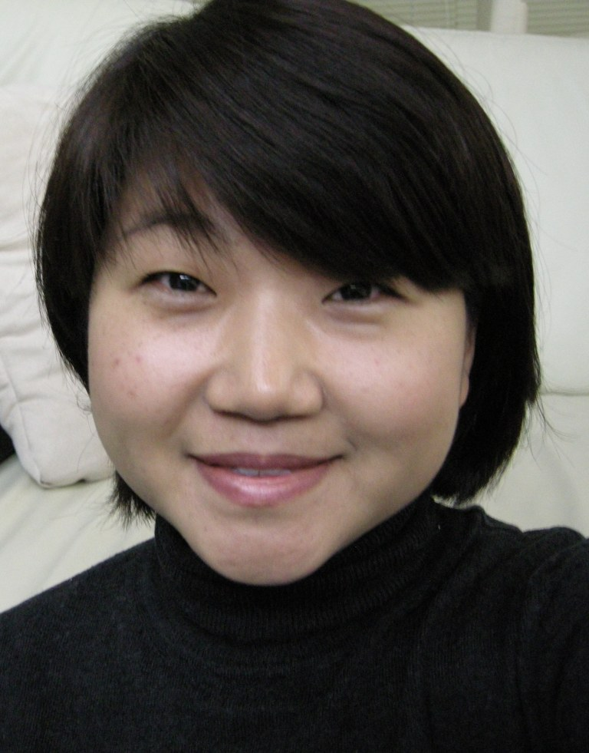
Address: 서울시 강남구 삼성동 107번지 미켈란APT 1303호
Phone: 010-2051-7900
Email: lisaleechang@gmail.com
OBJECTIVE
Seeking a teaching position where I may utilize what I have learned through TESOL.
EDUCATION
TESOL Certified
July 2009 Seattle University Seattle, WA
Bachelor Degree, Hotel & Restaurant Administration
Graduated December 1997 Washington State University (branch campus) Seattle, WA

WORK EXPERIENCE
Kennedy Associates Real Estate Counsel – Seattle, WA January 2007 – June 2009
Hotel Design and Construction Assistant
- Received calls pertaining to invoices from contractors
- Confirmed travel arrangements for Vice President and Director of Design and Construction
- Created documents using excel, word, and power point
- Produced daily operating reports of Kennedy owned hotels
Royal Coachman Inn - Fife, WA January 2004 – August 2006
General Manager
- Compiled data for daily, weekly, and monthly reports
- Prepared proposals for tour groups and corporate guests
- Booked reservations for large groups
- Maintained files of convention and sports group contracts
- Assisted answering calls at multi phone line at desk
- Hiring, training and discipline of employees
- Resolved guest issues and employee conflicts
- Liaison between owner and staff
Northland Communications Corporation - Seattle, WA May 1999 – November 1999
Assistant to VP of Finance and 3 Controllers
- Changed over hand written records to an Excel spreadsheet for easy and quick maintenance
- Prepared and distributed weekly and monthly reports to all division accountants
- Ordered office supplies for the accounting department
- Prepared and sent faxes to branch offices on behalf of Controllers
- Made travel arrangement for accountants visiting other sites
Northland Communications Corporation - Seattle, WA November 1999 – January 2004
Technical Services Representative
- Responsible for training branch office CSR’s on new software
- Answered help line for software support
- Created a more detailed month end procedures checklist to assist in the task of month end billing
- Revised and maintained Access database of trouble and solution logs
ARAMARK - Seattle, WA January 1998 – April 1999
Human Resources Assistant
- Responsible for weekly new hire orientation
- Processed and sent offer letters
- Managed confidential personnel files
- Recruited potential hires at various job fairs
- Created and maintained excel spreadsheet of customer comments
- Distributed mail for managers
- Coordinated year end employee party
VOLUNTEER EXPERIENCE
Federal Way Central Presbyterian Church – Federal Way, WA March 1991 – August 2009
Bible Study Teacher - Preschool through Senior High School
Youth Group Director

