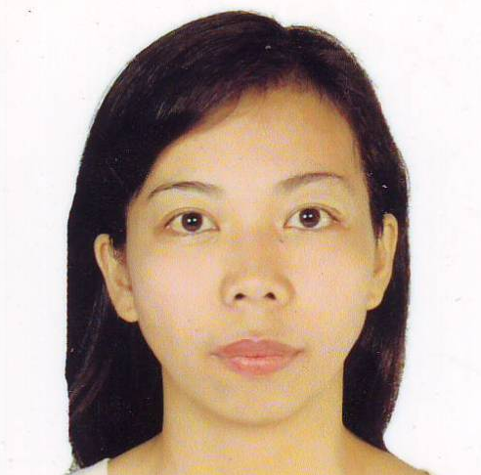
SHERRYLINE R. CORDETA

Blk 3 Lot 5 Poblacion 1
Army compound extension
GMA Cavite, Philippines
Cell Number: 09202545539
Mobile Number: (046) 890-1261

POSITION DESIRED: Teacher

Date of Birth: November 5, 1979
Place of Birth: Carmona, Cavite
Civil Status: Married
Citizenship: Filipino
Weight: 90lbs.
Height: 5’4
Religion: Baptist
Number of Children: 2
Name of Children: Age
Joash Danielle R. Cordeta 8yrs. Old
Shem Denice R. Cordeta 7yrs. Old

Father’s Name: Ernesto G. Reyes
Mother’s Name: Zenaida G. Reyes
Their Address: Blk 3 Lot 5 Poblacion 1 Army comp. extension GMA Cavite, Philippines

Person to be contacted: Zenaida G. Reyes
In case of emergency +63(046) 890-1261

EDUCATIONAL BACKGROUND

Primary: Area J elementary school of Cavite 1986-1992
Secondary: General Mariano Alvarez Technical High school 1992-1996
College: Philippine Christian University 1996-2000

ACHIEVEMENTS

Honor School Year

Dean’s Lister Philippine Christian University 1996-2000
First Honor General Mariano Alvarez Technical High school 1992-1996
Firs Honor Area J Elementary School of Cavite 1986-1992

EMPLOYMENT RECORD
Position School Year

Elementary and High school Shalom Akademeia School of Cavite Apr. 5, 2006- Apr. 20, 2009
Elementary teacher New Life Christian School Of Cavite Apr. 10, 2002- Mar. 23, 2005

SEMINARS

Shalom akedemeia School of Cavite Leadership Camp speaker
Phoenix Educational System INC, Educator Workshop: Story Telling
International Christian Academy Special Education: Autism
Victorious Christan Montessori Multiple Intelligences
VOX DEI Academy Faculty Development Seminar
VOX DEI Academy Test Construction and Measurement
Workshop

CHARACTER REFERENCES

Name Position School

Mrs. Portia Rivera Dean Philippine Christian University Silang Cavite
Mrs. Reynelda Alano English Professor Philippine Christian University Silang cavite

Applicant’s Signature

SHERRYLINE R. CORDETA

