Joey S. Park

#6-602 Kumho Apt Bongsundong
Namgu, Gwangju, South Korea
010-5274-0032
Jspark2774@yahoo.com
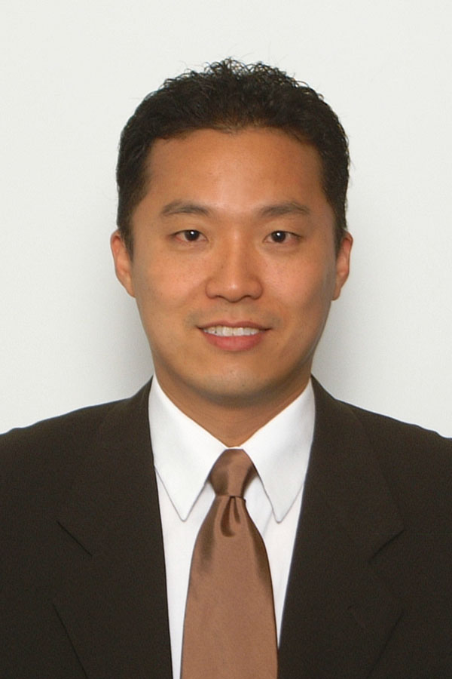

Personal Summary

Motivated and goal-oriented individual prepared to implement related education and experiences for an opportunity to pass on my English language skills to students in an international setting.
Strengths: Exceptionally motivated with proven ability to successfully complete challenging and deadline-driven projects. Outstanding organizational and time management skills, adept at prioritizing multiple tasks.

Presentation & Communication: Articulate and engaging with a keen ability to communicate and build strong relationships with diverse individuals. Extensive experience in a team atmosphere and working with others.

Teaching Experience

Avalon English, Human Resources Manager/Head Teacher Dec 2008-Present
Gwangju, Bongsundong Campus, Kumho Campus

Reading Star, Human Resources Manager/Head Teacher Dec 2008-Present
Gwangju, Bongsundong Campus

Current Responsibilities
Reside as the HR Manager and Head Native Teacher
Manage 20 native English teachers at three academies
Conduct subject training for both native and Korean teachers
Teach elementary classes as well as upper level TOEFL and TEPS based classes
Classes include reading, listening, writing, and speaking based subjects
Create teaching curriculum

English Teacher, Private Lessons Jan 2009-Present

Private Lessons for TOEFL/TEPS/TOEIC
Preparations for foreign schools/going Abroad/entering Company

Bongsundong Citizen’s Center, English Teacher Aug 2009 - Present

Teach a course to a group of adults in conversational English. The group consists of about 20 women with varying levels of English. The age ranges of the students varied from around 25 to 55 years of age.

G&K Learning Center, Doraville, GA 1996-1998

SAT Tutor Tutored both high school and middle school students in the subjects of math and English while in college. Specialized in SAT tutoring in both classroom settings and private sessions as well.

Professional Experience

Marietta Discount Mall, Marietta, GA 2007 - 2008
General Manager

Coordinated and opened up a 70,000 square foot Discount Mall in a high traffic area in the city of Marietta, Georgia. The Discount Mall was sectioned off into 150 individual units, which were all available for lease to small business owners. Job duties include managing the Mall, making budgets, marketing and sales.

Key Achievements
This Mall is the first of its kind in the city of Marietta.
Achieved 100% occupancy during the construction phase with the help of an advertising team implemented and led by myself.
Created a waiting list for storefronts that totaled over two hundred names in a tough economy that we have today.
Through advertising and promotions, made the community aware that this is the “One stop shop” for all citizens in and around the city.

Dixie Beverage Outlet, Woodstock, GA 2002 - 2007
General Manager/ CFO

Facilitated the purchase of one of the largest liquor stores in the metro Atlanta area. Target a broad market in order to make this store a destination point for consumers through aggressive pricing, large selection, and great customer service. Job duties include financials, dealing with beverage suppliers, and inventory control.

Key Achievements
Increased sales annually year over year. Revenues initially in 2002 were $5 million and rose to $6.9 million in 2006.
Although continually being a cost leader, gross profit rose from 14% to 18.3% through strategic inventory management and relationship building with key beverage suppliers.
Transformed the customer base through wine tasting events and wine education. This increased wine consumers substantially, which provides more customer loyalty and higher profit margins.
Dixie Beverage sold five years later at a profit of $1.7 million more than the original purchase price.

Madison Financial Group, Atlanta, GA 2000-2002
Certified Financial Planner

Key Achievements
Certified Financial Planner for high net worth individuals focusing in on business, estate, and retirement planning.
Constantly keeping abreast of the financial markets in order to stay on top of new investment strategies and investment vehicles.
Target market was the Korean community to help educate Koreans on the importance of financial planning.
Managed over $30 million in assets through various investment vehicles.
Assisted non-licensed Financial Services representatives in writing financial plans and purchasing investment securities

Education & Training

Georgia State University, Atlanta, GA
Bachelor of Business Administration, Major: Finance (1999)

Georgia Perimeter College, Dunwoody, GA
Associate Degree, Business Administration

Series 6 & 7 License (2000)
Financial Certification and Professional Education. License issued by the
U.S. Securities and Exchange Commission in order to trade all securities.

Series 66 License (2000)
Allows an individual to serve in the capacity of an investment advisor.

Extensive professional training in the areas of finance, sales, relationship building and leadership. Continuously update knowledge and skills through professional experience and courses.

Computer Skills

Skilled with MAC OS, Windows 3.11, 95, 98, NT, XP, XP Pro, MS Office (Word, Excel, PowerPoint, Access, and Outlook), Photoshop, QuickBooks. Advanced internet skills.

References Available Upon Request

