Paul Davis BA (Hons) Cert NatSci
Nationality: British Email: esl.teacher@live.com

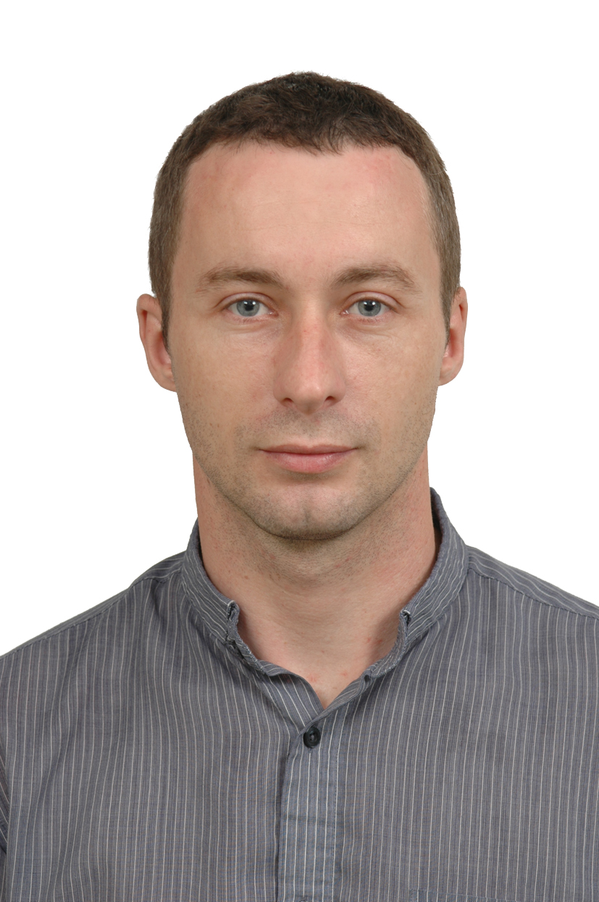
I am a creative, culturally aware and dedicated teacher who has an excellent reputation in Korea.
I am hard working, self-motivated, and have a real passion for teaching English to students of all levels. My patience, respect and approachability have proved vital to my success as a TEFL teacher.

Smart Kids (Taiwan) August 2009 – December 2009
English Teacher (7-12 year old students)
- Teaching English to students on a part-time basis.

Uiseong High School (South Korea) October 2006 – April 2009
Full-time English Teacher (16-18 year old students)
- Planned the schools’ English program and produced all necessary teaching materials.
- Ensured students' development in writing, reading, listening and speaking English.
- Developed students’ awareness of foreign cultures.
- Conducted regional teacher training programs.
- Created camp programs for regional schools.

Wonderland Private English Academy (South Korea)April 2005 – April 2006
Full-time English Teacher (5-16 year old students)
- Responsible for the development of students’ English reading and speaking skills.

Card Corporation Ltd (UK) August 2000 – March 2005

Operations Manager
- Business development and project management.
- Staff management and recruitment.
- Managed a £1 million contract for an international finance company.

Hammond Suddards Solicitors (UK) September 1999 – August 2000
Project Services Assistant
- Supported the development of an online legal service.
- Conducted presentations and training to over 300 staff.

Cellnet Plc (UK) September 1998 – September 1999
Call Centre Supervisor
- Responsible for over 40 staff and their training.
- Developed internet medium for customer service and sales.

Education/Qualifications
2009 Certificate in Natural Science – Grade: Distinction
2005 TEFL Diploma (60 hours)
1995 – 1998 BA (Hons) Economic Studies - The University of Leeds
1993 – 1995 4 A-Levels
1988 – 1993 GCSEs: 6As & 2Bs

Marital Status: Married
Interests: Reading, playing football and chess, music, travelling and studying science.

