RESUME
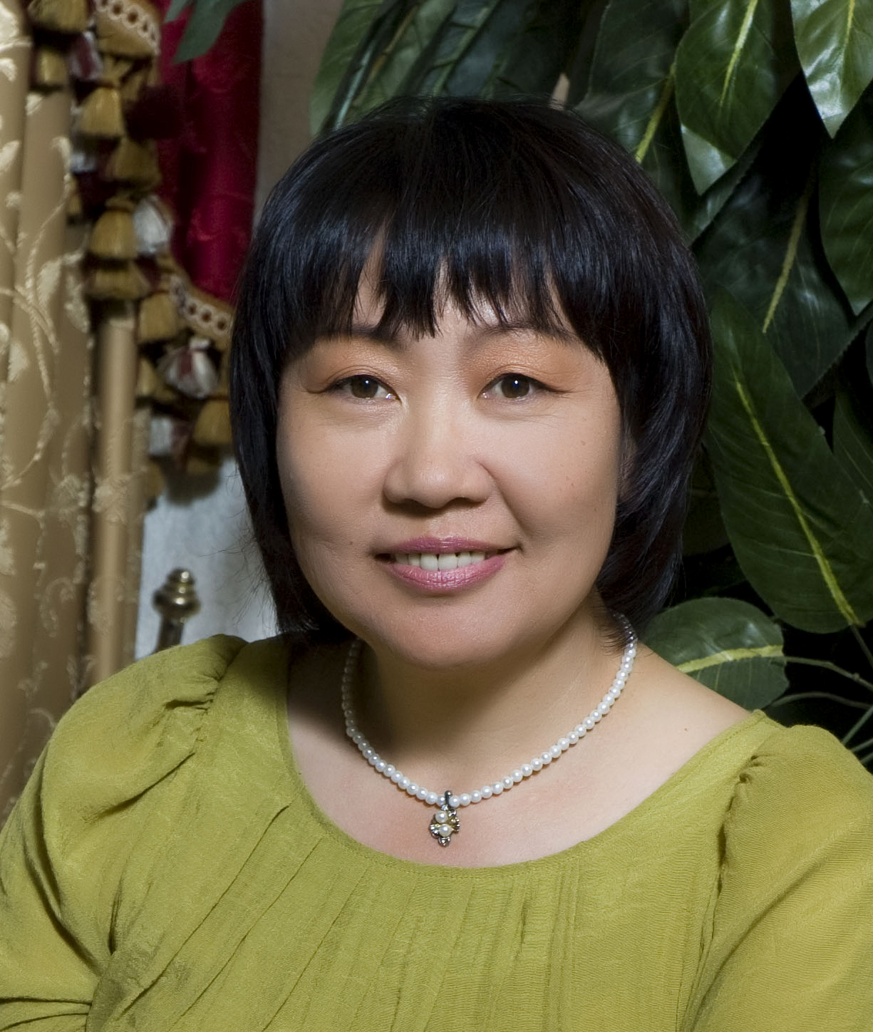

Name : Antonina Davidovna Lee

Nationality : Uzbekistan

Birth : 23 February, 1959

Address : 131-120 Seoul, Chungrang-gu Chunghwa-dong 325-56

Mobile Phone : 010-7597-2325

E-mail : antblessed@gmail.com

Languages Skills : Russian, English, Korean (spoken), Uzbek (spoken)

Computer Skills: Word, Excel, CAD, Power point

Educational degrees and
certificates: Diploma of the Tashkent State Institute of Foreign Languages
Republic of Uzbekistan. (M.A.) 1983

National Award for Excellence in teaching
“Excellent teacher of the Public Education of the Republic of Uzbekistan”
Republic of Uzbekistan. 2005

Certificate of completion for the Teaching Excellence Awards Program.
Montana State University- Bozeman, USA. July 2000.

Employment experience:

2008 July – present “Poong Lim Industrial Co., Ltd.”, Seoul, South Korea
Technical Translation & Interpretation. (English-Russian)

2007 - 2008 June Aurora Trading Corp./ Technical Translation and Interpretation
(Russian – English)

2005- 2007 Qanot Sharq, Uzbekistan / Translator (Russian – English)
Translation and coordination of CAD drawings

1989-2005 Teacher of EFL, school # 19
Yukorichirchik district, Tashkent region
Uzbekistan

1987-1988 Teacher of EFL, school # 21
Almalyk city, Tashkent region
Uzbekistan

1983-1987 Teacher of EFL, school # 32
Kommunisticheskiy district, Tashkent region
Uzbekistan

