Gerald E. Lynch
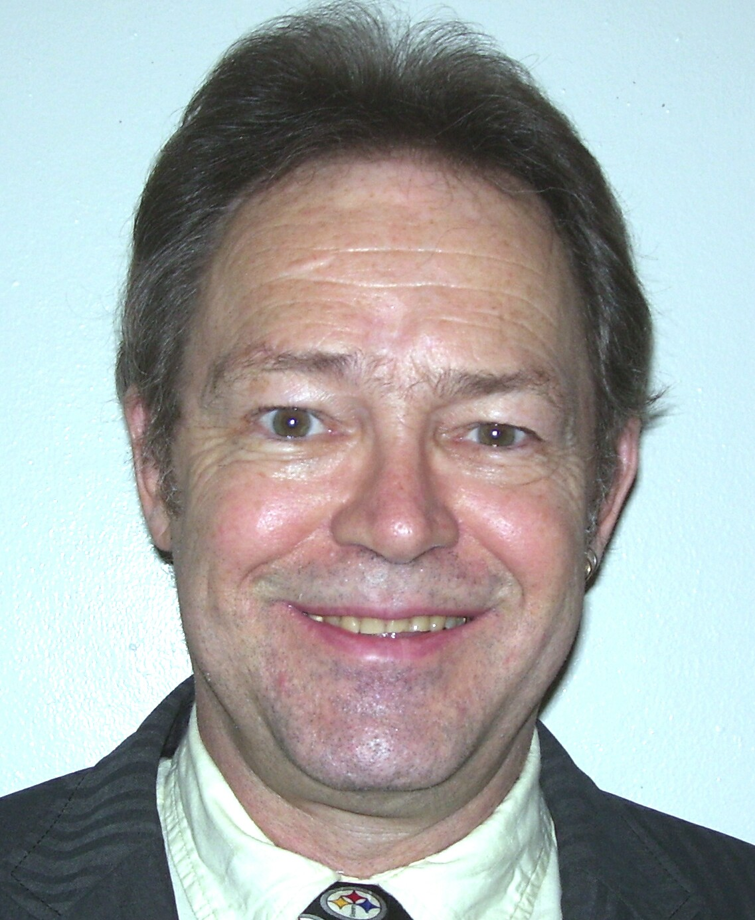
Apt. E. Go’s Compound, Patutong
Malaki South
4120 Tagaytay City, Cavite
The Philippines (native US citizen)
Ph.: +63-46-860-3023
Mobile #: +(63)-917-359-5311
e-mail: gelynch52@yahoo.com

- Objective: To obtain a position teaching English as a Second Language
- Education:
1. BA/English: Clarion University of Pennsylvania
2. Returned to Clarion University for several classes of continuing education taking courses such as: Instructional Methodology, Multi-Cultural Education, and Educational Psychology
3. Attended Motorcycle Mechanics Institute and obtained a Harley-Davidson Motorcycle Repair Technician Certification (1996)
4. 130 hour TEFL certification course: Winfield College, Vancouver, Canada, October, 2005

- Personal Data:
I am engaged to be married and have a stable life while enjoying the study of history and culture. I have traveled in and enjoyed many Asian countries including Korea, Japan, Thailand, Vietnam and The Philippines as well as Saudi Arabia.
- Experience:
  - Taught Mechanics four years while in the US Air Force
  - Have taught children and adults in Korea approximately 7 years
  - Taught children at English 20/20 in Seoul until they changed the contract and gave all foreigners a Letter of Release
  - Then taught adults for a year at TEPS in Ulsan, Korea
  - Some adults have been taught under corporate subcontract from TEPS, taught at a Samsung office several days a week
  - When I returned to Korea a year later I taught adults in Daegu and children & adults both in Gumi
  - Taught Samsung executives, engineers and VPs one year in Suwon, Korea
  - Finished a contract teaching high school and adult classes in Heungdeok, Jeollabuk-do, Korea March 7, 2008
  - Several other positions over a 10 year period
  - Taught English to Saudi and Kuwaiti men under short-term contracts for 6 months

Additional Information:
- Have a Philippine Drivers License and valid International License
- Have well developed sense of confidence developed as an instructor in the military and as a Shop Foreman & Service Manager for various truck and equipment repair businesses
- In those positions I both delegated work to employees and solicited business from customers
- Spent 30 years working mechanically in truck, heavy equipment, motorcycle and auto shops as well as in surface coal mines, deep hard-rock mining, oil fields and heavy construction
- Command of technical and industrial English language is considerable due to varied experience

