CATHARINA SUSANNA HOLTZHAUSEN
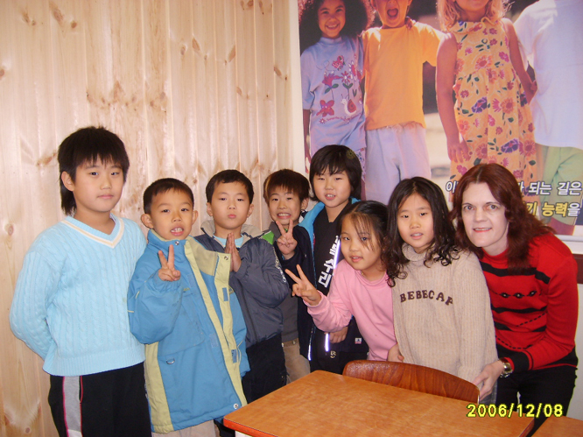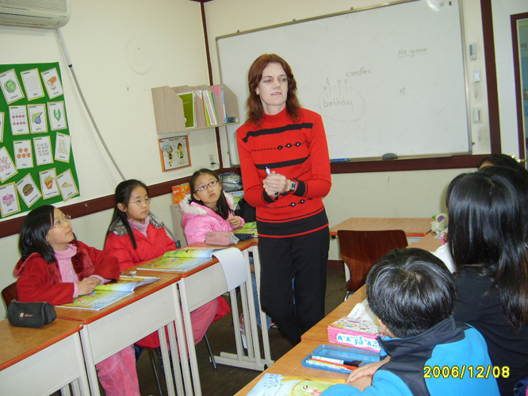
Tel : +277 909 75005
E-mail address : rinaholtzhausen@yahoo.co.uk
Nationality : South African
Age : 46
Marital status: Single (never married)

Qualifications
Bachelor of Science
Bachelor of Science Honors
Master of Science
PGCE (Early Childhood Development and Foundation Phase) with the following modules included:
Psychology of education and socio-pedagogic
Philosophy and history of education
Inclusive education
Health, safety and nutrition
Management and assessment
Reception year and foundation phase didactics
Reading, writing and spelling: first and second language
Teaching mathematics, science and technology
Visual arts and music and movement in the foundation phase
Teaching practice
English language proficiency
Afrikaans language proficiency

Working Experience

Medical Technologist: Du Buisson & Partners Pathology Lab
Research Assistant: Dept of Medical Microbiology, Institute for Pathology, University of Pretoria
Senior Forensic Expert (Superintendent): South African Police Service

Teaching Experience

Secondary Science Teacher: Cultura High School Bronkhorstspruit, Mpumalanga, South Africa.
Principal: Mr Els Tel : +27 13 931 0016 E-mail: cultura@penta-net.co.za
I taught Science and Life Skills to Grades 8 & 9 as temporary replacement for a teacher on maternity leave.
I left because the teacher had returned from her maternity leave and there wasn’t an opening at the school.

Montessori Kindergarten Teacher: Sunshine Child House, San Min District, Koahsiung, Taiwan
I taught one class (2 groups, 3/4 year olds & 4/5 year olds). The Montessori system had been followed.
I finished my 1-year contract with this school.

Volunteer ESL teacher: Taiwan
I taught kindergarten and primary levels at 3 small ‘bushibans’ in Henchen, Chenchen and Kenting using the Kid Castle’s books. This was for 3 months only since I was working illegally on a tourist visa. The bushibans couldn’t provide a work permit to a foreigner and I didn’t receive a salary.
This was a voluntary position.

Primary ESL Teacher: Jaram Eins Academy, Dapsimni Road, Dongdaemun-Gu, Seoul, Korea
I’d taught ESL to primary grades 2-6. This was a GnB franchise, but I used the Let’s Go series in addition to the GnB books.
I finished my 1-year contract with this school.

ESL Teacher: Wen Hua Middle School, Nanxing, Luzhou, Sichuan Province, China
I was recruited by a ‘school’ in China when I was back in South Africa after the passing of my dad. I signed a contract for 10 months. However, on my arrival in China I learned that the ‘school’ was actually a recruiting agency. They took me to a public school with 3000 students and I was the only foreigner in the city. I taught English conversation to students aged between 12 and 16 for 4 months.
I had to leave this position because the school didn’t have a legal licence to employ a foreigner. For reference: Amily: amily8410@yahoo.com.cn

Primary Science and Kindergarten ESL Teacher: Lardprao Udomsuksa School, Lardprao 94, Bangkok, Thailand
Director : Dr Kamolwan Chaiwanichsiri Tel:+66 2 5382954 E-mail address: kamolwan@udomsuksa.ac.th
I taught Science to Grade 4 and ESL to three Kindergarten 3 (6 year olds) classes. I also was a Grade 4 Homeroom Teacher. This is a bilingual school – all subjects are being taught in both Thai and English.
I finished my 1-year contract with this school and received an offer from a school to help them starting up a new English Program.

Primary Science and English Teacher: IDEAL English Academy, Sacred Heart Pattanavet School, Bangkok, Thailand
Academic Director: Niel Legrange Tel : +66 8 489 83377 E-mail address: nieleg@gmail.com
Thai Director and CEO of IDEAL : Khun Pim Tel: +66 2 672 9598
IDEAL English Academy provides the curriculum and teachers for the English Language Programs at Sacred Heart Schools. I worked for IDEAL at Pattanavet Sacred Heart School. I taught Science to Grades 2-5 and English to Grade 4 in the English Program. I taught at this school for 15 months (contract was for 12 months).
I returned to South Africa to register for a PGCE.

Primary ESL Teacher: GnB English School, Heungduk-gu, Wuncheondong, Korea
Director : Kyung-Hee Choi Tel: +82 43 267 0505 / +82 17 376 6210 E-mail address: jobckh@hanmail.net
I taught ESL to Grades 2 – 6 at this GnB franchise for 9 months while I was studying the theoretical part of a PGCE course from a distance university in South Africa (UNISA).
I left this position because I had to return to South Africa to take the PGCE exams.

Relief Teacher: Sarasas Witaed Saimai School, 234 Sukhapibaan 5 Road, Orgnern, Saimai, Bangkok, Thailand
Head of Foreign Staff: Lorraine Bonython Tel: +66 2 563 5050 / +66 8 91114162
E-mail address: sarasas_saimai@yahoo.com

I taught Kindergarten and Primary students at this bilingual school as temporary replacement for a teacher on maternity leave for 6 months.
I left this school because I had to do the teaching practice for the PGCE as Grade 1/2/3 teacher and this school couldn’t arrange it for me.

Primary Grade 2 Homeroom Teacher: Sacred Heart Nonthaburi IDEAL English Program (same company as other Sacred Heart School).

59/25 Moo 1, Tiwanon Road, Tambon Banmai, Pakkred, Nonthaburi, Thailand

Principal: Sister Somchit Tel: +66 2 961 5685

Thai Director and CEO of IDEAL: Khun Pim Tel: +66 2 672 9598

Manager: Gary Gilchrist Tel: +66 8 49026299 E-mail address: gg.ideal@gmail.com
I taught 5 subjects, namely English, Mathematics, Science, Computer Science and Health Education to a Grade 2 homeroom class in the English Program. I also taught ESL to a Grade 6 class in the Thai Program.
I finished the academic year (end of March) and didn’t want to start the new academic year(middle May) as I was looking for an opportunity to teach in the Middle East and thought it would be better for the students to start a new year with a teacher who could see them through the year. I informed my employer in written of my intentions to leave with 3 months’ notice.

Relief Teacher: Annubannonthaburi School, Thailand
I worked for an agency at this school and taught Social Studies and Health Education to Grades 1 – 6 in the English Program for 3 months.
The school had known that I would be working only until I could start at an international school in the Middle East. I still gave them 1 month written notice.

Last position: Newton International School, Doha, Qatar

I applied for a Reception / Year 1 position with NIS via Andrew Spinks (GlobaLinks). Director Gail de Martino from NIS interviewed me telephonically for this position and I was made an offer in written as Year 1 teacher. I gave the school in Thailand 1 month’s notice and returned to South Africa for the processing of a visa. However, on my arrival at NIS, I was told that they didn’t have a job for me. Later that night Matthew Bradley, the Head of Secondary at D-Ring, called me and begged me to take up a position as Secondary Science teacher. I reluctantly accepted, but refused to sign the contract as Key Stage 3 teacher as I didn’t get any formal training as secondary teacher and I didn’t apply for a secondary position. I had to teach the all boys’ classes and the two male Science teachers taught the all girls’ classes. I finished the first term and left on good terms with the SMT. I didn’t ask them for a reference letter, but they gave me a thank you letter with contact information. (see next page)
