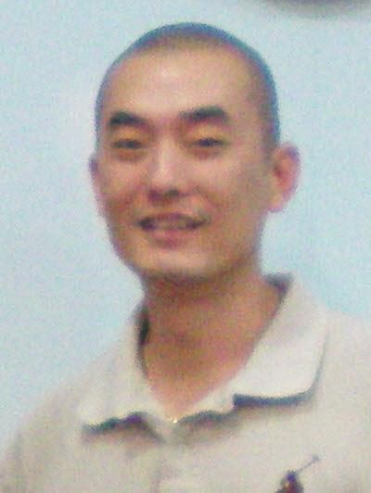
John Kim

John Kim
1040-13 Yeongtong-dong, Yeongtong-gu, Suwon
010-2083-0187
nhojmik@gmail.com

OBJECTIVE
 | To obtain a position as a full-time English teacher, enriching the lives of students.

SKILLS PROFILE
• A native English speaker
• Knowledge of and over 10 years of experience in caring for and teaching children
• Creativity in presenting learning material in a fun and relaxed manner
• Able to use a variety of materials and techniques to keep the students’ interest
• Ability to connect with the students and tailor the lessons to each child's needs
• Excellent student-relations background
• Experience in teaching English as a second language
• Responsible, professional and enthusiastic

EXPERIENCE
 | SLP Language School (Go Yang, Korea) | 2008-2009
• Developing children ages 4-6 through play experiences, pre-writing practice, creative arts,
science, and outdoor activities
• Responsible for tasks, including, helping management with the Native English teacher preparing lesson plans, monthly tests and evaluations
• Coordinated field trips and excursions to various educational and cultural exhibits and museums
 | Winner Institute (Bu Cheon, Korea) | 2004-2007
• Basic academics: phonics and pronunciation, reading, pre-writing, language arts, and TOEFL
• Teaching conversational English in real situations and role playing
• Helping the Director of the school with managing the Native English Teachers
 | New Bang Bae Institute (Seoul, Korea) | 2003-2004
• Teaching children ages 9-Adults basic and Business English using not only educational books and audio but also games and activities
• Helping the management with the Native English Teacher
Geneye Academy (Seoul, Korea) 2001-2002
• Helping the management with various tasks, making lesson plans, picking and helping develop the curriculum, and helping the management with the Native English teachers
• Teaching conversational English in real situation and role playing, and interactive computer teaching programs
Yes English Academy (Seoul, Korea) 2000-2001
•  Teaching children ages 9-16 basic English using not only educational books and audio and activities
• Responsible for various tasks, including preparing lesson plans, monthly tests and evaluations
• Keeping a lively and positive atmosphere which enables students to have fun while learning

Private Tutor (children and adults) 1997-2009
• Basic academics: phonics and pronunciation, reading, pre-writing, language arts, and spelling
• Teaching conversational English in real situations and role playing
• Providing a comfortable teaching environment while trying to enhance their learning process

EDUCATION
 | Diploma/Certificates
Bachelor of Arts in Business, University of Hawaii
High School Diploma, Kaimuki High School (Honolulu, Hi)
Teacher Training Course, SLP (Seoul)

References upon request

Self-Introduction on the next page

Self-Introduction

To who it my concern

Having moved to Hawaii in 1979 with my family when I was four years old, twenty years overseas has allowed me to learn and practice English like my mother tongue. Although not an American citizen, my English is of native standards.

After such long years away from Korea, I felt that I needed to get in touch with my roots and after long discussions with my family, I decided to come back, I came to Korea in 1995 and while studying Korean, I started working as an English teacher. I started off learning Korean by receiving private tutoring lessons but often ending up teaching my Korean tutor simple English phrases. That gave me the confidence and motivation to start teaching English. Since I was always fond of children, I had no trouble starting off as an English teacher for young students. From then on I have worked as an English teacher for young students and adults.

Unfortunately, as a Korean male citizen, the Korean army was an unavoidable stepping stone. With influent Korean skills and still a dazed understanding of Korean culture, I was sent to the army and was out a different man after 28 months of service. I must admit, despite all the hard times during my months of service, the army did a good job in making me understand Korea better.

After years of teaching I decided to take a break and travel, I also wanted to see my family in Hawaii. So in 2000, I went back to the States and stayed there for a while helping my brother with his business.

I’m very good with young children and have a lot of patience in teaching them from square one. I realized that a lot of my students in the English conversation classes knew much English but was afraid to express it. During my classes, I like to let them feel comfortable with themselves and realize that mistakes are natural in the process of learning, based on my experience with learning Korean, I try to make my students speak or blurt out whatever they think is right. Slowly, corrections can be made. Confidence to speak out, I think is a must, in learning English conversation.

My work schedule at the moment is very flexible so please feel free to contact me at the number and e-mail address above. I hope to hear from you soon, thank you.

Sincerely,
John Kim

