personal details
. 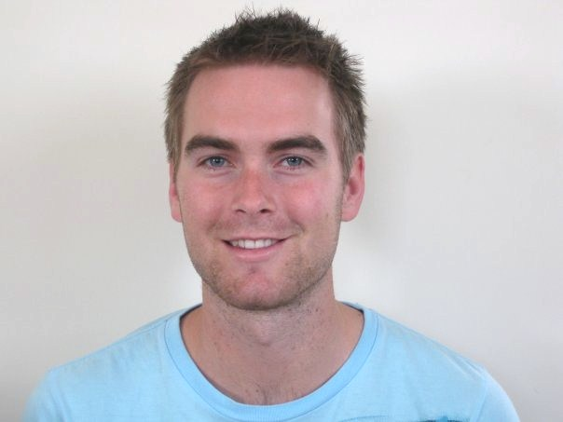
Date of Birth: 16th January 1987

Nationality: New Zealand

Marital Status: Single

personal statement

I am a recent graduate with degrees in both arts and science and am passionate about travel and working with youth. My recent experience in leading a youth group for the last 5 years has confirmed to me the love that I have for working with young people and the positive influence I can have on them. I would welcome the opportunity to work for your school. I have had numerous travel experiences, the most recent of which was 4 months traveling through America, the UK and working on a Norwegian Cruise Ship. Prior to that I have spent time in France, Italy, Indonesia, Thailand, Australia, New Caledonia and Tahiti. I do relish the opportunity to live abroad and expand my horizons by immersing myself in other cultures. I have many close friends who are of Korean ancestry and whose friendship has stirred in me the desire to live and work in Korea. I am known to be reliable, patient and personable, and am keen to contribute to all aspects of school life. I do have an ability to work on my own or as part of a team.

qualifications / education:

- I have completed a 100 hour Level 4 course for a certificate in TESOL course with INTESOL International TESOL Training, leading to graduation with grade A2, equating to ‘Excellent’. This course was accredited as being at NQF level 4 by Ascentis, a QCA approved National Awarding Body.

Ascentis
Office 4
Lancaster Business Park
Mannin Way
Caton Road
Lancaster
LA13SW
Tel. 01524 845046
www.ocnw.com
Email: ocnw@lancaster.ac.uk

- Bachelor of Arts – The major for this degree was French. This included grammar, speaking, listening, literature and film studies. In this way a vast array of skills were learnt, encouraging a very thorough command of the French language and grammatical construction. In addition, the degree included other subjects such as: Psychology, Statistics, History, and Philosophy, among others.

- Bachelor of Science – The major for this was Sport and Exercise Science. This was a comprehensive degree covering many aspects of Science specific to sport, including: Nutrition, Biomechanics, Anatomy, Physiology and Psychology.

work experience:

2002 – Present PARKLANE RETIREMENT VILLAGE

Waiter, Kitchenhand and Domicare Assistant

- Serving and caring for the needs of the elderly.

2006 – Present WINDSOR PARK BAPTIST CHURCH

Youth Group Leader

- Leading, mentoring and taking care of a group of youth through from the ages of 12 to their current age of 17. During this time of guidance, I have watched them grow into young men and women full of potential. This role includes organizing events, giving talks in front of the group (about 60 people), and leading at camps.

2008 – 2010 MILLENIUM INSTITUTE OF SPORT AND HEALTH

Fitness Instructor

- Conducting and teaching exercise classes which significantly increased member participation, delivering nutritional consultations, developing individual and group exercise programmes. In this job I provided a high standard of service to exercise and health clients.

2008 SALVATION ARMY

Feeding the homeless

- Volunteer role with the Salvation Army going out on the streets of Auckland City once a week to deliver food to homeless people. This role included developing relationships with these people in the hope of having a positive influence on them.

2004 RANGITOTO COLLEGE

Headboy

- Being the Head Prefect for the largest school in New Zealand, involving leading meetings, organizing events, public speaking on many occasions and liaising with teachers. My success in this role was proven by me being asked to return many times in the ensuing years to give inspirational and encouraging talks to groups of prefects and other students.

relevant interests and skills

My skills and interests are reflected in a background of sport, music, travel and study that I believe has equipped me to successfully lead, encourage and inspire students in the classroom toward common objectives. My involvement in over 15 years of playing Basketball at provincial and national level (as team Captain on many occasions), refereeing and coaching have provided me with leadership and effective teaching skills that would apply greatly to the classroom. I also have experience in athletics at senior level and my interest in sport generally is also something that may be a common interest for many of the students in the class. I hope that my ability to play the guitar and sing may certainly help to spark the interest of students in their studies, enabling them to add a bit of fun to the lessons. The learning process that has led to my fluency in French has enabled me to understand the challenges that come with learning a new language. It has allowed me to relate to the perspective of a student learning English as a second language. I have a current certificate in First Aid as part of being prepared for circumstances that may require some medical attention in a lesson setting.

references

Ben Matthewson
Youth Pastor
Windsor Park Baptist Church
550 East Coast Road
Mairangi Bay, Auckland
New Zealand

Judi Higginson
Manager
Parklane Retirement Village
106 Becroft Drive
Forrest Hill, Auckland
New Zealand

Lynda Hazelwood
INTESOL Course Director
INTESOL International TESOL training
4 Higher Downs, Knutsford
Cheshire WA16 8AW
England

