Position Applied for: Native English Teacher
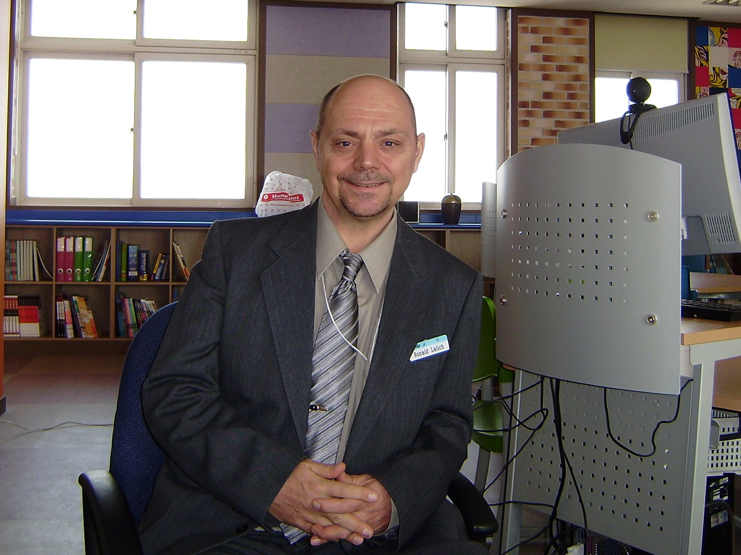

Highlights of Qualifications:

- Three years teaching experience in Korea
- Dependable and Reliable
- A productive, positive and dependable team player
- Excellent communication and organizational skills
- Innovative and Imaginative
- Sensitive to the uniqueness of cultures

Educational Achievements (Ongoing…)
Degrees;  Bachelor of Arts –  First Nations Studies | Malaspina University-College, Nanaimo,  British Columbia, Canada | Granted  June 05,01

Certificate Programs;
Teaching English As  A Foreign Language  (TEFL Certificate Program)  Special Education Assistant  Community Support  Worker  Literacy Tutor Training | Malaspina University-College, Nanaimo,  British Columbia, Canada  Malaspina University-College, Nanaimo,  British Columbia, Canada  Malaspina University-College, Nanaimo,  British Columbia, Canada  Malaspina University-College, Parkville,  British Columbia, Canada | Granted  Aug 02, 07  Granted  June 15, 05  Granted  June 15, 05  Granted  Nov 07, 04

Work History (partial list):

Jinju DongMyeong Native English Teacher September 2008- Middle School August 2011
Gyeongsangnam-do
South Korea

Bill’s Place Community support worker June 2005-
Bill Hicks Residential Support Services June 2007
(250) 751-1853 (Acquired Brain Injury)
Canada http://www.billsplace.ca/

Malaspina Library Library support technician 1996-2005
Nanaimo Campus http://www.viu.ca/library/
Contact: Mary Wood
Mary.Wood@viu.ca
Canada

Skills and Experience
Interpersonal / Volunteer- Parksville, B. C. Canada

District 69 TOTAM 2004
S.O.S. Services (Child care infant to 5 years old)
www.sosd69.com

Nights Alive Youth Coordinator 2002
Youth Program (Ballenas High School)

Peer Support Team Student/Community support 1998-2002 (Malaspina University-College)

Related Training:

Nonviolent Crisis Intervention Crisis Prevention Institute, Inc

Service and Leadership Training Student Support Services,
Malaspina University-College

Safety Awareness & First Aid Ministry of Health’s
for Childhood Emergencies Provincial Child Care Facilities Licensing Board

Duties and Responsibilities:

Native English Teacher - Development and implementation of Grammar and Conversational Lesson Plans using Power Point Presentations based on text book and current affairs. Preparation and supervision of Summer and Winter Camps integrating various educational tools such as online EPAL services, board games, and role play scenarios.

Bills Place Support Counselor - ABI - Acquired brain injury refers to any type of brain damage that happens after birth. My position as a counselor required me to retrain those suffering from ABI, teach them how to lead as normal a life as possible. Patient symptoms can range from the slight to the severe; I might have to teach them to relearn how to live on their own, or to something more complex like learning how to talk or walk. Learning to deal with a new disability takes time, patience and understanding, patients must learn how to react to everyday situations and how to control their anger, when things do not go right.

Library support Technician – My duties were both to assist University students in the various services available in a modern Library and to also assist the library staff in the upkeep and maintenance of the Library. I was required to assist students on how to use the Reference services, Online Computer interlibrary services, Equipment services such as the microfiche, copiers, faxes, and physical library services, such as Catalog systems, Books, Newspapers, Magazines, Video, Periodicals and Journals. These were the ongoing and important services that I provided to all who visited and used the Malaspina University-College Library.

