Resume
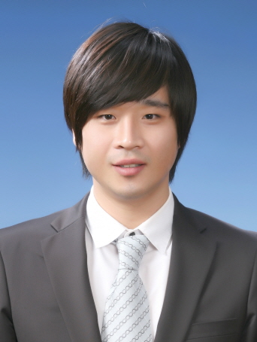
Jeong Sig (Terry) Kim
Uijeongbu Uijeongbu dong 207-20 Room 805
Tel. 010-2013-1982
E-mail: blackcaps@hotmail.com

PROFILE
I was born in 1982, Seoul, South Korea. I immigrated to Auckland, New Zealand with my family in 1994 when I was twelve years old. I finished my secondary and tertiary education in New Zealand and came back to Korea in 2009 to teach English.

EDUCATION
AUT University, Auckland New Zealand
B.A in Japanese 2006-2009

WORK EXPERIENCE
English Friends Academy. Native English teacher
Mar. 2011-Aug 2011

Hoeng Sung middle school. Native English teacher
Sep. 2010-Mar 2011, grade 1,2,3

Ucheon middle school. Native English teacher
Sep. 2009-Sep 2010, grade 1,2,3

E-Cube ltd. Translator
Jan. 2009-Aug 2009

Daikoku Restaurant. Waiter
Jan. 2008-Dec 2008

Bivouac outdoor. Sales staff
Jan. 2007-Dec 2007

SKILLS
Languages Fluent in English, Korean and Japanese.

Self starting, with the ability to prioritize workloads efficiently and successfully meet deadlines.

Proven ability to work under pressure, either on own initiative or as part of a team

Microsoft Office proficient

Able to ‘think on feet’, meeting and overcoming challenges as they arise

